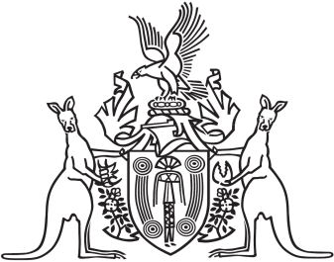
Northern Territory of Australia

Government Gazette
ISSN-0157-833X
No. S67 9 October 2017
Northern Territory of Australia
Mutual Recognition Act 1992 (Cth)
Request for Making of Regulations
I, John Laurence Hardy, Administrator of the Northern Territory of Australia, acting with the advice of the Executive Council, for section 47 of the Mutual Recognition Act 1992 (Cth), request the Governor-General of the Commonwealth to make regulations under that section in the terms set out in the Schedule.
Dated 9 October 2017
J. L. Hardy
Administrator
By His Honour's Command
E. D. Lawler
Minister for Education
acting for
Chief Minister
Schedule
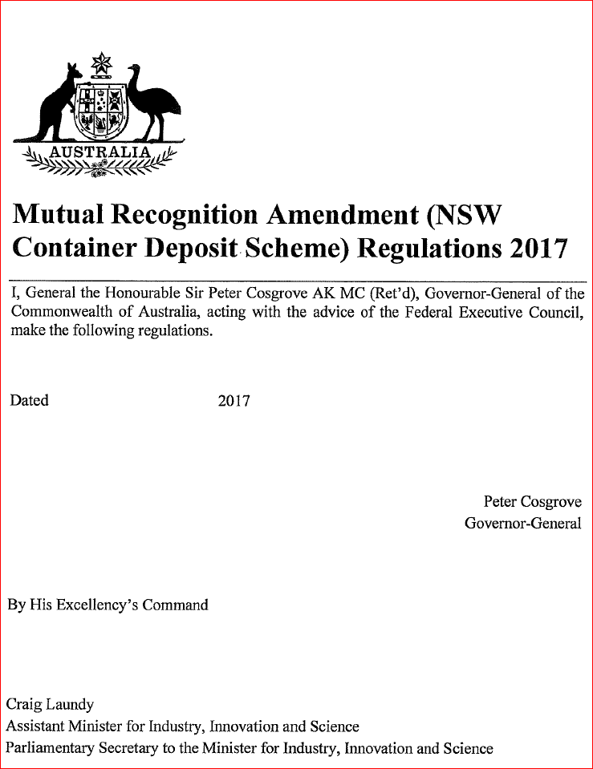
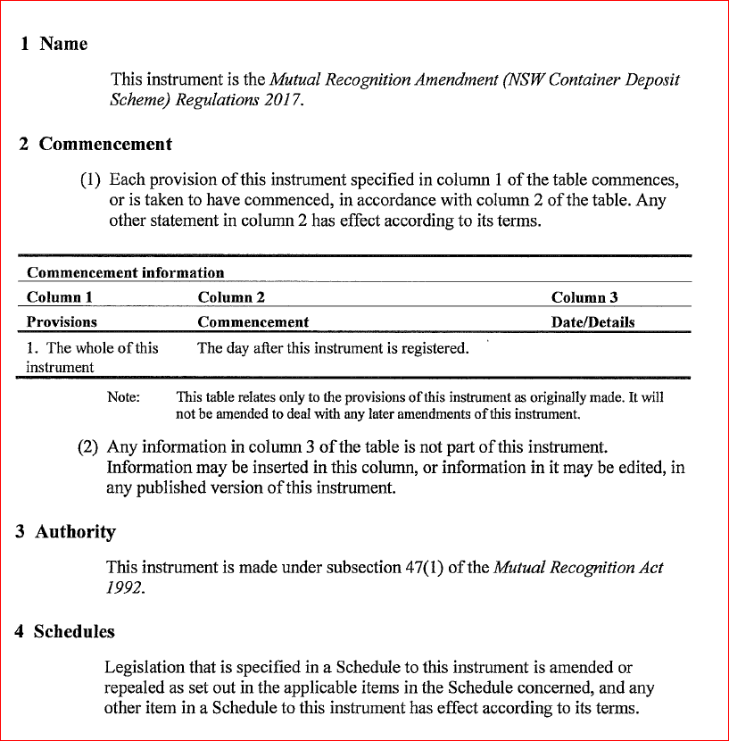
Northern Territory of Australia

Trans-Tasman Mutual Recognition Act (NT)

Trans-Tasman Mutual Recognition Act 1997 (Cth)
Endorsement of Regulations
I, John Laurence Hardy, Administrator of the Northern Territory of Australia, acting with the advice of the Executive Council, for section 43(1) of the Trans-Tasman Mutual Recognition Act 1997 (Cth), which applies as a law of the Territory because of section 5(1) of the Trans-Tasman Mutual Recognition Act (NT), endorse the making of regulations under section 47 of the Commonwealth Act in the terms set out in the Schedule.
Dated 9 October 2017
J. L. Hardy
Administrator
By His Honour's Command
E. D. Lawler
Minister for Education
acting for
Chief Minister
Schedule
