

Northern Territory of Australia

Government Gazette

ISSN-0157-8324

No. G4 25 January 2017

# General information

The Gazette is published by the Office of the Parliamentary Counsel.

The Gazette will be published every **Wednesday**, with the closing date for notices being the previous Friday at 4.00 pm.

Notices not received by the closing time will be held over until the next issue.

Notices will not be published unless a Gazette notice request form together with a copy of the signed notice and a clean copy of the notice in Word or PDF is emailed to [gazettes@nt.gov.au](mailto:gazettes@nt.gov.au)

Notices will be published in the next issue, unless urgent publication is requested.

# Availability

The Gazette will be available online at 12 Noon on the day of publication at <http://www.nt.gov.au/ntg/gazette.shtml>

Unauthorised versions of Northern Territory Acts and Subordinate legislation are available online at <http://www.legislation.nt.gov.au>

**Northern Territory of Australia**

# Petroleum Act

**Revocation of Reservation of Blocks – RB 61**

I, Debby Anne James, the Director Petroleum Tenure, as the delegate of the Minister for Primary Industry and Resources, in pursuance of section 9(1) of the *Petroleum Act* and with reference to section 43 of the *Interpretation Act,* revoke the blocks within RB61 in the Darwin locality, shown on the plan in the schedule published in the Northern Territory Government Gazette No. G21 on 27 May 2015.

Dated 12 January 2017

D. A. James

Director Petroleum Tenure

**Schedule**

**SD52 Darwin**

SD52 Darwin


**RB 61**

**395.9 Sq Km**

*Datum: The dispayed grid defining the 5’x5’ blocks is AGD66 and coordinates shown are GDA94*

Northern Territory of Australia

# *Petroleum Act*

Reservation of Blocks – RB 68

I, Debby Anne James, the Director Petroleum Tenure, as the delegate of the Minister for Primary Industry and Resources, in pursuance of section 9(1) of the *Petroleum Act*, declare that the blocks within the area, shown on the plan in the Schedule are not to be the subject of a grant of an exploration permit or licence.

Dated 12 January 2017

D. A. James

Director Petroleum Tenure

**Schedule**

**SD52 Darwin**

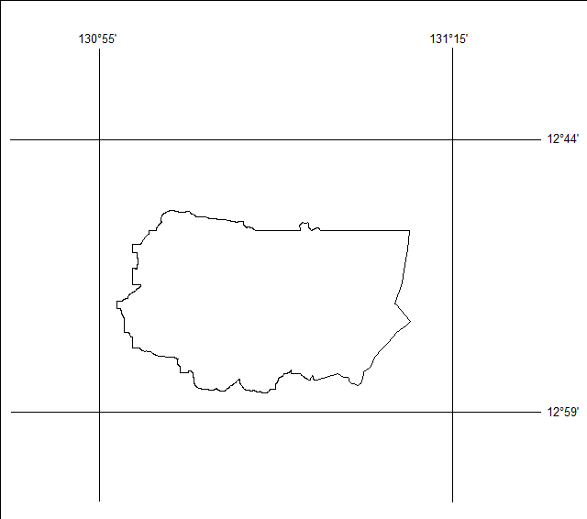

**RB 68**

**416.9 Sq. Km**

*Datum: The displayed grid defining the 5’x 5’ blocks is AGD66 and coordinates shown are GDA94*

**Northern Territory of Australia**

# *Geothermal Energy Act*

**Reservation of Blocks – GRO 7**

I, Debby Anne James, the Director Petroleum Tenure, as the delegate of the Minister for Primary Industry and Resources, in pursuance of section 6(1) of the *Geothermal Energy Act*, reserve each block within the area, shown bounded by a black line on the plan in the Schedule, from exploration for, or the extraction or production of, geothermal energy resources or geothermal energy.

Dated 12 January 2017

D. A. James

Director Petroleum Tenure

Locality Bynoe

Northern Territory of Australia

*Professional Standards Act*

**Notification of Instrument Amending**

**the RICS Valuers Limited Scheme**

I, Natasha Kate Fyles, Attorney-General and Minister for Justice, under section 13(1) of the *Professional Standards Act*, give notice that:

(a) an instrument entitled "Instrument Amending the RICS Valuers Limited Scheme" has been approved by the Professional Standards Council constituted by section 39 of the *Professional Standards Act 1994* (NSW) (the ***Council***); and

(b) copies of the instrument are available from the Council at Level 2, St James Centre, 111 Elizabeth Street, Sydney NSW 2000 and at http://www.psc.gov.au/news-and-publications/notifications.

Dated 18 January 2017

N. K. Fyles

Attorney-General and Minister for Justice