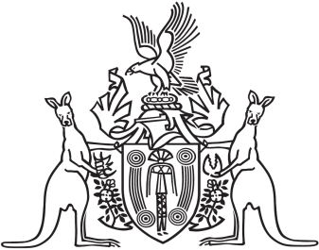
Northern Territory of Australia

Government Gazette
ISSN-0157-833X
No. S80 2 August 2016
Northern Territory of Australia

Northern Territory Aboriginal Sacred Sites Act
Aboriginal Areas Protection Authority
Appointment of Member
I, John Laurence Hardy, Administrator of the Northern Territory of Australia, acting with the advice of the Executive Council, under section 6(1) of the Northern Territory Aboriginal Sacred Sites Act and with reference to section 6(4) and (6) of the Act, appoint Valerie Napaljarri Martin to be a member of the Aboriginal Areas Protection Authority for 3 years on and from the date on which this instrument is published in the Gazette.
Dated 2 August 2016
J. L. Hardy
Administrator
By His Honour's Command
B. N. Price
Minister for Local Government and Community Services

