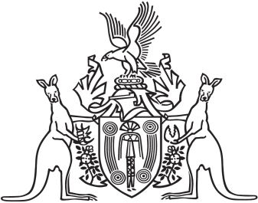
Northern Territory of Australia

Government Gazette
ISSN-0157-833X
No. S35 29 April 2016
Northern Territory of Australia

Inquiries Amendment Act 2016
Commencement Notice
I, John Laurence Hardy, Administrator of the Northern Territory, under section 2 of the Inquiries Amendment Act 2016 (No. 7 of 2016), fix 1 May 2016 as the day on which that Act commences.
Dated 29 April 2016
J. L. Hardy
Administrator

