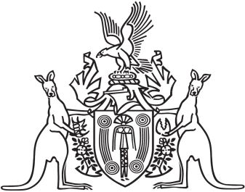
Northern Territory of Australia

Government Gazette
ISSN-0157-833X
No. S29 26 April 2016
Northern Territory of Australia

Education Act
Appointment of Registrar of Non-Government Schools
I, Peter Glen Chandler, Minister for Education, under section 123(1) of the Education Act, appoint Kevin Phillip Gillan to be the registrar of non-Government schools on and from the date of this instrument.
Dated 20 April 2016
P. G. Chandler
Minister for Education

