Mineral Titles Act 2010
NOTICE OF LAND CEASING TO BE A MINERAL TITLE AREA
Title Type and Number: | Exploration Licence 30226
Area Ceased on: | 11 August 2026
Area: | 17 Blocks, 27.25 km²
Locality: | GOVE
Name of Applicant(s)/Holder(s): | 100% GULKULA MINING COMPANY PTY LTD [ACN. 153 861 806]
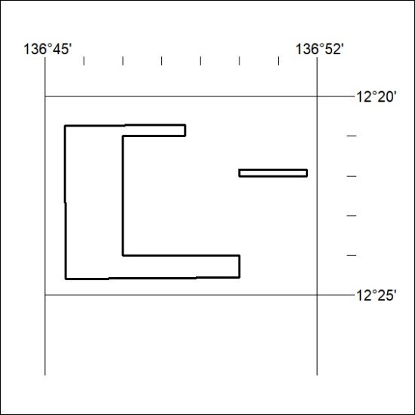

352/26

Mineral Titles Act 2010
NOTICE OF LAND CEASING TO BE A MINERAL TITLE AREA
Title Type and Number: | Exploration Licence 33000
Area Ceased on: | 19 August 2026
Area: | 21 Blocks, 66.43 km²
Locality: | AILERON
Name of Applicant(s)/Holder(s): | 100% URO CORPORATION PTY LTD [ACN. 653 927 998]
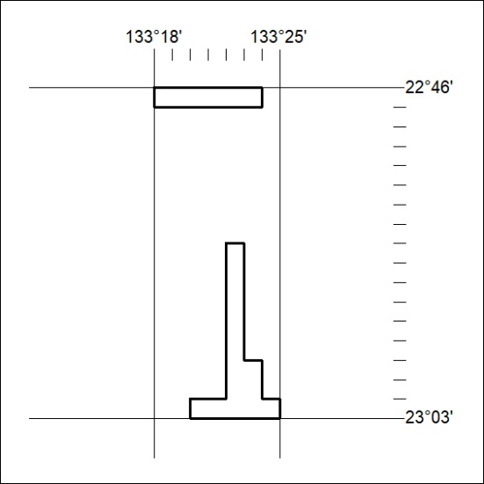

353/26

Mineral Titles Act 2010
NOTICE OF LAND CEASING TO BE A MINERAL TITLE APPLICATION AREA
Title Type and Number: | Exploration Licence 34332
Area Ceased on: | 24 August 2026
Area: | 250 Blocks, 825.90 km²
Locality: | PINKERTON
Name of Applicant(s)/Holder(s): | 100% TECK AUSTRALIA PTY LTD [ACN. 091 271 911]
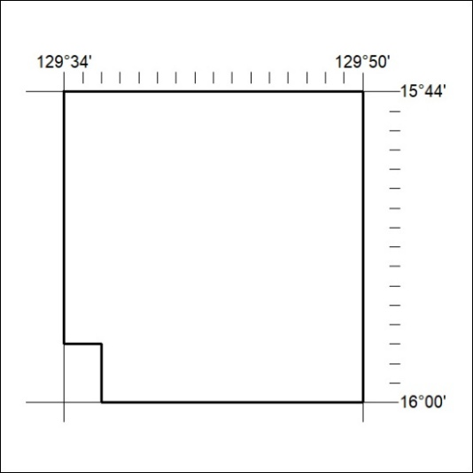

354/26

Mineral Titles Act 2010
NOTICE OF LAND CEASING TO BE A MINERAL TITLE APPLICATION AREA
Title Type and Number: | Exploration Licence 34333
Area Ceased on: | 24 August 2026
Area: | 250 Blocks, 827.01 km²
Locality: | AUVERGNE
Name of Applicant(s)/Holder(s): | 100% TECK AUSTRALIA PTY LTD [ACN. 091 271 911]
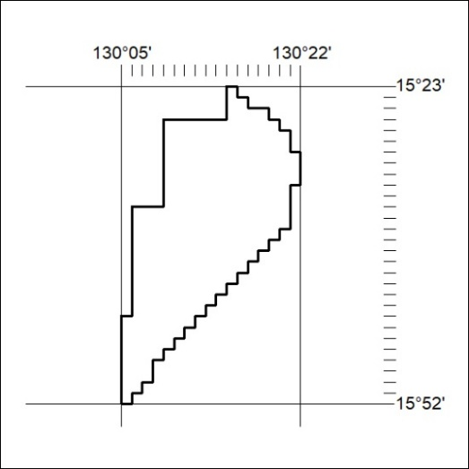

355/26

Mineral Titles Act 2010
NOTICE OF LAND CEASING TO BE A MINERAL TITLE APPLICATION AREA
Title Type and Number: | Exploration Licence 34334
Area Ceased on: | 24 August 2026
Area: | 250 Blocks, 827.17 km²
Locality: | PINKERTON
Name of Applicant(s)/Holder(s): | 100% TECK AUSTRALIA PTY LTD [ACN. 091 271 911]
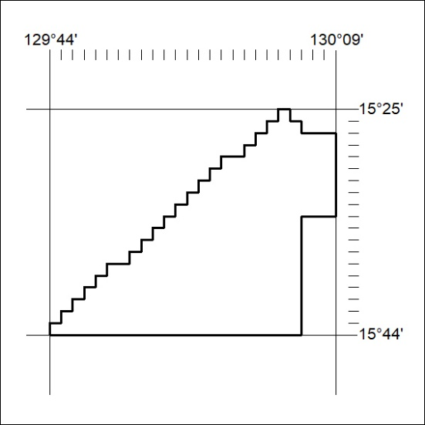

356/26

Mineral Titles Act 2010
NOTICE OF LAND CEASING TO BE A MINERAL TITLE APPLICATION AREA
Title Type and Number: | Exploration Licence 34335
Area Ceased on: | 24 August 2026
Area: | 197 Blocks, 651.98 km²
Locality: | PINKERTON
Name of Applicant(s)/Holder(s): | 100% TECK AUSTRALIA PTY LTD [ACN. 091 271 911]
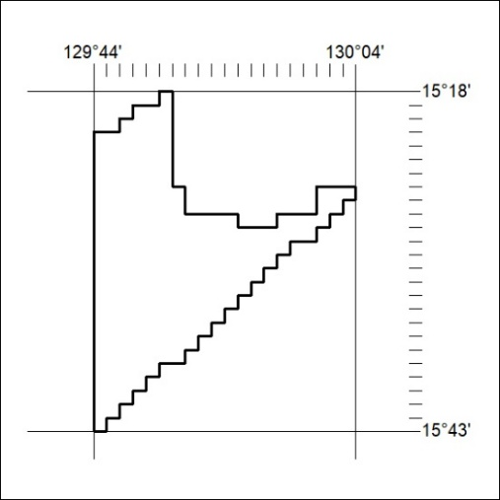

357/26

Mineral Titles Act 2010
NOTICE OF LAND CEASING TO BE A MINERAL TITLE APPLICATION AREA
Title Type and Number: | Exploration Licence 34336
Area Ceased on: | 24 August 2026
Area: | 247 Blocks, 817.15 km²
Locality: | PINKERTON
Name of Applicant(s)/Holder(s): | 100% TECK AUSTRALIA PTY LTD [ACN. 091 271 911]
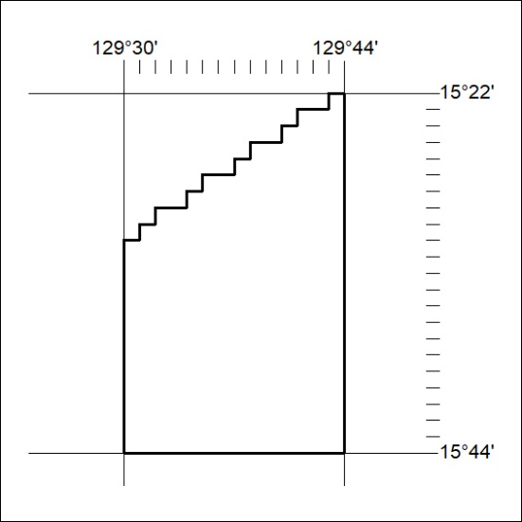

358/26

Mineral Titles Act 2010
NOTICE OF LAND CEASING TO BE A MINERAL TITLE APPLICATION AREA
Title Type and Number: | Exploration Licence 34337
Area Ceased on: | 24 August 2026
Area: | 208 Blocks, 687.14 km²
Locality: | PINKERTON
Name of Applicant(s)/Holder(s): | 100% TECK AUSTRALIA PTY LTD [ACN. 091 271 911]
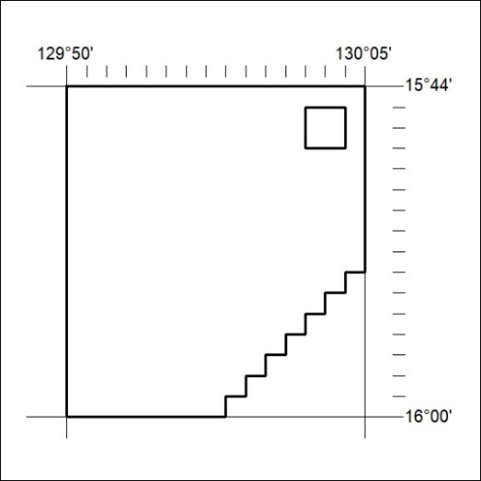

359/26

Mineral Titles Act 2010
NOTICE OF LAND CEASING TO BE A MINERAL TITLE APPLICATION AREA
Title Type and Number: | Exploration Licence 34338
Area Ceased on: | 24 August 2026
Area: | 250 Blocks, 825.92 km²
Locality: | KEEP
Name of Applicant(s)/Holder(s): | 100% TECK AUSTRALIA PTY LTD [ACN. 091 271 911]
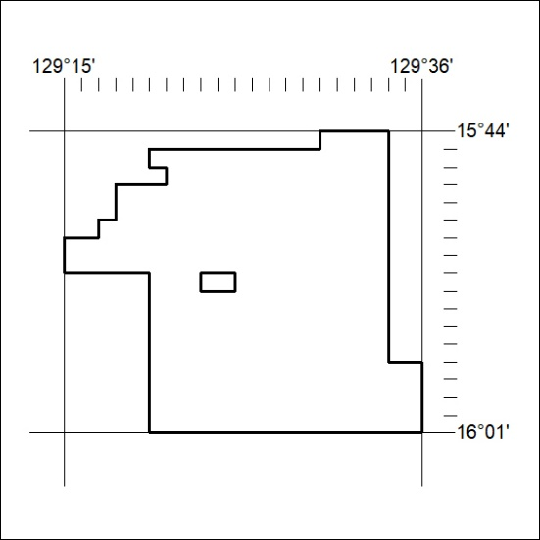

360/26

Mineral Titles Act 2010
NOTICE OF LAND CEASING TO BE A MINERAL TITLE APPLICATION AREA
Title Type and Number: | Exploration Licence 34339
Area Ceased on: | 24 August 2026
Area: | 243 Blocks, 800.89 km²
Locality: | KEEP
Name of Applicant(s)/Holder(s): | 100% TECK AUSTRALIA PTY LTD [ACN. 091 271 911]
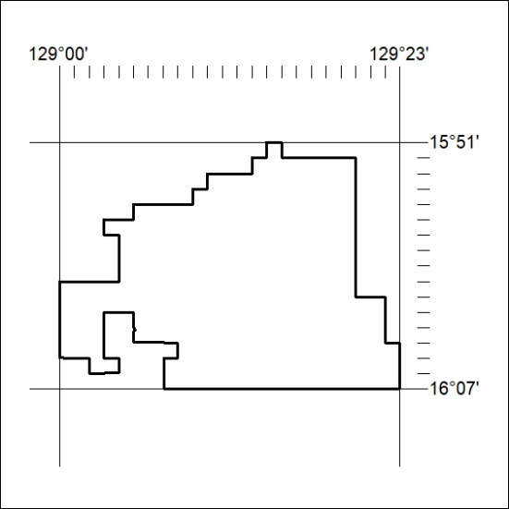

361/26

Mineral Titles Act 2010
NOTICE OF LAND CEASING TO BE A MINERAL TITLE APPLICATION AREA
Title Type and Number: | Exploration Licence 34340
Area Ceased on: | 24 August 2026
Area: | 199 Blocks, 656.27 km²
Locality: | KILDURK
Name of Applicant(s)/Holder(s): | 100% TECK AUSTRALIA PTY LTD [ACN. 091 271 911]
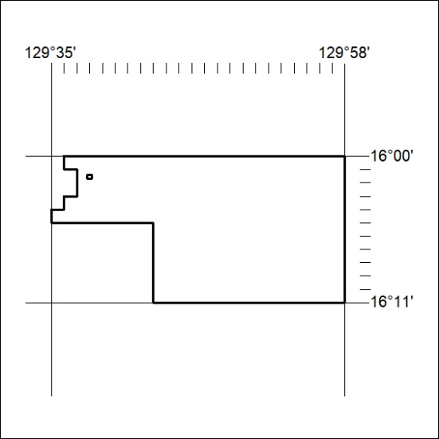

362/26

Mineral Titles Act 2010
NOTICE OF LAND CEASING TO BE A MINERAL TITLE APPLICATION AREA
Title Type and Number: | Exploration Licence 34341
Area Ceased on: | 24 August 2026
Area: | 172 Blocks, 566.99 km²
Locality: | NEWRY
Name of Applicant(s)/Holder(s): | 100% TECK AUSTRALIA PTY LTD [ACN. 091 271 911]
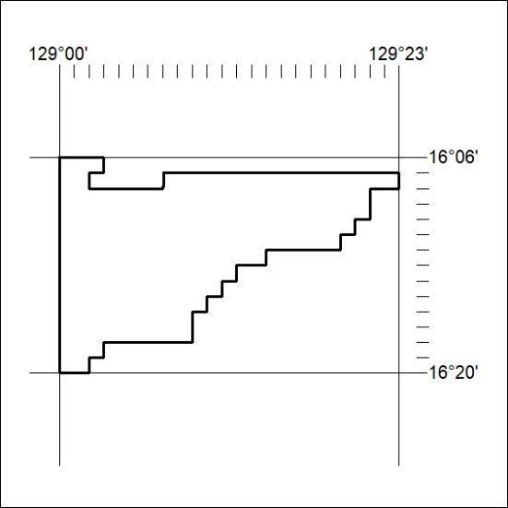

363/26

Mineral Titles Act 2010
NOTICE OF LAND CEASING TO BE A MINERAL TITLE AREA
Title Type and Number: | Mineral Lease (Northern) 542
Area ceased on: | 24 August 2026
Area: | 15.00 Hectare
Locality: | BATCHELOR
Name of Applicants(s)Holder(s): | 100% KORAB RESOURCES LIMITED [ACN. 082 140 252]
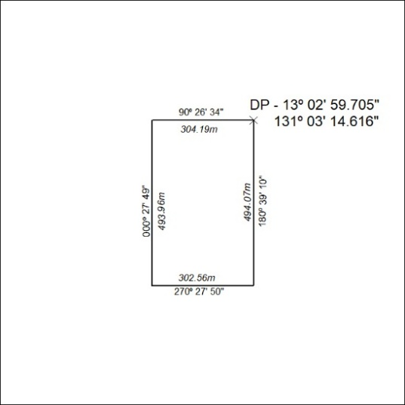

364/26

Mineral Titles Act 2010
NOTICE OF LAND CEASING TO BE A MINERAL TITLE AREA
Title Type and Number: | Mineral Lease (Northern) 543
Area ceased on: | 24 August 2026
Area: | 14.00 Hectare
Locality: | BATCHELOR
Name of Applicants(s)Holder(s): | 100% KORAB RESOURCES LIMITED [ACN. 082 140 252]
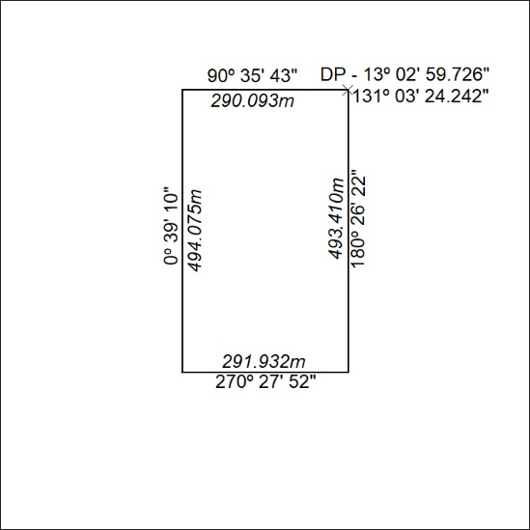

365/26

Mineral Titles Act
NOTICE OF GRANT OF A MINERAL TITLE
Title Type and Number: | Exploration Licence 33843
Granted: | 20 August 2026, for a period of 6 Years
Area: | 3 Blocks, 10.01 km²
Locality: | RANFORD HILL
Name of Holder/s: | 100% WILTON MINING PTY LTD [ACN. 668 370 643]
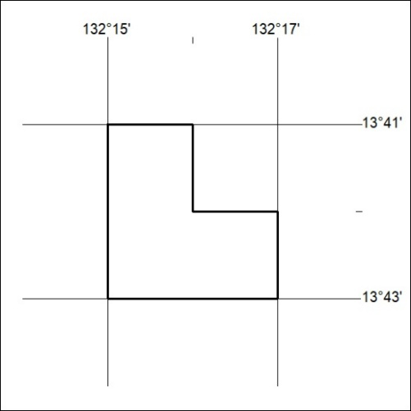
Area granted is indicated above. The titleholder is not permitted to exercise occupational rights on any land that is subject to a development title, or an application for a development title. Any land the subject of a Reserved Land gazettal under the Mineral Titles Act and all land vested in the Commonwealth of Australia is also excluded by description but not excised from the grant area.

366/26

Mineral Titles Act
NOTICE OF GRANT OF A MINERAL TITLE
Title Type and Number: | Exploration Licence 34049
Granted: | 20 August 2026, for a period of 6 Years
Area: | 13 Blocks, 16.54 km²
Locality: | RANFORD HILL
Name of Holder/s: | 100% WILTON MINING PTY LTD [ACN. 668 370 643]
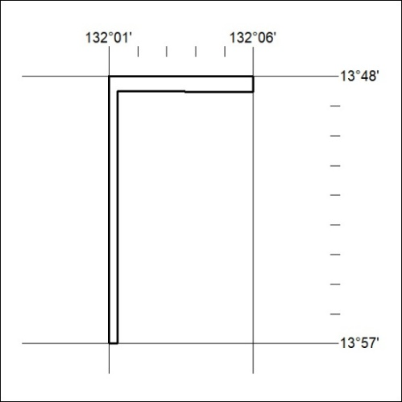
Area granted is indicated above. The titleholder is not permitted to exercise occupational rights on any land that is subject to a development title, or an application for a development title. Any land the subject of a Reserved Land gazettal under the Mineral Titles Act and all land vested in the Commonwealth of Australia is also excluded by description but not excised from the grant area.

367/26

Mineral Titles Act
NOTICE OF GRANT OF A MINERAL TITLE
Title Type and Number: | Extractive Mineral Permit 34212
Granted: | 24 August 2026, for a period of 5 Years
Area: | 22.00 Hectares
Locality: | BRUNCHILLY
Name of Holder/s: | 100% REMOTE INDUSTRIES AUSTRALIA PTY LTD [ACN. 155 256 214]
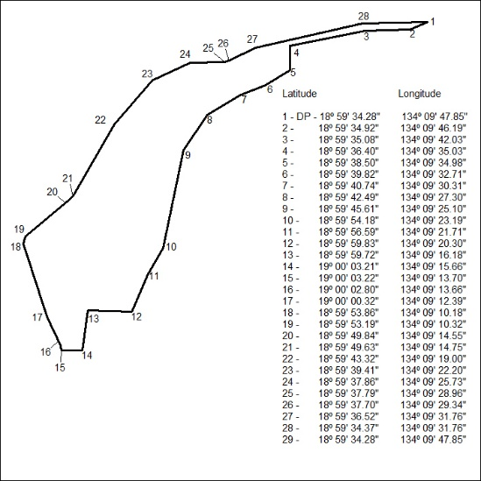

368/26

Mineral Titles Act
NOTICE OF GRANT OF A MINERAL TITLE
Title Type and Number: | Exploration Licence 34248
Granted: | 21 August 2026, for a period of 6 Years
Area: | 196 Blocks, 605.97 km²
Locality: | LAUGHLEN
Name of Holder/s: | 100% BLACK GATE RARE EARTHS PTY LTD [ACN. 681 345 317]
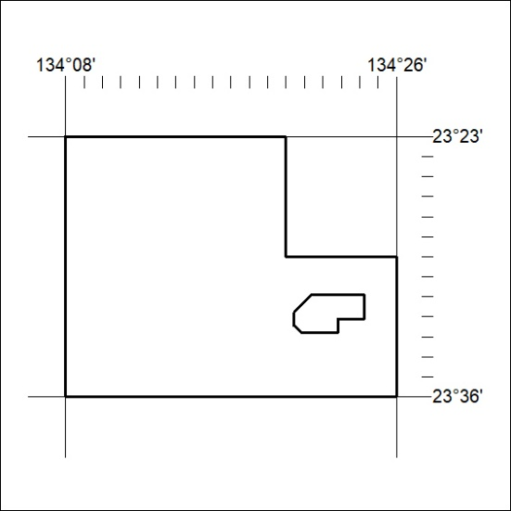
Area granted is indicated above. The titleholder is not permitted to exercise occupational rights on any land that is subject to a development title, or an application for a development title. Any land the subject of a Reserved Land gazettal under the Mineral Titles Act and all land vested in the Commonwealth of Australia is also excluded by description but not excised from the grant area.

369/26

Mineral Titles Act
NOTICE OF GRANT OF A MINERAL TITLE
Title Type and Number: | Exploration Licence 34249
Granted: | 21 August 2026, for a period of 6 Years
Area: | 161 Blocks, 486.72 km²
Locality: | LAUGHLEN
Name of Holder/s: | 100% BLACK GATE RARE EARTHS PTY LTD [ACN. 681 345 317]
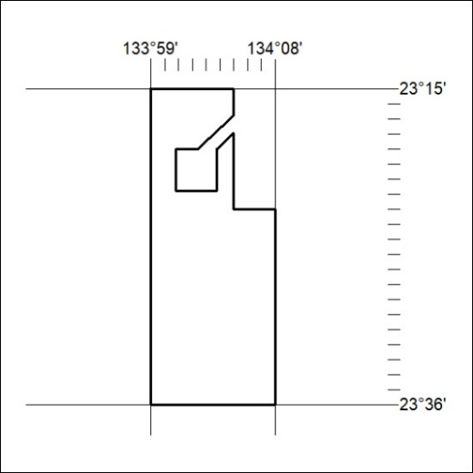
Area granted is indicated above. The titleholder is not permitted to exercise occupational rights on any land that is subject to a development title, or an application for a development title. Any land the subject of a Reserved Land gazettal under the Mineral Titles Act and all land vested in the Commonwealth of Australia is also excluded by description but not excised from the grant area.

370/26

Mineral Titles Act
NOTICE OF GRANT OF A MINERAL TITLE
Title Type and Number: | Exploration Licence 34256
Granted: | 20 August 2026, for a period of 6 Years
Area: | 34 Blocks, 86.83 km²
Locality: | RIDDOCH
Name of Holder/s: | 100% TDM INTERNATIONAL PTY LTD [ACN. 684 939 884]
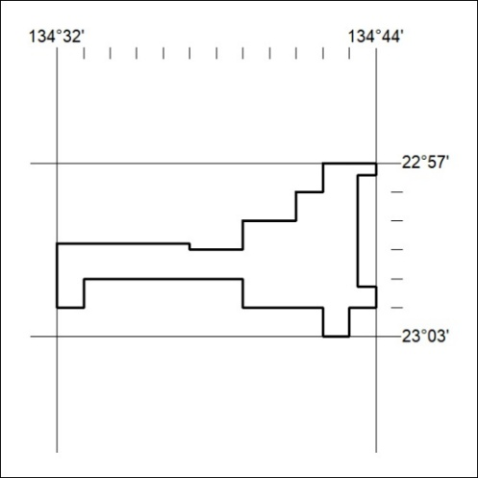
Area granted is indicated above. The titleholder is not permitted to exercise occupational rights on any land that is subject to a development title, or an application for a development title. Any land the subject of a Reserved Land gazettal under the Mineral Titles Act and all land vested in the Commonwealth of Australia is also excluded by description but not excised from the grant area.

371/26

