Mineral Titles Act
NOTICE OF GRANT OF A MINERAL TITLE
Title Type and Number: | Extractive Mineral Exploration Licence 33570
Granted: | 01 December 2023, for a period of 2 Years
Area: | 1 Block, 3.35 km²
Locality: | BATCHELOR
Name of Holder/s: | 100% TERRITORY SANDS PTY LTD [ACN. 632 797 972]
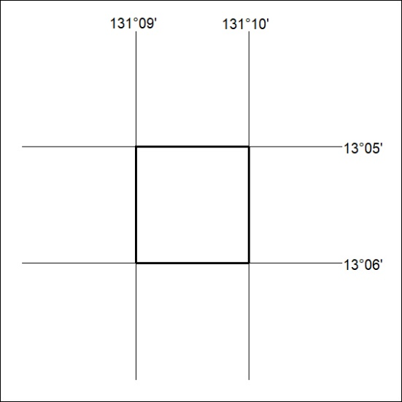
Area granted is indicated above. The titleholder is not permitted to exercise occupational rights on any land that is subject to a development title, or an application for a development title. Any land the subject of a Reserved Land gazettal under the Mineral Titles Act and all land vested in the Commonwealth of Australia is also excluded by description but not excised from the grant area.

501/23

