Mineral Titles Act 2010
NOTICE OF LAND CEASING TO BE A MINERAL TITLE AREA
Title Type and Number: | Exploration Licence 31983
Area Ceased on: | 31 August 2023
Area: | 27 Blocks, 82.87 km²
Locality: | LAUGHLEN
Name of Applicant(s)/Holder(s): | 100% MATSON Paul Richard
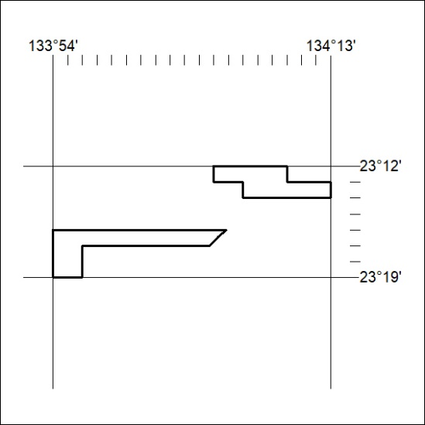

356/23

Mineral Titles Act 2010
NOTICE OF LAND CEASING TO BE A MINERAL TITLE AREA
Title Type and Number: | Exploration Licence 32427
Area Ceased on: | 31 August 2023
Area: | 20 Blocks, 63.19 km²
Locality: | BURT
Name of Applicant(s)/Holder(s): | 100% MATSON Paul Richard
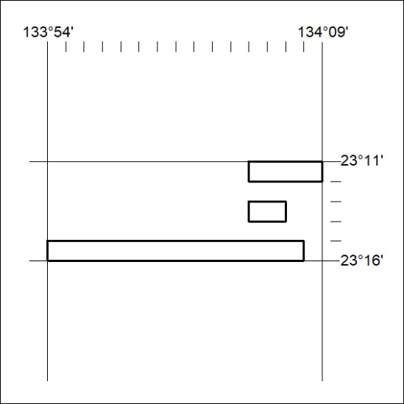

357/23

