Mineral Titles Act 2010
NOTICE OF LAND CEASING TO BE A MINERAL TITLE AREA
Title Type and Number: | Exploration Licence 32247
Area Ceased on: | 07 June 2023
Area: | 14 Blocks, 45.98 km²
Locality: | LANCEWOOD
Name of Applicant(s)/Holder(s): | 100% CERBERUS RESOURCES PTY LTD [ACN. 615 192 535]
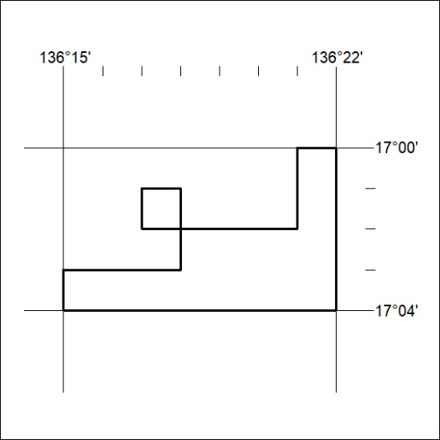

180/23

Mineral Titles Act 2010
NOTICE OF LAND CEASING TO BE A MINERAL TITLE AREA
Title Type and Number: | Exploration Licence 32450
Area Ceased on: | 05 June 2023
Area: | 21 Blocks, 68.89 km²
Locality: | KILGOUR
Name of Applicant(s)/Holder(s): | 100% TRANSITION MINERALS LIMITED* [ACN. 641 565 139]
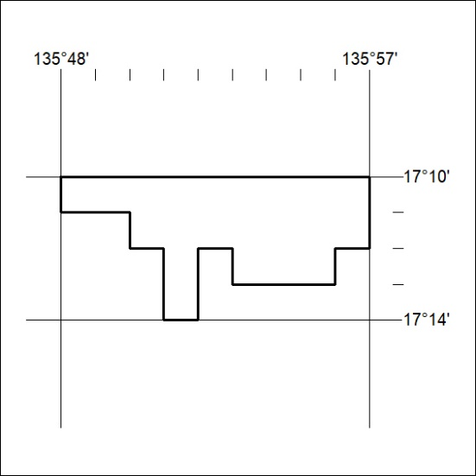

181/23
Mineral Titles Act 2010
NOTICE OF LAND CEASING TO BE A MINERAL TITLE AREA
Title Type and Number: | Exploration Licence 32451
Area Ceased on: | 05 June 2023
Area: | 26 Blocks, 85.28 km²
Locality: | LANCEWOOD
Name of Applicant(s)/Holder(s): | 100% TRANSITION MINERALS LIMITED* [ACN. 641 565 139]
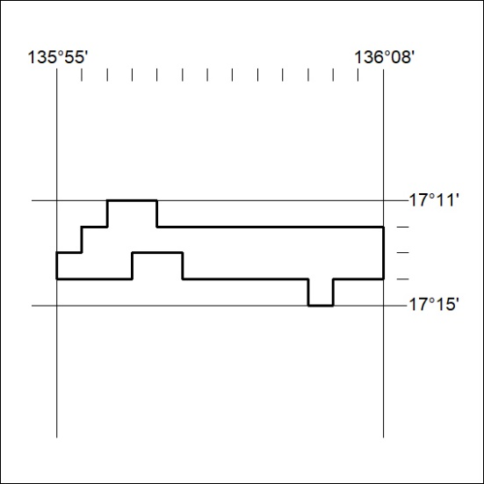

182/23

Mineral Titles Act 2010
NOTICE OF LAND CEASING TO BE A MINERAL TITLE AREA
Title Type and Number: | Exploration Licence 32452
Area Ceased on: | 05 June 2023
Area: | 27 Blocks, 88.56 km²
Locality: | LANCEWOOD
Name of Applicant(s)/Holder(s): | 100% TRANSITION MINERALS LIMITED* [ACN. 641 565 139]
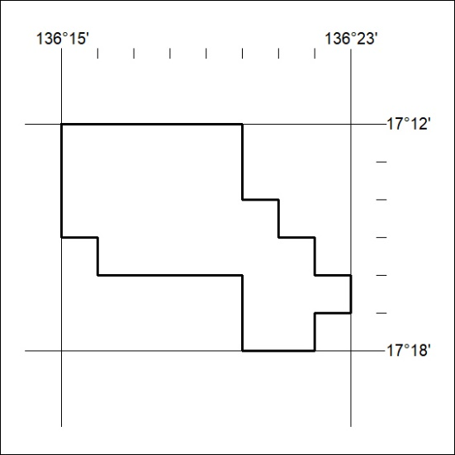

183/23

