Mineral Titles Act 2010
NOTICE OF LAND CEASING TO BE A MINERAL TITLE AREA
Title Type and Number: | Mineral Authority 24584
Area ceased on: | 29 April 2023
Area: | 45.00 Hectare
Locality: | BYNOE
Name of Applicants(s)Holder(s): | 100% BOB KERR TRANSPORT PTY LTD [ACN. 109 115 059]
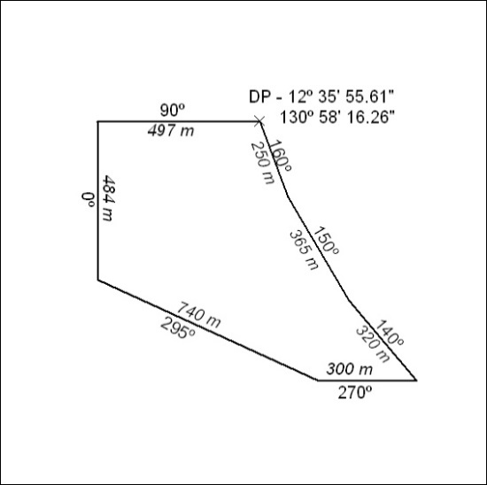

120/23

