Mineral Titles Act 2010
NOTICE OF LAND CEASING TO BE A MINERAL TITLE AREA
Title Type and Number: | Mineral Lease 30723
Area ceased on: | 13 April 2023
Area: | 4.00 Hectare
Locality: | PINE CREEK
Name of Applicants(s)Holder(s): | 100% MCKINLAY RIVER MINING PTY. LTD [ACN. 059 869 224]
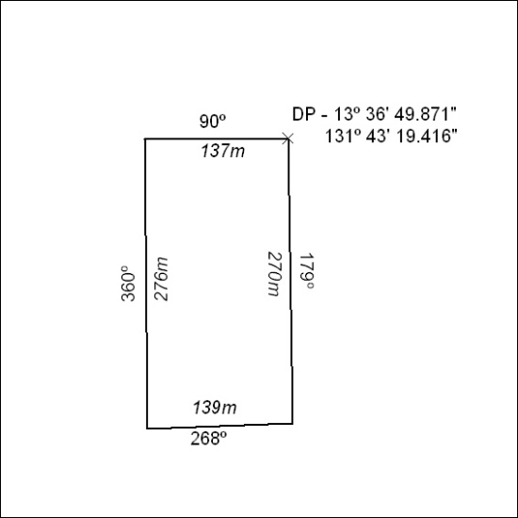

098/23

Mineral Titles Act 2010
NOTICE OF LAND CEASING TO BE A MINERAL TITLE APPLICATION AREA
Title Type and Number: | Exploration Licence 33345
Area Ceased on: | 13 April 2023
Area: | 3 Blocks, 5.22 km²
Locality: | BYNOE
Name of Applicant(s)/Holder(s): | 100% RED MOUNTAIN MINING LTD [ACN. 119 568 106]
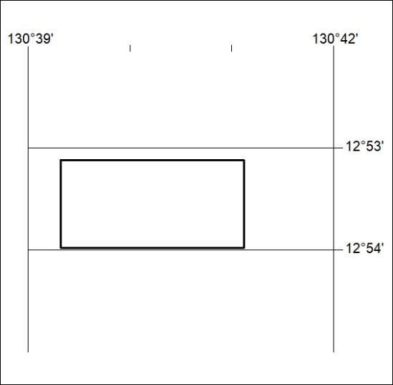

099/23

