Mineral Titles Act
NOTICE OF GRANT OF A MINERAL TITLE
Title Type and Number: | Exploration Licence 33028
Granted: | 07 March 2023, for a period of 6 Years
Area: | 21 Blocks, 69.16 km²
Locality: | BATTEN
Name of Holder/s: | 100% DALY TENEMENTS PTY LTD [ACN. 658 845 786]
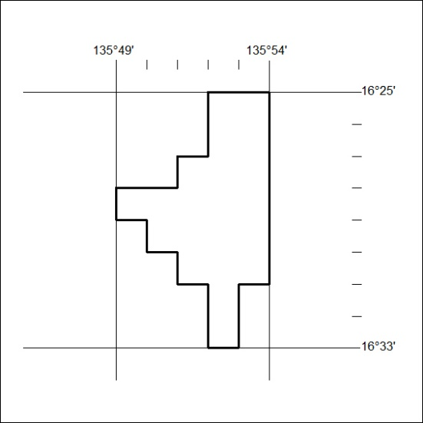
Area granted is indicated above. The titleholder is not permitted to exercise occupational rights on any land that is subject to a development title, or an application for a development title. Any land the subject of a Reserved Land gazettal under the Mineral Titles Act and all land vested in the Commonwealth of Australia is also excluded by description but not excised from the grant area.
069/23

Mineral Titles Act
NOTICE OF GRANT OF A MINERAL TITLE
Title Type and Number: | Exploration Licence 33297
Granted: | 16 March 2023, for a period of 6 Years
Area: | 94 Blocks, 304.97 km²
Locality: | BOWMAN
Name of Holder/s: | 100% GREENSAND AUSTRALIA PTY LTD [ACN. 654165929]
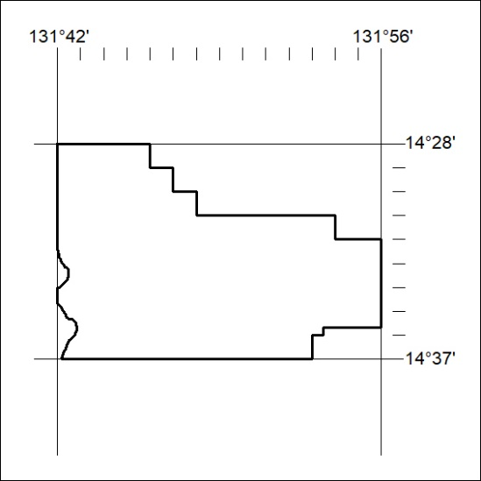
Area granted is indicated above. The titleholder is not permitted to exercise occupational rights on any land that is subject to a development title, or an application for a development title. Any land the subject of a Reserved Land gazettal under the Mineral Titles Act and all land vested in the Commonwealth of Australia is also excluded by description but not excised from the grant area.
070/23

