Mineral Titles Act 2010
NOTICE OF LAND CEASING TO BE A MINERAL TITLE AREA
Title Type and Number: | Extractive Mineral Exploration Licence 32490
Area Ceased on: | 20 December 2022
Area: | 3 Blocks, 1.16 km²
Locality: | MARY RIVER
Name of Applicant(s)/Holder(s): | 50% ANICTOMATIS Ross, 50% OSTOJIC GROUP PTY LTD* [ACN. 009 629 805]
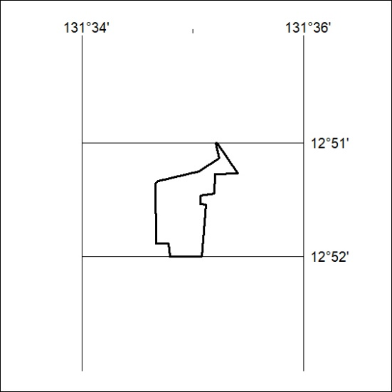

434/22

