Value For Territory Assessment
  - A guide for tendering with the Northern Territory Government
Document title | Value For Territory Assessment
Contact details | Department of Industry, Tourism and Trade
Approved by | Executive Director Business Development
Date approved | 8 July 2021
Document review | Annually

Version | Date | Author | Changes made
1 | 8 July 2021 | Procurement NT | Initial version
1.1 | 16 July 2021 | Procurement NT | Minor updates and revisions for consistency

Acronyms | Full form
NT | Northern Territory
VFT | Value For Territory
CAL | Contractor Accreditation Limited

Contents
1. Introduction 4
2. What is Value for Territory 4
3. Value For Territory Assessment Criteria 5
3.1. Local Content 5
3.2. Past Performance 5
3.3. Capability 6
3.4. Capacity and Timeliness 6
3.5. Scope Specific 7
4. The Assessment Process 7
4.1. Local Content 7
4.1.1. Objective Assessment 7
4.1.2. Assessing Commitment To Advancing The Territory 8
4.2. Subjective Scoring Scale 9
Appendix A – Focus Areas for Commitment to Advancing the Territory 11
Increased Aboriginal participation in employment and business 11
Regional development 11
Territory culture 12
Support for disadvantaged people or groups 12
Environmental protection 12
Gender equality 12
Research and innovation 12

Introduction
This guide is intended to provide business with an insight into how the Northern Territory Government defines and assesses Value For Territory in its tender assessment process and has been developed to be read in conjunction with the Tendering Guide.
The document will outline each of the assessment criteria used in tender assessments, and will discuss how they are considered by the assessment panel when evaluating Value for Territory.

What is Value for Territory
Value For Territory (VFT) is one of five Procurement Principles that guide the way that Government undertakes and assesses tenders. It is a key driver in the effective realisation of NTG economic, social and cultural objectives. That means government wants more for its contract delivery than just the best price. VFT in a tender is a combination of:
- Good quality – tenderers provide a fit for purpose solution that meets the Northern Territory Governments needs
- Good price – tenderers provide a competitive price that is sustainable for both government and industry
- Good outcomes – tenderers contribute towards the Northern Territory Government’s economic, social, environmental and cultural objectives for the Northern Territory.
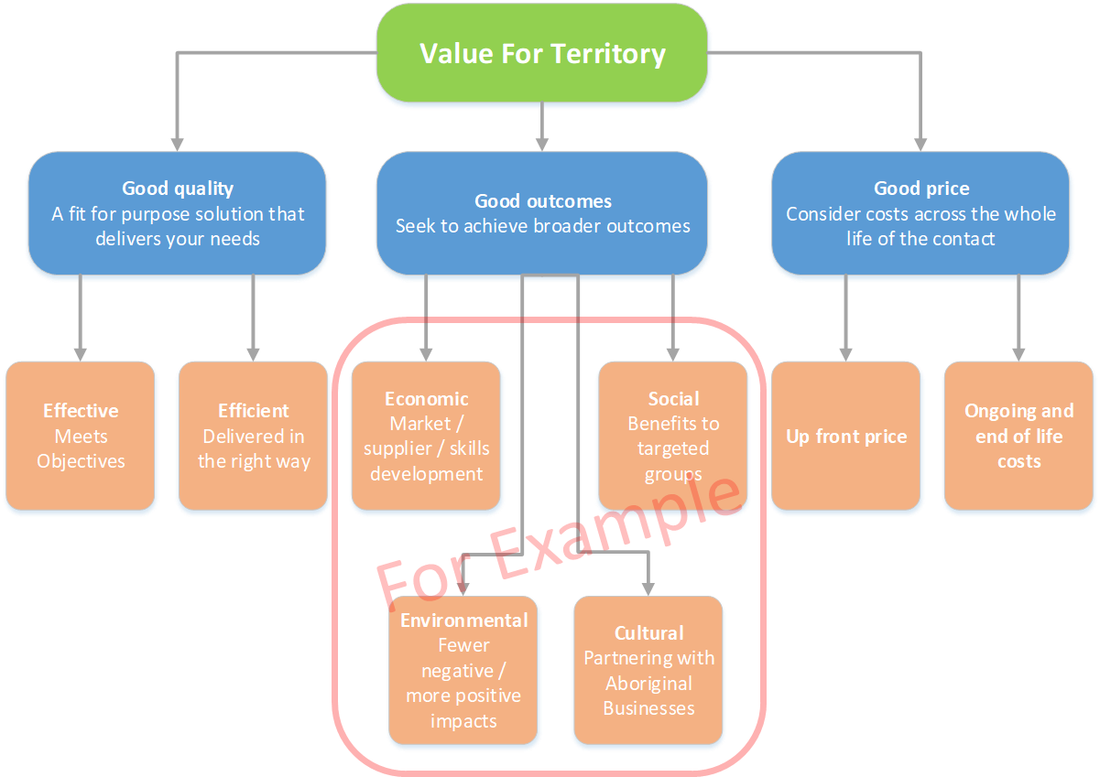
Figure 1 - Value For Territory diagram showing Good Quality, Good Outcomes and Good Price
While the considerations that make up good quality and good price are reasonably consistent across all procurement contracts, the consideration of good outcomes can vary considerably based on the specific priorities of government at the time.

Value For Territory Assessment Criteria
To assess VFT, the Northern Territory Government uses up to six standard assessment criteria:
- Local Content
- Past performance
- Capability
- Capacity & Timeliness
- Scope Specific
- Price
Each of these criterion, where selected, is allocated a weighting as indicated in the tender documents. Local Content must always be weighted at a minimum of 30%.
An overview of each of the non-price criteria is included below. Refer to the Tendering Guide for information on how price is assessed.

Local Content
The Northern Territory Government is committed through its Buy Local Plan to supporting businesses that use local contractors, suppliers, hire and train Territorians and support the development of the Territory.
Assessment of this criteria takes into consideration the tenderers commitments to:-
- Supporting and employing Territorians including Aboriginal Territorians, through provision of accredited training for its employees, sourcing goods and services from local businesses or other activities that support the development and advancement of theTerritory; and
- Development of business and industry in the Northern Territory.
These are referred to as Local Benefit Commitments and the Contractor will be required to fulfil all aspects of these commitments.
Important Information
If you nominate subcontractors or suppliers, they may be contacted by the tender assessment panel to confirm that they are aware that they have been put forward as a potential subcontractor, particularly where the subcontractor contributes significantly towards the tenderers Local Content assessment.

Past Performance
Contractors with a good history of delivering on contract commitments, particularly in projects that are of a similar scope, scale and delivered in the region, are considered to be more likely to deliver on commitments made in the tender.
Assessment of Past Performance may consider:
- History of delivering on commitments made (timeframe, budget, scope, etc)
- Standard and quality of supplies previously provided
- Quality of communication throughout previous contract periods
- Disputes and claims history
- Commitment to resolving issues where they have occurred
- Extent of supervision previously required
- References (including CAL if applicable)
- Safe and fair workplace record
- Timely payment to employees, subcontractors and suppliers
- History of enhancing local, economic and community outcomes.
If referees or examples of previous work are requested, it is of value to provide samples that:
- align closely to the scope of the tender
- are relevant to the project requirements
- are similar in value, complexity and scope
- include key personnel being put forward who had a significant role in delivery of the requirement.
Where an organisation has limited direct experience in delivering contracts directly comparable to the tender, referees and examples that demonstrate past performance of key personnel which relate to the tender may be put forward.
Important Information
Referees may be contacted by the agency to discuss your past performance and substantiate any written statement on past performance you have made.
The Tenderer is encouraged to contact their referees to confirm they are willing to be a referee for a particular submission before listing them in the response schedule.
Unless stated otherwise, responses to Past Performance assessment criteria should focus on the last two years.
Previous/recent Contractor Performance Reports for similar works and services can be used by the assessment panel as an indicator for this assessment criteria.

Capability
The Capability assessment criteria is used to validate the technical capability of tenderers.
Assessment of Capability may include:
- Qualifications of personnel
- Verification of required licences and accreditations being held
- Verification of understanding the business needs and industry specifics
- Verification of Membership of industry bodies.

Capacity and Timeliness
The assessment of Capacity and Timeliness is to ensure that tenderers have planned for and have the ability to allocate appropriate resources to deliver the scope of requirements within the timeframe outlined in the tender response.
Assessment of Capacity and Timeliness will usually consider:
- Number and role of personnel allocated towards the delivery of the requirements
- Plant, equipment and facilities available for use in the delivery of the requirements
- Financial capacity of the organisation
- Risk management policies and procedures
- Methodologies to be used to deliver the tender requirement
- Acceptability of the proposed delivery timeline.
Assessment of Capacity and Timeliness will often involve cross referencing responses to other assessment criteria. For example where qualifications and experience of key personnel are requested, assessment panels will often look for where those resources are allocated throughout the contract.

Scope Specific
The Scope Specific assessment criteria is used to assess other aspects of tenders that are considered important, but are not covered by other criteria.
Assessment of Scope Specific criteria could include:
- Assessment of technical specifications of products, equipment, services or infrastructure being offered
- Value added or cost saving proposals
- Innovation offered as part of the tender response.

The Assessment Process
The information and examples below are provided to demonstrate how the assessment process is undertaken.

Local Content

Objective Assessment
The majority of questions will be assessed objectively based on benchmarks that describe the response required to achieve a particular score. Benchmarks may include more than one requirement that must be satisfied (as show in Figure 2 – Objective assessment example).
Weighting | Criteria | % Score | Raw score | Benchmark description
3 | Employing Territorians | 100% | 3 | 50% or 10+ local employees
 |  | 67% | 2 | 20% or 5+ local employees
 |  | 33% | 1 | Some local employment
 |  | 0% | 0 | No local employment
Figure 2 – Objective assessment example

Assessing Commitment To Advancing The Territory
Commitment to advancing the Territory (also referred to as Territory Benefit) is generally included in all assessments. There are a number of ways that a respondent can demonstrate this commitment. This includes advancing the Northern Territory through focusing on:
- Increased Aboriginal participation in employment and business
- Regional development
- Development of territory culture
- Support for disadvantaged people or groups
- Environmental protection
- Gender equality
- Research and innovation.
Further information on the focus areas is included at Appendix A.
Depending on the value of the procurement activity, tenderers may be required to respond to up to three of these areas, however on lower value procurements tenderers will only be required to respond to one.
Assessing commitment to advancing the Territory is a subjective assessment (as shown in Figure 3 – Territory Benefit assessment example).
Weighting | Criteria | % Score | Raw score | Benchmark description
3 | Contribute to the NT | 100% | 3 | Significant contribution in 3 areas
 |  | 67% | 2 | Significant contribution in 2 areas
 |  | 33% | 1 | Significant contribution in 1 area
 |  | 0% | 0 | No significant contribution
Figure 3 – Territory Benefit assessment example
In determining if a contribution/s is significant, the following is considered.
Scale – Size of the business in relation to the significance of the commitment?
For example a few hours of pro bono work performed by small business (1 or 2 employees) could be viewed as a significant commitment. A similar commitment from a medium or large size business would not be viewed as significant.
Relevance – How relevant is the contribution to the development of the Territory?
Consideration will be limited to contributions that directly benefit the Territory above and beyond what would be considered normal industry practice. For example complying with environmental protection legislation would not be considered as a relevant contribution as it represents the minimum expected behaviour; however introduction of environmental management practices that significantly exceed minimum expectations and normal industry practice would be.
Timely – How recent were the benefits delivered to the Territory?
As a guide, contributions to the Territory should have been made within the last 24 months, however assessors have discretion to consider older contributions where the scale and relevance are considered justifiable.
Verifiable – Has the respondent provided evidence or a means to verify the contributions made?

Subjective Scoring Scale
Criteria which are assessed subjectively will be assessed using a scoring scale with scores and descriptors.
Figure 5 is an example of a subjective scoring scale.
Score | Description
10 | Requirements are exceeded all areas.  Response demonstrates superior capability, capacity and experience relevant to, or understanding of the requirements of the evaluation criterion. Completely convincing and credible - comprehensively documented with all claims fully substantiated. Low or no risk.
9 | Requirements are exceeded in most key areas and addressed to a very high standard in all others.  Response demonstrates outstanding capability, capacity and experience relevant to, or understanding of, the requirements of the evaluation criterion. Most claims are fully substantiated with others very well substantiated. Low risk.
8 | Requirements met to a very high standard in all areas.  Response demonstrates very good capability, capacity and experience relevant to, or understanding of, the requirements of the evaluation criterion. All claims are well substantiated. Low risk.
7 | Requirements met to a high standard in all areas.  Response demonstrates good capability, capacity and experience, relevant to, or understanding of, the requirements of the evaluation criterion. Claims are well substantiated in key areas. Low to medium risk.
6 | Requirements are addressed well in all areas.  Response demonstrates fair capability, capacity and experience, relevant to, or understanding of, the requirements of the evaluation criterion. Some minor shortcomings.  Claims are well substantiated in most areas. Credible strategies that address all minimum requirements and exceed requirements in some areas. Most key risks are covered well. Medium risk.
5 | Requirements addressed to an acceptable standard with no major shortcomings.  Response demonstrates acceptable capability, capacity and experience, relevant to, or understanding of, the requirements of the evaluation criterion. Some gaps identified. All claims are adequately substantiated. Medium risk.
4 | Requirements not fully met.  Response demonstrates marginal capability, capacity and experience, relevant to, or understanding of, the requirements of the evaluation criterion. Some claims unsubstantiated; others only adequate. Some proposals unworkable. Medium to high risk.
3 | Requirements poorly addressed in some areas or not at all.  Response demonstrates poor capability, capacity and experience, relevant to, or understanding of, the requirements of the evaluation criterion. Claims largely unsubstantiated. A number of proposals unworkable. High risk.
2 | Requirements inadequately dealt with in most or all areas.  Response demonstrates very poor capability, capacity and experience, relevant to, or understanding of, the requirements of the evaluation criterion. Claims almost totally unsubstantiated. A number of proposals unworkable with a high probability of failure. Very high risk.
1 | Requirements not met.  Response does not demonstrate capability, capacity and experience, relevant to, or understanding of, the requirements of the evaluation criterion. Claims unsubstantiated and unworkable. Extreme risk.
0 | Non-compliance either stated or demonstrated by the Respondent or there is insufficient information to assess compliance.  Respondent was not evaluated as it did not provide minimum level of requested information and/or did not comply with the stated requirement.
Figure 4 – Subjective scoring scale example

Appendix A – Focus Areas for Commitment to Advancing the Territory
The Northern Territory Government recognises and supports tenderers that are committed to the economic, social, environmental and cultural development of the Northern Territory. There are a number of ways that tenderers can demonstrate this commitment. This includes advancing the Northern Territory through focusing on:
- Increased Aboriginal participation in employment and business
- Regional development
- Development of territory culture
- Support for disadvantaged people or groups
- Environmental protection
- Gender equality
- Research and innovation.
Each of these focus areas are recognised as providing benefit to the Territory.

Increased Aboriginal participation in employment and business
For the purposes of this focus area Aboriginal Territorians includes both Aboriginal and Torres Strait Islander people who reside in the Northern Territory on an ongoing permanent basis.
Tenderers can contribute to Aboriginal participation in many ways such as:
- Employing Aboriginal people as part of your permanent workforce
- Supporting high levels of Aboriginal Business Enterprise utilisation in your supply chain
- Mentoring or coaching Aboriginal people in and out of the immediate workforce and business enterprises
- Establishing and supporting targeted recruitment programs aimed at increasing Aboriginal employment in specific professions or trades (including trainees and apprentices)
- Establishing and actioning a reconciliation action plan.

Regional development
Regional development activities that contribute to maintaining a strong and competitive industry environment across the Territory, and contribute significantly to community employment and business opportunities for Territorians residing in regional and remote locations.
Tenderers contribute to regional development in many ways such as:
- Investing in permanent infrastructure that builds or establishes regional industry capability
- Mentoring and coaching other industry members in regional location
- Undertaking research and development activities which provide benefits to regional areas
- Joint venturing or partnering with regional business
- Supporting regional community and social outcomes.

Territory culture
Territory culture refers to activity that supports the social environment in the Northern Territory.
Tenderers contribute to territory culture in many ways such as:
- Sponsoring or supporting Northern Territory:
  - sporting teams, associations or events
  - arts and cultural events or programs
- Improving the liveability of the Northern Territory through support for public infrastructure or events.

Support for disadvantaged people or groups
Tenderers contribute to the support for disadvantaged people or groups in many ways such as:
- Supporting Australian Disability Enterprise’s
- Employing people with disabilities
- Establishing or supporting programs aimed at benefiting disadvantaged people or minority and culturally and linguistically diverse (CALD) groups.

Environmental protection
Tenderers contribute to Environmental protection in many ways such as:
- Implementing sustainable business practices beyond industry standard
- Research and development of new processes, practices or techniques that reduce the environmental impact of business activities
- Undertaking or supporting environmental rehabilitation activities (does not include activities that you are either contractually or legally obliged to undertake)
- Establishing or supporting community programs aimed at increasing awareness of and addressing environmental issues.

Gender equality
Tenderers contribute to Gender equality in many ways such as:
- ensuring fair representation of genders on boards and committees (including board of directors where relevant)
- implementing internal policies aimed at increasing gender equality and diversity through focusing on key areas such as pay, leadership, hiring and inclusion.

Research and innovation
Tenderers contribute to Research and innovation in many ways such as:
- Undertaking significant research and development activity within the Northern Territory
- Developing, implementing or commercialising innovative practices, products and services.

https://nt.gov.au/industry/procurement/how-to-tender/tendering-with-government

