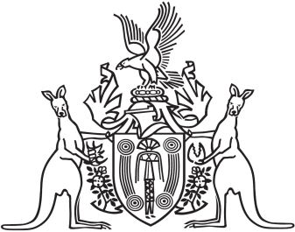
Northern Territory of Australia

Government Gazette
ISSN-0157-833X
No. S6 13 March 2017

Assent to Proposed Laws
His Honour the Administrator assented to the following proposed laws:
10 March 2017
Classification of Publications, Films and Computer Games Amendment Act 2017 (Act No 1 of 2017)
Domestic and Family Violence (Recognition of Domestic Violence Orders) (National Uniform Law) Amendment Act 2017 (Act No 2 of 2017)
Medical Services Legislation Amendment Act 2017 (Act No 3 of 2017)
Statute Law Revision Act 2017 (Act No 4 of 2017)
Yours sincerely
Michael Tatham
Clerk of the Legislative Assembly
Date 13 March 2017

