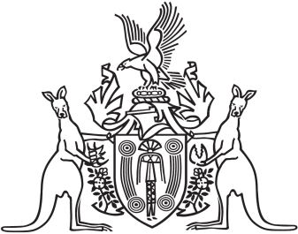
Northern Territory of Australia

Government Gazette
ISSN-0157-833X
No. S92 8 August 2016
Northern Territory of Australia
Northern Territory (Self-Government) Act 1978 (Cth)

Prorogation Notice
I, John Laurence Hardy, Administrator of the Northern Territory of Australia, under section 22(1) of the Northern Territory (Self-Government) Act 1978 (Cth), prorogue the Legislative Assembly of the Northern Territory of Australia.
Dated 8 August 2016.
J. L. Hardy
Administrator

