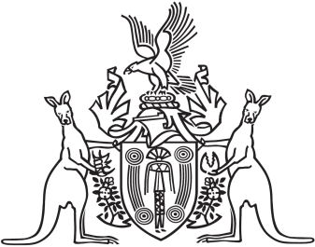
Northern Territory of Australia

Government Gazette
ISSN-0157-833X
No. S39 4 May 2016
Northern Territory of Australia

Heritage Act
Revocation of Provisional Declaration of Heritage Place
I, David William Tollner, Minister for Lands and Planning, under section 35(4) of the Heritage Act, revoke the declaration entitled "Provisional Declaration of Heritage Place", dated 10 February 2016 and published in Gazette No. G9 of 2 March 2016, in relation to the place known as the Kulaluk Lease Area.
Dated 29 April 2016
D. W. Tollner
Minister for Lands and Planning

