Mineral Titles Act 2010
NOTICE OF LAND CEASING TO BE A MINERAL TITLE AREA
Title Type and Number: | Exploration Licence 32344
Area Ceased on: | 22 April 2025
Area: | 27 Blocks, 86.64 km²
Locality: | DAVENPORT RANGE
Name of Applicant(s)/Holder(s): | 100% TREASURE CREEK PTY LTD [ACN. 619 057 644]
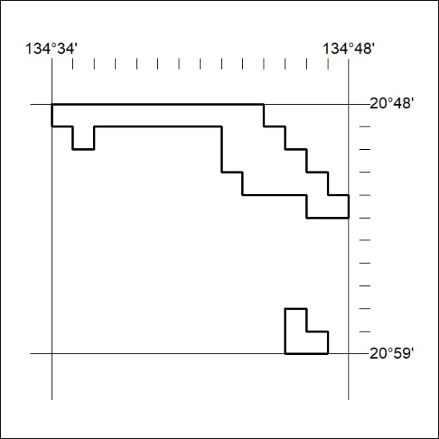

287/25

Mineral Titles Act
NOTICE OF GRANT OF A MINERAL TITLE
Title Type and Number: | Exploration Licence 31310
Granted: | 22 April 2025, for a period of 6 Years
Area: | 7 Blocks, 6.71 km²
Locality: | HOWARD
Name of Holder/s: | 100% RIO TINTO EXPLORATION PTY LIMITED [ACN. 000 057 125]
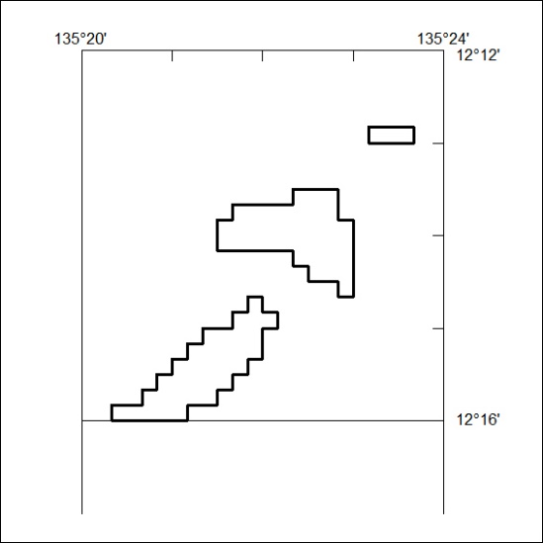
Area granted is indicated above. The titleholder is not permitted to exercise occupational rights on any land that is subject to a development title, or an application for a development title. Any land the subject of a Reserved Land gazettal under the Mineral Titles Act and all land vested in the Commonwealth of Australia is also excluded by description but not excised from the grant area.

288/25

Mineral Titles Act
NOTICE OF GRANT OF A MINERAL TITLE
Title Type and Number: | Exploration Licence 34088
Granted: | 22 April 2025, for a period of 6 Years
Area: | 12 Blocks, 16.04 km²
Locality: | HOWARD
Name of Holder/s: | 100% RIO TINTO EXPLORATION PTY LIMITED [ACN. 000 057 125]
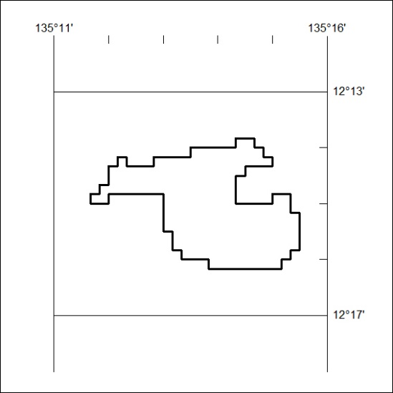
Area granted is indicated above. The titleholder is not permitted to exercise occupational rights on any land that is subject to a development title, or an application for a development title. Any land the subject of a Reserved Land gazettal under the Mineral Titles Act and all land vested in the Commonwealth of Australia is also excluded by description but not excised from the grant area.

289/25

