Mineral Titles Act 2010
NOTICE OF LAND CEASING TO BE A MINERAL TITLE AREA
Title Type and Number: | Exploration Licence 32230
Area Ceased on: | 25 March 2024
Area: | 111 Blocks, 351.77 km²
Locality: | KELLY
Name of Applicant(s)/Holder(s): | 100% RIO TINTO EXPLORATION PTY LIMITED [ACN. 000 057 125]
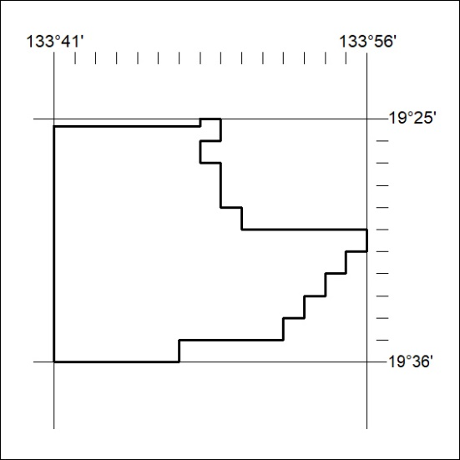

Mineral Titles Act 2010
NOTICE OF LAND CEASING TO BE A MINERAL TITLE AREA
Title Type and Number: | Exploration Licence 32231
Area Ceased on: | 25 March 2024
Area: | 58 Blocks, 184.85 km²
Locality: | KELLY
Name of Applicant(s)/Holder(s): | 100% RIO TINTO EXPLORATION PTY LIMITED [ACN. 000 057 125]
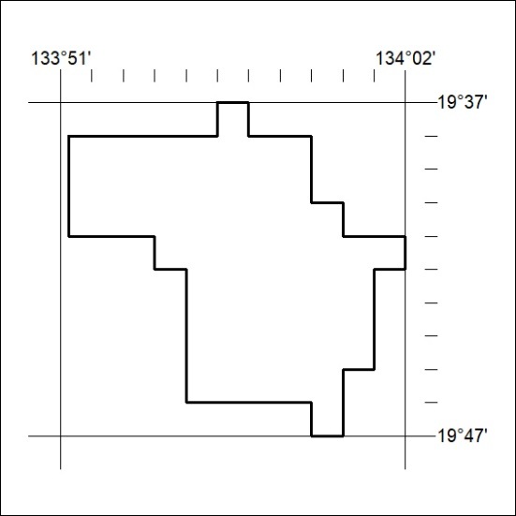

Mineral Titles Act 2010
NOTICE OF LAND CEASING TO BE A MINERAL TITLE AREA
Title Type and Number: | Exploration Licence 32232
Area Ceased on: | 25 March 2024
Area: | 11 Blocks, 35.59 km²
Locality: | KELLY
Name of Applicant(s)/Holder(s): | 100% RIO TINTO EXPLORATION PTY LIMITED [ACN. 000 057 125]
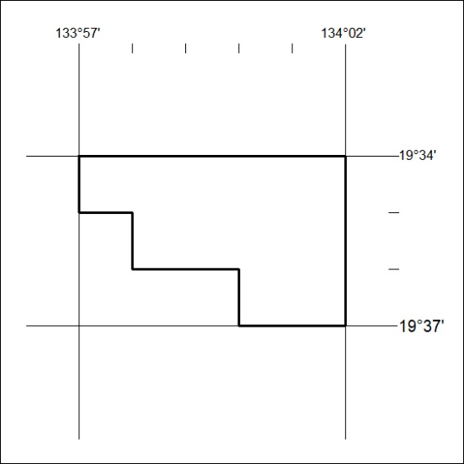

Mineral Titles Act 2010
NOTICE OF LAND CEASING TO BE A MINERAL TITLE AREA
Title Type and Number: | Exploration Licence 32233
Area Ceased on: | 25 March 2024
Area: | 6 Blocks, 19.43 km²
Locality: | FLYNN
Name of Applicant(s)/Holder(s): | 100% RIO TINTO EXPLORATION PTY LIMITED [ACN. 000 057 125]
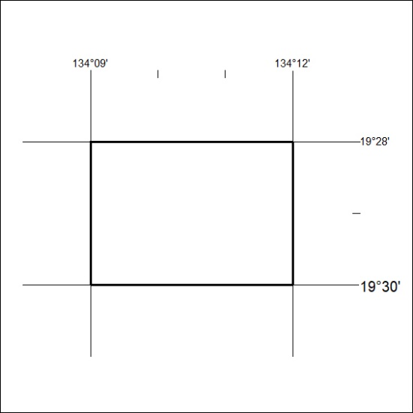

Mineral Titles Act 2010
NOTICE OF LAND CEASING TO BE A MINERAL TITLE AREA
Title Type and Number: | Exploration Licence 32234
Area Ceased on: | 25 March 2024
Area: | 5 Blocks, 16.20 km²
Locality: | FLYNN
Name of Applicant(s)/Holder(s): | 100% RIO TINTO EXPLORATION PTY LIMITED [ACN. 000 057 125]
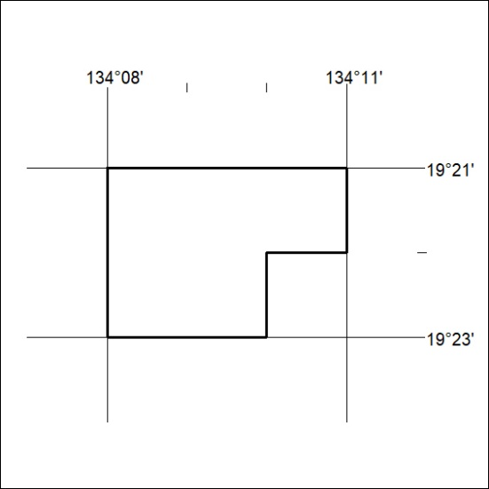

Mineral Titles Act 2010
NOTICE OF LAND CEASING TO BE A MINERAL TITLE AREA
Title Type and Number: | Exploration Licence 32246
Area Ceased on: | 25 March 2024
Area: | 67 Blocks, 217.12 km²
Locality: | FLYNN
Name of Applicant(s)/Holder(s): | 100% RIO TINTO EXPLORATION PTY LIMITED [ACN. 000 057 125]
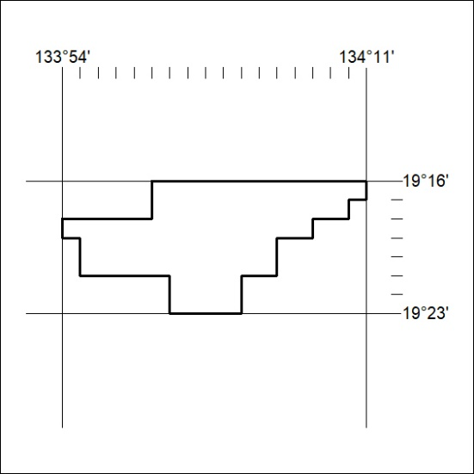

Mineral Titles Act 2010
NOTICE OF LAND CEASING TO BE A MINERAL TITLE AREA
Title Type and Number: | Exploration Licence 23565
Area Ceased on: | 25 March 2024
Area: | 19 Blocks, 55.76 km²
Locality: | PARSONS
Name of Applicant(s)/Holder(s): | 100% RIO TINTO EXPLORATION PTY LIMITED [ACN. 000 057 125]
