Mineral Titles Act 2010
NOTICE OF LAND CEASING TO BE A MINERAL TITLE APPLICATION AREA
Title Type and Number: | Exploration Licence 156
Area Ceased on: | 02 June 2023
Area: | 225 Blocks, 756.23 km²
Locality: | MURGENELLA
Name of Applicant(s)/Holder(s): | 50% EMEW CLEAN TECHNOLOGIES PTY LTD [ACN. 000 751 093], 50% KERR MCGEE CORPORATION
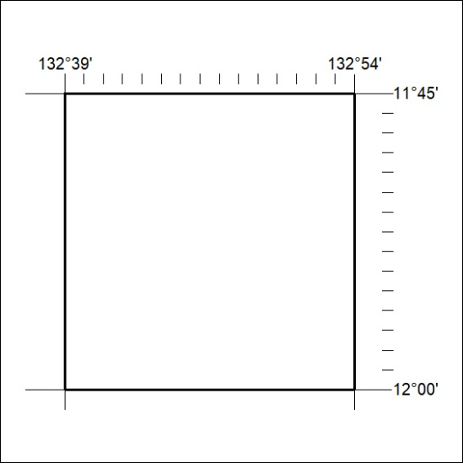

174/23

Mineral Titles Act 2010
NOTICE OF LAND CEASING TO BE A MINERAL TITLE APPLICATION AREA
Title Type and Number: | Exploration Licence 157
Area Ceased on: | 02 June 2023
Area: | 90 Blocks, 302.49 km²
Locality: | MURGENELLA
Name of Applicant(s)/Holder(s): | 50% EMEW CLEAN TECHNOLOGIES PTY LTD [ACN. 000 751 093], 50% KERR MCGEE CORPORATION
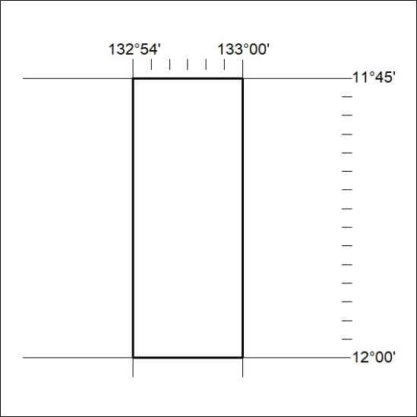

175/23
Mineral Titles Act 2010
NOTICE OF LAND CEASING TO BE A MINERAL TITLE AREA
Title Type and Number: | Exploration Licence 32453
Area Ceased on: | 06 June 2023
Area: | 48 Blocks, 157.45 km²
Locality: | SURPRISE CREEK
Name of Applicant(s)/Holder(s): | 100% TRANSITION MINERALS LIMITED* [ACN. 641 565 139]
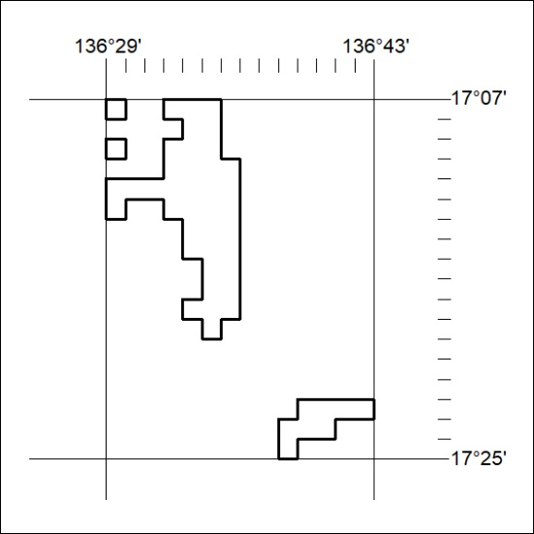

176/23

Mineral Titles Act 2010
NOTICE OF LAND CEASING TO BE A MINERAL TITLE AREA
Title Type and Number: | Exploration Licence 32454
Area Ceased on: | 06 June 2023
Area: | 57 Blocks, 186.96 km²
Locality: | SURPRISE CREEK
Name of Applicant(s)/Holder(s): | 100% TRANSITION MINERALS LIMITED* [ACN. 641 565 139]
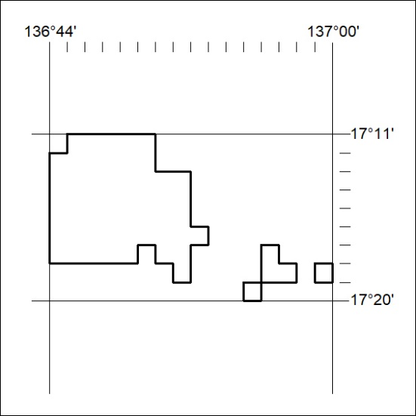

177/23
Mineral Titles Act 2010
NOTICE OF LAND CEASING TO BE A MINERAL TITLE AREA
Title Type and Number: | Exploration Licence 32473
Area Ceased on: | 06 June 2023
Area: | 48 Blocks, 157.38 km²
Locality: | CALVERT HILLS
Name of Applicant(s)/Holder(s): | 100% TRANSITION MINERALS LIMITED* [ACN. 641 565 139]
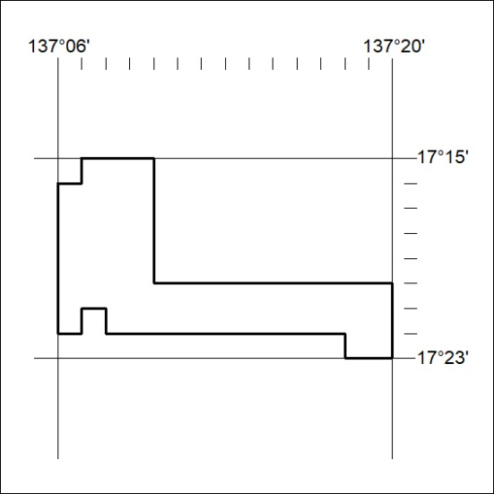

178/23

Mineral Titles Act 2010
NOTICE OF LAND CEASING TO BE A MINERAL TITLE AREA
Title Type and Number: | Exploration Licence 32474
Area Ceased on: | 06 June 2023
Area: | 16 Blocks, 52.43 km²
Locality: | CALVERT HILLS
Name of Applicant(s)/Holder(s): | 100% TRANSITION MINERALS LIMITED* [ACN. 641 565 139]
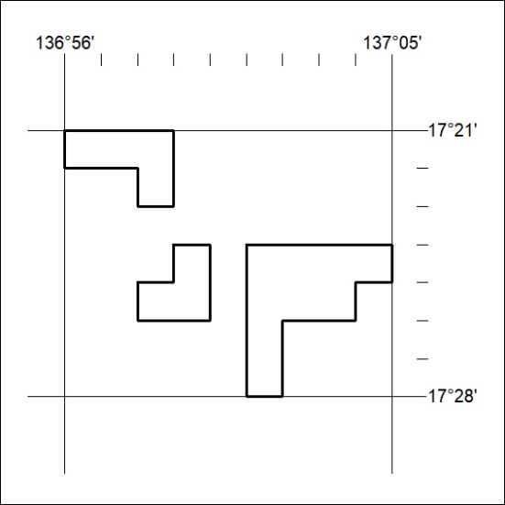

179/23

