Mineral Titles Act 2010
NOTICE OF LAND CEASING TO BE A MINERAL TITLE AREA
Title Type and Number: | Exploration Licence 26930
Area Ceased on: | 04 May 2023
Area: | 15 Blocks, 49.45 km²
Locality: | VICTORIA RIVER DOWNS
Name of Applicant(s)/Holder(s): | 100% HEARL Terry Philip
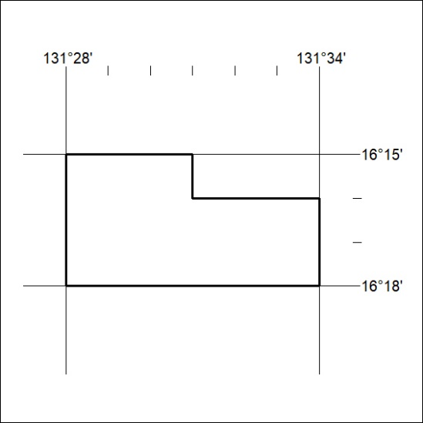

121/23

Mineral Titles Act 2010
NOTICE OF LAND CEASING TO BE A MINERAL TITLE APPLICATION AREA
Title Type and Number: | Exploration Licence 32926
Area Ceased on: | 05 May 2023
Area: | 24 Blocks, 76.09 km²
Locality: | SIDDELEY
Name of Applicant(s)/Holder(s): | 100% PET FC PTY LTD [ACN. 602 050 117]
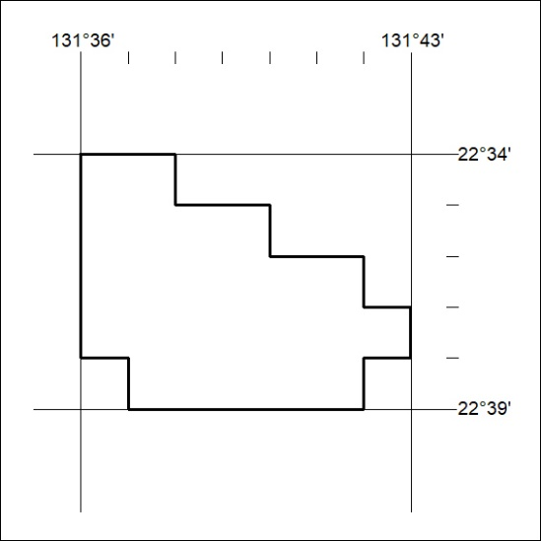

122/23

Mineral Titles Act
NOTICE OF GRANT OF A MINERAL TITLE
Title Type and Number: | Exploration Licence 32977
Granted: | 05 May 2023, for a period of 6 Years
Area: | 244 Blocks, 755.88 km²
Locality: | KULGERA
Name of Holder/s: | 100% CORE URANIUM LIMITED [ACN. 652 691 579]
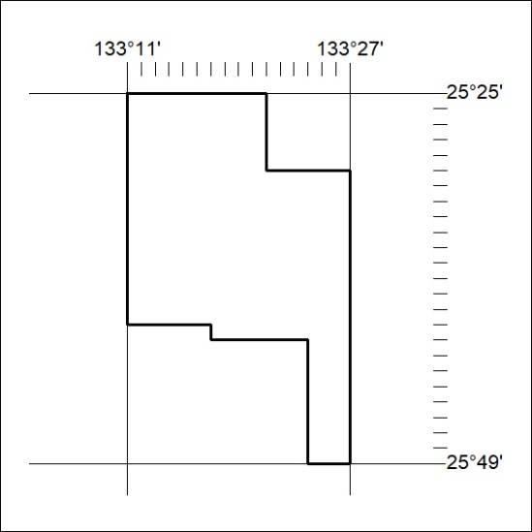
Area granted is indicated above. The titleholder is not permitted to exercise occupational rights on any land that is subject to a development title, or an application for a development title. Any land the subject of a Reserved Land gazettal under the Mineral Titles Act and all land vested in the Commonwealth of Australia is also excluded by description but not excised from the grant area.
123/23

Mineral Titles Act
NOTICE OF GRANT OF A MINERAL TITLE
Title Type and Number: | Exploration Licence 32983
Granted: | 05 May 2023, for a period of 6 Years
Area: | 240 Blocks, 745.31 km²
Locality: | IDRA COWRA
Name of Holder/s: | 100% CORE URANIUM LIMITED [ACN. 652 691 579]
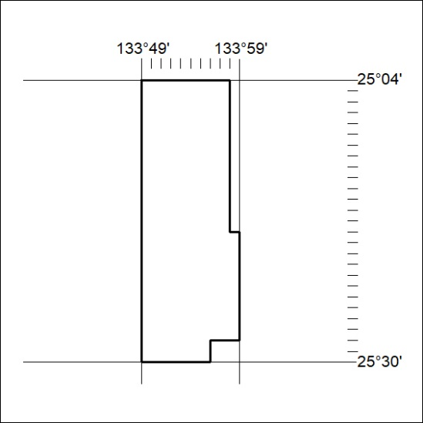
Area granted is indicated above. The titleholder is not permitted to exercise occupational rights on any land that is subject to a development title, or an application for a development title. Any land the subject of a Reserved Land gazettal under the Mineral Titles Act and all land vested in the Commonwealth of Australia is also excluded by description but not excised from the grant area.
124/23

Mineral Titles Act
NOTICE OF GRANT OF A MINERAL TITLE
Title Type and Number: | Exploration Licence 32984
Granted: | 05 May 2023, for a period of 6 Years
Area: | 246 Blocks, 764.27 km²
Locality: | ENGOORDINA
Name of Holder/s: | 100% CORE URANIUM LIMITED [ACN. 652 691 579]
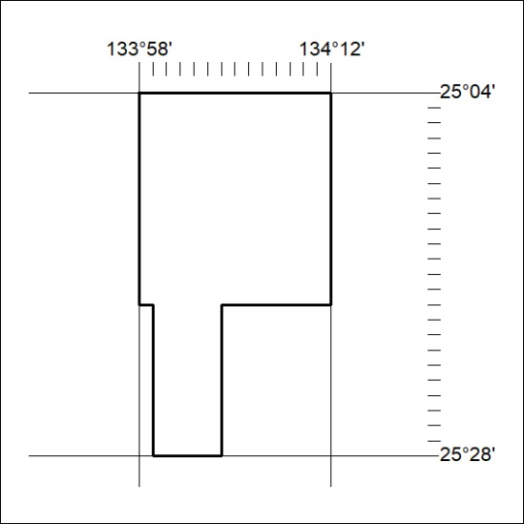
Area granted is indicated above. The titleholder is not permitted to exercise occupational rights on any land that is subject to a development title, or an application for a development title. Any land the subject of a Reserved Land gazettal under the Mineral Titles Act and all land vested in the Commonwealth of Australia is also excluded by description but not excised from the grant area.
125/23

