Mineral Titles Act
NOTICE OF GRANT OF A MINERAL TITLE
Title Type and Number: | Exploration Licence 33292
Granted: | 03 April 2023, for a period of 6 Years
Area: | 46 Blocks, 146.31 km²
Locality: | DOREEN
Name of Holder/s: | 100% GSW RESOURCES PTY LTD [ACN. 653 791 130]
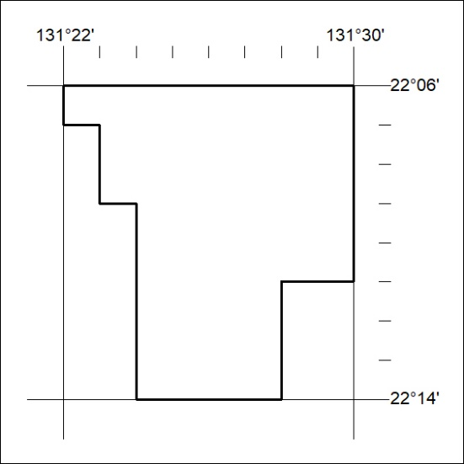
Area granted is indicated above. The titleholder is not permitted to exercise occupational rights on any land that is subject to a development title, or an application for a development title. Any land the subject of a Reserved Land gazettal under the Mineral Titles Act and all land vested in the Commonwealth of Australia is also excluded by description but not excised from the grant area.
088/23

Mineral Titles Act
NOTICE OF GRANT OF A MINERAL TITLE
Title Type and Number: | Exploration Licence 33332
Granted: | 03 April 2023, for a period of 6 Years
Area: | 250 Blocks, 812.77 km²
Locality: | MITTIEBAH
Name of Holder/s: | 100% BAUDIN RESOURCES PTY LTD [ACN. 618 455 593]
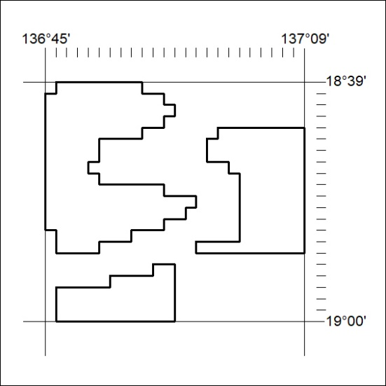
Area granted is indicated above. The titleholder is not permitted to exercise occupational rights on any land that is subject to a development title, or an application for a development title. Any land the subject of a Reserved Land gazettal under the Mineral Titles Act and all land vested in the Commonwealth of Australia is also excluded by description but not excised from the grant area.
089/23

Mineral Titles Act
NOTICE OF GRANT OF A MINERAL TITLE
Title Type and Number: | Exploration Licence 33334
Granted: | 03 April 2023, for a period of 6 Years
Area: | 250 Blocks, 814.13 km²
Locality: | MITTIEBAH
Name of Holder/s: | 100% BAUDIN RESOURCES PTY LTD [ACN. 618 455 593]
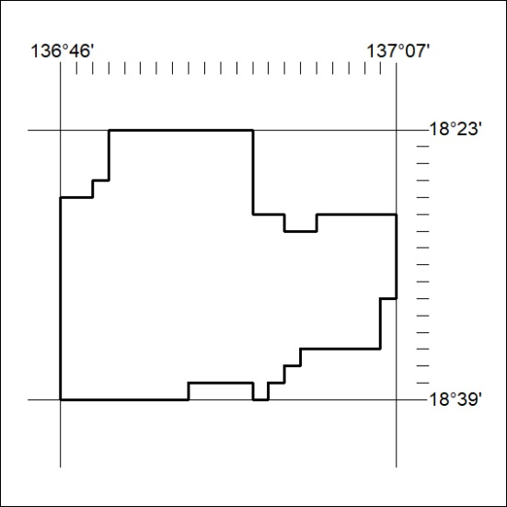
Area granted is indicated above. The titleholder is not permitted to exercise occupational rights on any land that is subject to a development title, or an application for a development title. Any land the subject of a Reserved Land gazettal under the Mineral Titles Act and all land vested in the Commonwealth of Australia is also excluded by description but not excised from the grant area.
090/23

