Mineral Titles Act
NOTICE OF GRANT OF A MINERAL TITLE
Title Type and Number: | Exploration Licence 32942
Granted: | 27 June 2022, for a period of 6 Years
Area: | 188 Blocks, 589.35 km²
Locality: | PELLINORE
Name of Holder/s: | 100% GEMPART (NT) PTY LTD* [ACN. 081 859 896]
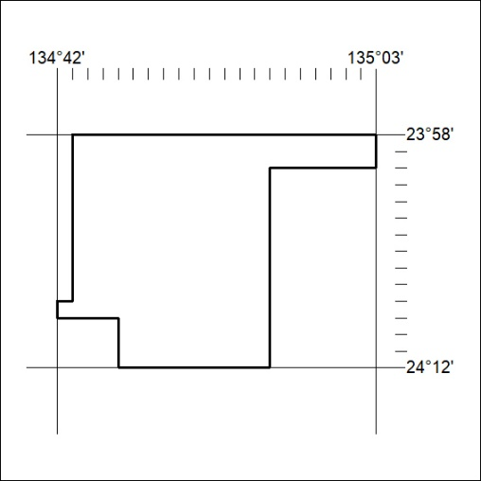
Area granted is indicated above. The titleholder is not permitted to exercise occupational rights on any land that is subject to a development title, or an application for a development title. Any land the subject of a Reserved Land gazettal under the Mineral Titles Act and all land vested in the Commonwealth of Australia is also excluded by description but not excised from the grant area.

210/22

Mineral Titles Act
NOTICE OF GRANT OF A MINERAL TITLE
Title Type and Number: | Exploration Licence 32943
Granted: | 27 June 2022, for a period of 6 Years
Area: | 238 Blocks, 719.34 km²
Locality: | FERGUSSON RANGE
Name of Holder/s: | 100% GEMPART (NT) PTY LTD* [ACN. 081 859 896]
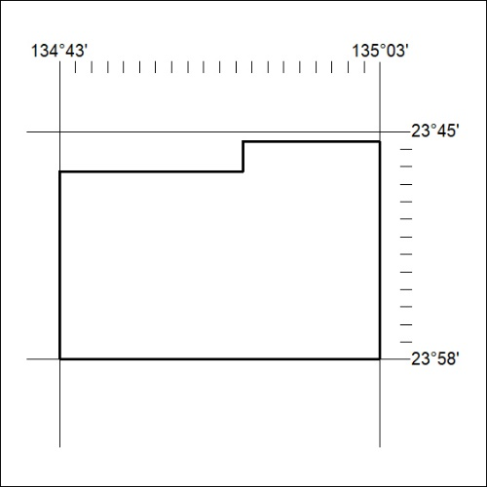
Area granted is indicated above. The titleholder is not permitted to exercise occupational rights on any land that is subject to a development title, or an application for a development title. Any land the subject of a Reserved Land gazettal under the Mineral Titles Act and all land vested in the Commonwealth of Australia is also excluded by description but not excised from the grant area.

211/22

Mineral Titles Act
NOTICE OF GRANT OF A MINERAL TITLE
Title Type and Number: | Exploration Licence 33042
Granted: | 27 June 2022, for a period of 6 Years
Area: | 236 Blocks, 750.14 km²
Locality: | VAUGHAN
Name of Holder/s: | 100% GSW RESOURCES PTY LTD [ACN. 653 791 130]
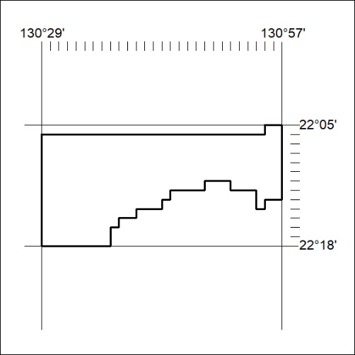
Area granted is indicated above. The titleholder is not permitted to exercise occupational rights on any land that is subject to a development title, or an application for a development title. Any land the subject of a Reserved Land gazettal under the Mineral Titles Act and all land vested in the Commonwealth of Australia is also excluded by description but not excised from the grant area.

212/22

Mineral Titles Act
NOTICE OF GRANT OF A MINERAL TITLE
Title Type and Number: | Exploration Licence 33043
Granted: | 27 June 2022, for a period of 6 Years
Area: | 245 Blocks, 700.85 km²
Locality: | CHILLA
Name of Holder/s: | 100% GSW RESOURCES PTY LTD [ACN. 653 791 130]
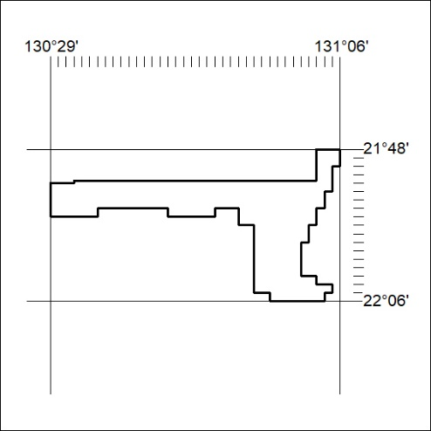
Area granted is indicated above. The titleholder is not permitted to exercise occupational rights on any land that is subject to a development title, or an application for a development title. Any land the subject of a Reserved Land gazettal under the Mineral Titles Act and all land vested in the Commonwealth of Australia is also excluded by description but not excised from the grant area.

213/22

