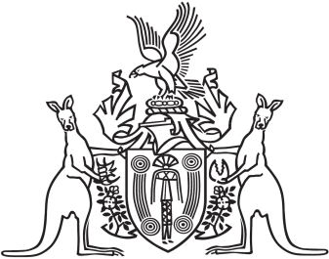
Northern Territory of Australia

Government Gazette
ISSN-0157-833X
No. S31 15 June 2017
Northern Territory of Australia

Criminal Code Amendment (Mental Impairment and Unfitness to be Tried) Act 2017
Commencement Notice
I, John Laurence Hardy, Administrator of the Northern Territory of Australia, under section 2 of the Criminal Code Amendment (Mental Impairment and Unfitness to be Tried) Act 2017 (No. 8 of 2017), fix the day on which this notice is published in the Gazette as the day on which the Act commences.
Dated 14 June 2017
J. L. Hardy
Administrator
Northern Territory of Australia

Limitation Amendment (Child Abuse) Act 2017
Commencement Notice
I, John Laurence Hardy, Administrator of the Northern Territory of Australia, under section 2 of the Limitation Amendment (Child Abuse) Act 2017
(No. 10 of 2017), fix the day on which this notice is published in the Gazette as the day on which the Act commences.
Dated 14 June 2017
J. L. Hardy
Administrator

