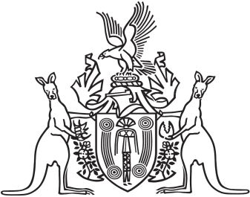
Northern Territory of Australia

Government Gazette
ISSN-0157-833X
No. S11 20 March 2017
Northern Territory of Australia

Bail Amendment Act 2017
Commencement Notice
I, John Laurence Hardy, Administrator of the Northern Territory of Australia, under section 2 of the Bail Amendment Act 2017 (No. 5 of 2017), fix the day on which this notice is published in the Gazette as the day on which the Act commences.
Dated 17 March 2017
J. L. Hardy
Administrator

