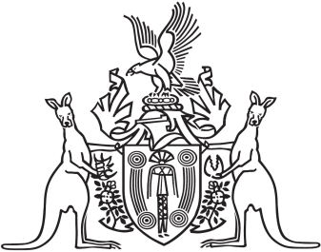
Northern Territory of Australia

Government Gazette
ISSN-0157-833X
No. S79 2 August 2016

Notification of Subordinate Legislation
Notice is given of the making of the following subordinate legislation, effective from the date specified:
Subordinate Legislation | Commencement details | Empowering Act
Agents Licensing Amendment Regulations 2016  (No. 37 of 2016) | Date of this Gazette | Agents Licensing Act
Commercial and Private Agents Licensing Amendment Regulations 2016  (No. 38 of 2016) | Date of this Gazette | Commercial and Private Agents Licensing Act
For copies of legislation please direct your request to the Print Management Unit, email pmu.dcm@nt.gov.au or phone (08) 8999 6727

