Animal Welfare Fund
Grants Program Guidelines

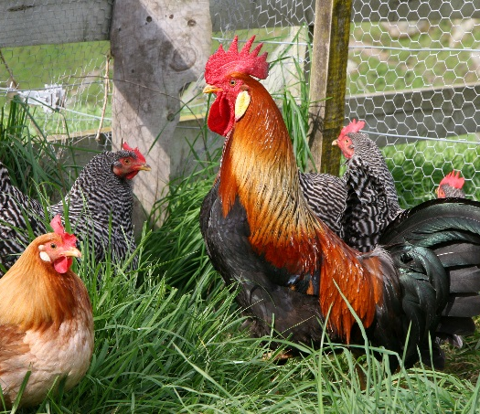
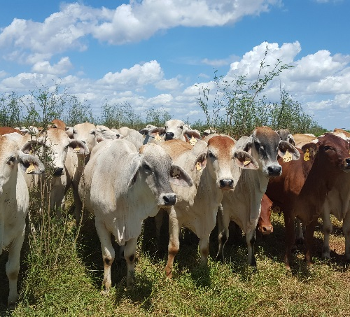
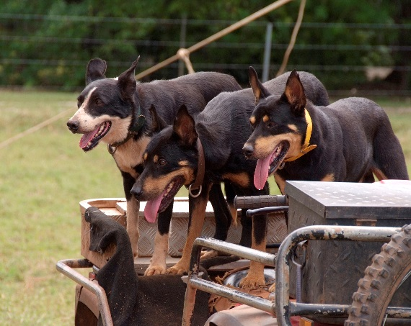

Contact Animal Welfare Branch
To obtain further information or advice on the Northern Territory (NT) Animal Welfare Fund Grants Program, contact the Animal Welfare Branch of the Department of Primary Industry and Resources at email animalwelfare@nt.gov.au or call 1300 720 386.
Darwin Office Postal Address
Animal Welfare Branch PO Box 3000
Department of Primary Industry and Resources DARWIN NT 0801
Berrimah Farm
29 Makagon Road
Berrimah NT
More information is available by visiting the Animal Welfare Fund website. https://nt.gov.au/environment/animals/animal-welfare/grants-and-funding

Privacy
The personal information you must provide in an application is necessary to assess your eligibility for a grant under the Animal Welfare Fund, and for related contact purposes. If you do not provide the requested details, the Animal Welfare Branch may not be able to process your application. Applicant information is held by the Department of Primary Industry and Resources and managed in accordance with the Information Act (NT).
By signing the application form, you consent to your personal information being provided to the Department of Primary Industry and Resources for the purpose of promoting and reporting the outcomes of the grants program, which may be a public announcement by the Minister. This includes, but may not be limited to, the applicant’s name/organisation name, funded project description, funded amount and location.
You can access and update personal information you provide to the Animal Welfare Branch. Do not hesitate to contact us if you need further information.

Interpreter Services
If you have difficulty with the English language and require the services of an interpreter, please contact the Interpreting and Translating Service NT on 8999 8506 or 1800 676 254 or the Aboriginal Interpreter Service Darwin on 1800 334 944.

Funding Acknowledgment
Recipients of funding through the Animal Welfare Fund must prominently acknowledge this support in all publicity and promotional materials for the funded activity. Please refer to the Acknowledgement section of these guidelines for more information about acknowledging funding.

Contents
Contact Animal Welfare Branch 2
Privacy 2
Interpreter Services 2
Funding acknowledgment 2
About the Animal Welfare Fund 4
Objectives 4
Eligibility 4
Who is eligible to apply? 4
Who cannot apply? 5
Grant funding available 5
What can be funded? 5
What cannot be funded? 6
Partnering for projects 6
How to apply 7
Before you submit your application 7
Completing the application 7
Submitting the application 8
Assessment Process 8
Assessment 8
Notification 9
Feedback 9
Funding Administration 10
Successful applications 10
Grant Funding agreement 10
Commencement 10
Acknowledgement 10
Funding rules 11
Grant Project monitoring and reporting 12
Completion 12
Acquitting the grant funding 12

About the Animal Welfare Fund
The Animal Welfare Fund is funded by the Northern Territory Government and the grants program is administered by the Animal Welfare Branch of the Department of Primary Industry and Resources. The Government recognises the tremendous social and economic value of companion animals, native wildlife, food producing livestock and animals used in sport and recreation. As Territorians we have a legal and ethical responsibility to treat all animals with care and respect, including the prevention of cruelty.
Once a year the Animal Welfare Fund offers grants funding to eligible organisations, for animal welfare projects and activities that improve the well-being, care and responsible management of animals in the NT.
Eligible organisations can apply for small grants of up to $10,000, or large grants up to $50,000, for finite projects and activities that align with the Animal Welfare Fund objective.

Objective
The objective of the Animal Welfare Fund is to improve the well-being of animals in the NT by:
- Promoting and influencing appropriate animal welfare and humane management practices, through the provision of increased awareness, knowledge and skills to custodians of animals and the community
- Providing for the minimum care of animals by improving quality of life and preventing or relieving the suffering of animals
- Developing sustainable animal management approaches through partnerships and shared programs with like-minded organisations

Eligibility

Who is eligible to apply?
An organisation may apply to the Animal Welfare Fund for grants funding if it is an Australian entity, legally constituted and has its main place of business registered and operating in the NT.
An applicant to the Animal Welfare Fund must also comply with the following criteria:
- Meet the Animal Welfare Fund definition of an animal welfare organisation
- Hold current business status of a registered incorporated body, a co-operative or an association, operating as a not-for profit organisation

Definition of animal welfare organisation
An animal welfare organisation has the care and protection of animals at the core of its mission; or animal welfare programs and education are fundamental to the goals of the organisation.

Who cannot apply?
All of the following are ineligible to apply to the Animal Welfare Fund for grant funding.
- Entities operating outside of the NT, such as national/peak organisations
- Individuals
- Private for-profit groups
- NT Government Agencies, including government schools
- Local government councils, but may partner with a not-for-profit organisation (please refer to the Partnering for projects section of these guidelines for details)
- Unincorporated bodies, but may partner with a not-for-profit organisation (please refer to the Partnering for projects section of these guidelines for details)

Acquittal of previous grant funding
An applicant is ineligible if they have not fully acquitted previous Animal Welfare Fund grant funding at the time of applying to the current grants round without an approved variation to the term of the grant funding.

Grant funding available
The maximum grant funding available for any project in the 2019-20 grant round is:
- Up to $10,000 for a small grant
- Up to $50,000 for a large grant
Eligibility criteria and application requirements are slightly different for small and large grants, and different reporting arrangements may apply. Generally speaking, small grant recipients are not required to provide audited annual financial statements, while a greater level of reporting is applied to large grants. Please refer to the Grant Project monitoring and reporting section of these guidelines for more information about reporting requirements.

What can be funded?
Finite projects and activities with outcomes that align with the Animal Welfare Fund grant program objectives and meet the eligibility and application requirements will be assessed for funding.
Eligible applications must demonstrate that other financial or in-kind income support is available to deliver the project or activity. Grant funding cannot cover the entire cost of a project or activity.

Repeat projects or activities
The funding of projects or activities that have previously received Animal Welfare Fund grant funding is discretionary (i.e. repeat projects). All prescribed reporting from previous grant funding must have been submitted for assessment at the time of application to the current grants round, to enable the consideration of repeat funding.

Multiple projects or activities
If an applicant is seeking funding for more than one project or activity, a separate application is required for each project or activity.
Each application is considered on its merits and it is not always possible to fund all applications. Funding is not automatic and should not be anticipated.

What cannot be funded?
- Projects or activities which do not substantially align with and further the objective of the Animal Welfare Fund
- Projects or activities that have been commenced or completed prior to the application (i.e. grants funding cannot be used for retrospective purposes)
- The entire cost of a project or activity
- Commercial business ventures (i.e. for-profit activities)
- Wages of existing salaried staff, including ongoing administration costs of an organisation associated with a grant project
- Conservation projects that do not have a primary focus on animal welfare.
- Competitions, prizes, awards, gifts or event catering
- Lobbying, activist activities or animal rights campaigns
- Services of unregistered veterinary professionals
- Services of veterinary professionals not based in the NT, unless the service required is unable to be sourced locally
- Additionally, grant funding cannot be used for goods already purchased, legal fees, overseas travel, purchase of motor vehicles, non-urgent repairs and maintenance, or research work for private academic purposes

Partnering for projects
When applying to the Animal Welfare Fund, applicants are encouraged to consider a partnership approach with like-minded organisations. This may be another not-for-profit organisation, a local government council or an unincorporated body. This approach is a way of strengthening the NT’s capacity to achieve the objective of the Animal Welfare Fund.
In an application involving a partnership with another not-for-profit organisation, local government council or unincorporated body, the application must include a letter of support from the other organisation that specifies its financial and/or in-kind commitment to the project or activity.
In an application involving a partnership, the applicant must be a legally constituted not-for-profit organisation (please refer to the Eligibility section of these guidelines).

The role of local government councils
The key function of local government is to support the social, economic, environmental, and cultural well-being of local communities. Within this function, most urban and regional local government councils in the NT provide companion animal management services with a specific role in animal control and targeted animal health programs. Councils have an important ancillary role in promoting and advocating animal welfare services in the community through veterinary, social and education programs.
Local government councils may not apply to the Animal Welfare Fund independently.
Eligible applications based on partnership projects that benefit NT regional and remote areas will be regarded highly.

How to Apply
An electronic application form is available from the Animal Welfare Fund web page or the form can be requested by contacting the Animal Welfare Branch at email animalwelfare@nt.gov.au or call 1300 720 386.

Before you submit your application
- Check that all previous grants funding from Animal Welfare Fund is acquitted
- Read these guidelines and/or visit the Animal Welfare Fund web page for more details
- It is recommended that you speak to the Animal Welfare Branch if you are still uncertain of your eligibility to apply

Completing the application
The application form is designed to provide all the necessary information to allow detailed consideration and comparison of applications. The application form must be fully completed and applicants are encouraged to contact the Animal Welfare Branch to discuss any queries.

Budget support material
Your budget must be comprehensive and clear, and it must include all details of income and expenses for your project or activity.
You must demonstrate that financial or in-kind support from other sources is confirmed. Evidence may be provided via letters/emails of support or budget notes.
A quote for any budget item over $5,000, or for capital works of any value, is required to be submitted with your application.
Your organisational details (including ABN) must be provided.
If you apply for a large grant (up to $50,000), you must provide your organisation’s most recent audited annual financial statements with the application. If you apply for a small grant (up to $10,000), an audited annual financial statement with the application is not an application requirement, but must be produced on request.

Other support material
If you are applying in partnership with another not-for-profit organisation, local government council or unincorporated body, a letter of support from the other organisation must be attached to the application. Please refer to the Partnering for projects section of these guidelines for more detail about project partnering.
Up to three letters of support relevant to the project or activity may be attached to the application.

Insurance requirements
The Animal Welfare Fund Grant Funding Agreement will set out the insurance requirements in relation to the grant awarded. As a minimum a successful applicant can expect a requirement for comprehensive public liability insurance for the project for not less than $10 million in relation to any single event.
A grant applicant or recipient must provide a copy of the insurance policy for any insurance required to the Northern Territory on request.
Grants and the Good and Services Tax (GST)
A non-profit organisation must be registered for Goods and Services Tax (GST) if it has an annual turnover of $15,000 or more.
The funding under a grant agreement may become subject to GST. If your organisation is registered (or required to be registered) for GST, it may have to pay GST on the funding payment if it makes a supply in return for that funding.
The Animal Welfare Fund Grant Funding Agreement sets out the terms in relation to GST. It is the organisation’s responsibility to understand its obligations with respect to GST, and to ensure that any GST component of the grant is remitted to the Australian Tax Office.

Submitting the application
Applications will not be considered outside of the advertised timeframes. The submission date is the date you submit your completed application by one of the following methods:
Email: animalwelfare@nt.gov.au
Mail: Animal Welfare Fund
Animal Welfare Branch
Department of Primary Industry and Resources
GPO Box 3000, DARWIN NT 0801
Hand delivered to: Animal Welfare Branch
Department of Primary Industry and Resources
Berrimah Farm
29 Makagon Road
Berrimah NT

Applications due date
The due date for applications is published in the list of key dates on the Animal Welfare Fund web page.
Late applications will not be accepted and incomplete applications will not be assessed.

Assessment Process

Assessment
The Department of Primary Industry and Resources will conduct due diligence at its discretion to confirm the eligibility of applicants.
Assessment of grant applications will only be undertaken after the closing date.
The assessment of grant applications and the decisions made are on the basis of the information supplied in the application and the accompanying support material against the assessment criteria.

Assessment criteria
- Compliance with eligibility requirements
- Appropriateness of the project in relation to the activities of the organisation
- Project or activity meets the objectives of the Animal Welfare Fund
- Application demonstrates effective planning and use of resources to achieve clear and effective outcomes for animal welfare in the NT
- Application demonstrates capacity of the organisation to deliver the project successfully with respect to previous financial and non-financial performance and past governance performance
- Adequacy of the organisation’s total funding capacity to successfully complete the project with minimal disruption or inconvenience to stakeholders
- If the organisation intends to continue the project or activity beyond the life of the grant funding, it must articulated how the project can be self-sustaining in future.
- Viability of budget and value for money, including appropriate level of financial and in-kind support from the organisation and other sources
- Priority rating for funding compared with other suitable applications
Eligible applications based on partnership projects that benefit NT regional and remote areas will be regarded highly.
A panel of senior officers of the Biosecurity and Animal Welfare Division of the Department of Primary Industry and Resources will assess applications against the grant objectives and assessment criteria. Recommendations for approval are made to the Minister for Primary Industry and Resources. All decisions are final and there is no appeal process.

Notification
A formal letter in the mail notifying you of the outcome of your application will be sent by the notification date. If your application was not eligible, you will be advised of the reasons.

Notification date
The due date for notification is published in the list of key dates on the Animal Welfare Fund web page.

Feedback
After the notification date you can obtain feedback on your application by contacting the Animal Welfare Branch. Refer to the inside cover of these guidelines for contact details.
It should be noted that some applications meet the published criteria but are unsuccessful, as the Animal Welfare Fund typically receives more applications than are able to be supported.

Funding Administration

Successful applications
If your application is approved for grants funding, you will receive the following:
- Letter of offer
- Animal Welfare Fund Grant Funding Agreement outlining the terms and conditions of funding
- Animal Welfare Fund Grant Acquittal form
- Request for your payment details (vendor creation form)
- Recipient Created Tax Invoice Authority.

Grant funding agreement
An Animal Welfare Fund Grant Funding Agreement must be signed by successful grant recipients and returned to the Animal Welfare Branch before a grant will be paid.
It is recommended that the funded project or activity does not commence until the funding agreement has been signed by the grant recipient, administering body (if applicable) and the Department of Primary Industry and Resources.
Funds are distributed on an annual basis.

Commencement
The funded project or activity must commence within three (3) months of the date of signing the funding agreement.
If the funded project cannot commence within three (3) months of the date of signing the funding agreement, the grant recipient must apply for a variation in accordance with the terms of the Animal Welfare Fund Grant Funding Agreement. Please refer to the Project variation section of these guidelines for more information on variations.

Acknowledgement
Recipients of grant funding through the Animal Welfare Fund must acknowledge the support of the Northern Territory Government (NTG) in all publicity or promotional material. This requirement extends to verbal acknowledgement of the Northern Territory Government in relevant media forums.
The NTG logo must be prominently featured on all promotional materials associated with grant or sponsorship arrangements, and/or the following phrase should be used:
Proudly supported by the Northern Territory Government
More information about acknowledgement and electronic access to logos is available on the NTG website.

Grant recipients are encouraged to contact the Department of Primary Industry and Resources on (08) 8999 2098 if they are holding public events to launch or celebrate a project or activity for which funding was secured. There may be an opportunity for the Minister for Primary Industry and Resources to attend your event, and as appropriate, launch the project or activity.

Funding rules

Project variation
If a grant recipient wishes to vary the purpose or term of a project or activity for which it has secured funding, the grant recipient must contact the Animal Welfare Branch in writing, outlining in detail the reason for the variation and the proposed change. A new budget for the project variation may be required. A variation to the purpose or term of the funding is not automatic and is subject to approval by the Head of the Biosecurity and Animal Welfare Division.
Unexpended funds
If the funding, or part of it, is not expended during the approved term of the grant project or activity, the grant recipient must apply for a variation in accordance with the terms of the Animal Welfare Fund Grant Funding Agreement. If no variation is sought or the variation is not approved, the grant recipient may be required to return the unexpended funds. Please refer to the above section of these guidelines for more information on variations.

Failure to meet terms of Grant Agreement
If the Head of the Biosecurity and Animal Welfare Division determines that a grant recipient has not used the grant for the approved purposes, or the conditions of funding have not been met as set out in the Animal Welfare Fund Grant Funding Agreement, the grant recipient will be notified in writing to repay the funds in full or in part as determined by the Head of the Biosecurity and Animal Welfare Division.
The Department of Primary Industry and Resources also reserves the right to withdraw approval for funding at any time if there is a change in circumstances in the nature or financial viability of the project or organisation.

Publication of outcomes
Grant recipients must be willing for details of the project funding to be published (e.g. media or Department of Primary Industry and Resources annual reports).

Buy Local
In accordance with its ‘Buy Local’ policy, the Northern Territory Government supports the choice of NT businesses when procuring goods and services and strongly encourages its grant recipients to do the same. For more information, visit the NTG Buy Local web page.

Disposal of assets
If a grant recipient wishes to dispose of an asset that has been purchased with grant funds and it has a value exceeding $5,000 at that time, the grant recipient must submit a written application to the Department of Primary Industry and Resources through the Head of the Biosecurity and Animal Welfare Division, requesting consent to the disposal. Consent may be withheld at the Department’s discretion.

Grant project monitoring and reporting
For successful applicants, project reporting requirements will be set out in a reporting schedule in the Animal Welfare Fund Grant Funding Agreement. The minimum requirement is a written end-of-project report that details the actual animal welfare outcomes of the funded project or activity. This includes the extent to which the project objectives were achieved and any issues that affected the project. Reporting should include statistics if relevant.
Recipients of large grants (up to $50,000) may be required to submit progress reports in addition to the end-of-project report, as prescribed in the reporting schedule.

Completion
The project or activity for which grant funding was received must be completed by the approved completion date. Failure to do so without approval for a project variation, may result in the Department requesting the funds to be repaid. Please see the Project variation section of these guidelines for more information about project variations.
Grant recipients should not assume that projects or activities that have previously received Animal Welfare Fund grants funding will be funded in future years. Organisations should work towards securing funding from other sources. Alternatively, a suitable plan should be devised to wind down activity with minimal disruption.

Acquitting the grant funding
Acquitting a grant means accurately accounting for funding. Grant acquittal requirements are outlined in the Animal Welfare Fund Grant Funding Agreement. The Animal Welfare Fund Grant Acquittal form must be used for financial reporting to certify that the grant funding has been used in accordance with the Grant Funding Agreement.

Acquittal time frame
You must acquit the grant funding within 30 days of the approved completion date, or within 30 days of the end of the funding period (i.e. the financial year in which the funding will be provided and spent).
The financial acquittal must be submitted with any other project report requirement set out in the reporting schedule.

Disclaimer
At the time of production, details contained within these guidelines were accurate. Although every effort has been made to ensure the accuracy and reliability of the information contained in this document, the authors, publishers and the Department of Primary Industry and Resources expressly disclaim any liability or responsibility for the accuracy of the information contained herein.
The information contained in this document is provided as a guide only and applicants and grant recipients are encouraged to contact Animal Welfare Branch for clarity on any items with these guidelines.

