RESPONSIBILITIES AND PLANNING
1 | Time off food and water prior to loading is managed and, if the journey is likely to exceed | □ | 7 | Vehicles, and facilities (holding, loading, or unloading) are constructed, maintained and | □ | 14 | Electric prodders are not used unless reasonable actions to cause movement have | □
 | 24 hours, recorded and provided to the |  |  | operated in a way that minimises risk to the |  |  | failed. Prodders are not used:
 | transporter |  |  | welfare of cattle |  |  | • on genital, anal or facial areas; or
 |  |  |  |  |  |  | • on cattle under three months of age; or
2 | If the journey is likely to exceed 24 hours, | □ | 8 | Vehicles and facilities are appropriate for cattle; | □ |  | • on cattle that are unable to move away; or

TRANSPORT VEHICLES AND FACILITIES

records of the date and time of access to water, inspections and subsequent actions and emergency contacts are provided to the transporter. These records are updated and passed on to the next person in charge for the duration of the journey.

3 Cattle are prepared, inspected and selected as □
being ‘fit for the intended journey’.

4. The livestock crate is inspected immediately □
before departure, to ensure that doors are
closed and secured.
with effective airflow and flooring that minimises the likelihood of slipping or falling or injury; free from internal protrusions and other objects that could cause injury; and with sufficient vertical clearance to minimise the likelihood of injury.

9. The ramp and the vehicle are properly aligned, □ so any gap between them is narrow enough to minimise the likelihood of injury during loading
and unloading.

LOADING AND OFF LOADING OF CATTLE
10 Loading density minimises risk to cattle and □
considers their class, size and body condition
• excessively on an animal.

TIME OFF WATER, JOURNEYS AND SPELLS
15 Transport and spell times comply with the table □
below and the criteria for calculating time off
water and journey duration are applied an met*

PRE-TRANSPORT SELECTION OF CATTLE and hair length, horn status, the predicted
Class | Maximum  time off water (hours) | Minimum  Spell duration (hours)
Cattle over 6 months old  Calves 30 days to 6 months old  Lactating cows with calves at foot  Calves 5–30 days old  travelling without mothers Cattle known to be more than 6 months pregnant, excluding the last 4 weeks | 48  24  24  18  24  24 | 36  12  12  -  12  12

5 Cattle are not loaded if they are: □
• unable to bear weight on all legs; or
• severely emaciated; or
• visibly dehydrated; or
• showing visible signs of severe injury or distress; or
• suffering from conditions that are likely to cause increased pain or distress during transport; or
• blind in both eyes; or
• in the last four weeks of pregnancy (unless the time off water and journey is less than four hours duration and the destination is directly to another property)
unless under veterinary advice.

6 Cattle that are not fit to load are managed, □
treated or humanely destroyed promptly
climatic conditions, the nature of the journey and the design and capacity of the vehicle.

11 Cattle are segregated according to their class □
and size; general health, level of aggression;
and the nature of the journey to minimise risks to their welfare.

12 Cattle are handled appropriately. They are: □
• not lifted by only the head, ears, horns,
neck, tail or hair; or
• not lifted off the ground by a single leg,
• supported and secured if lifted mechanically;
• not thrown or dropped;
• not unreasonably struck, punched or kicked;
• not dragged if they can’t stand, (except for emergency handling, lifting, treatment or destruction).

Notes
• If cattle are spelled for the time stated in the table above, the transport process is completed and another transport process can be undertaken.
• If cattle are unloaded and provided with water for less than 4 hours, their time off water, is not reduced.
• If water is provided for 4 to 24 hours, the time is deducted from the time off water.
• The time off water is calculated by adding: assembly time; time in a holding facility prior to loading; loading;
time on a vehicle; unloading; holding in a handling

13 Dogs are under control when working cattle. □  facility or at a destination until water is provided.

16 Time off water minimises risks to cattle and □
takes into account:
• increased risk of journeys close to the maximum time off water;
• assessment that the cattle are fit for the remainder of the journey;
• climatic conditions, especially heat or cold;
• the class of cattle , especially if weak, pregnant, recently having given birth, lactating or immature; and
• the nature of the intended journey.

17 In the absence of records, on arrival at their □
destination, cattle are watered within the
maximum time off water for their class and, if their maximum time off water is reached, spelled before commencing another journey.

HUMANE DESTRUCTION
18 If an animal is killed, it is done in a manner □
which results in rapid loss of consciousness
followed by death while unconscious.

19 Cattle are killed by a person who is competent □
in the method of killing. If there is no
competent person available and the person in charge of the cattle at the time considers that he is capable of killing it humanely and if it is in the welfare interest of the animal, he may kill it.

20 Weak, ill or injured cattle are identified to the □ receiver and separated for rest and recovery, treatment, or humane destruction promptly.

21 A cattle which has been killed is checked to □
ensure that it is dead.

22 Cattle are not killed by cuttingtheir throats □
or (except calves less than 24 hours old)
by using blunt trauma.
DURING THE JOURNEY

23 Cattle are inspected: □
• on the vehicle before departure; and
• within the first hour of the journey; and
• at least every 3 hours or at each driver rest stop, whichever comes first, to assess the cattle as being fit for the journey;
• each time the vehicle stops for a change of driver or vehicle; and
• at unloading.

24 If an inspection finds that a cattle is distressed □
or injured, it is attended to at the first
reasonable opportunity.

25 The impact of severe weather is minimised. □

ON ARRIVAL AT THE DESTINATION
27 The receival yard is inspected before □
unloading, to ensure that there is access and
sufficient space for the cattle to be unloaded

28 The receiver is notified of the arrival of the □
cattle (if possible) and, if the journey was
over 24 hours, provided with the records of the journey

29 Weak, ill or injured cattle are promptly □
identified to the receiver and separated for
rest and recovery, treatment, or destruction

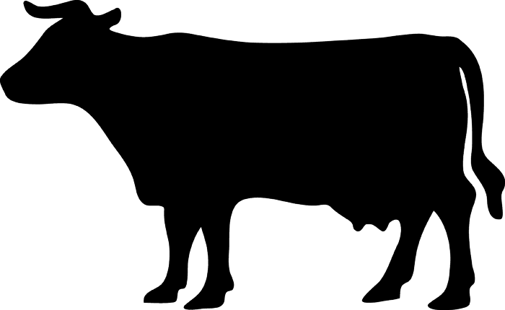

Australian Livestock Transport
Standards and Guidelines

Cattle
more than six months of age

Checklist

This check list applies from the time cattle are assembled for transport until they are unloaded, and fed and watered or killed at their destination. It is a series of outcome statements based on Livestock Transport Standards as they apply to cattle. These are the criteria that inspectors will use when they conduct a routine inspection of arrangements.

DEPARTMENT OF PRIMARY INDUSTRY AND FISHERIES

