The correct application of NLIS ear tags is in the off-side ear (right hand side ear).
Correct ear tag application increases the tags retention and reading ability of NLIS reading equipment.
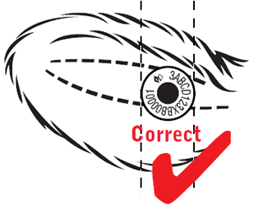
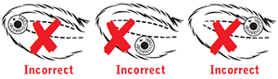
NLIS devices are stamped with the NLIS logo and the words ‘Do not remove’.
Cattle only need to be permanently identified once, either with an NLIS Breeder tag (white) or an NLIS Post-breeder tag (orange).
If cattle you buy are already identified with an NLIS Device, do not attach a second NLIS Device.

Principal livestock regulatory officer (PLRO)
Renae McLean | M: 08 8973 9703 | M: 0448 441 9124 | Email: ntnlis@nt.gov.au
Website: https://nt.gov.au/industry/agriculture/livestock/brand-and-identify-livestock/nlis-in-the-nt
Darwin Region  Regional Livestock Biosecurity Officer (RLBO)  Ph: 08 8999 2034 M: 0401 115 802 | Alice Springs Region Fax: 08 8951 8123  Regional Livestock Biosecurity Officer (RLBO)  Ph: 08 8951 8125 M: 0401 118 125
Katherine Region Fax: 08 8973 9759  Regional Livestock Biosecurity Officer (RLBO)  Ph: 08 8973 9767 M: 0467 740 233  Livestock Biosecurity Officer (LBO)  Ph: 08 8973 9765 M: 0427 604 002 | Tennant Creek Region Fax: 08 8962 4480  Principal Livestock Biosecurity Officer (PLBO)  Ph: 08 8962 4458 M: 0401 113 445  Livestock Biosecurity Officer (LBO)  Ph: 08 8962 4492 M: 0457 517 347
NT Brands Register Search Database http://brand.primaryindustry.nt.gov.au/
NT Property Identification Code (PIC) Search http://pic.primaryindustry.nt.gov.au/
NT NLIS Website (info, forms and factsheets) www.nt.gov.au/industry/agriculture/livestock

