Mineral Titles Act 2010
NOTICE OF LAND CEASING TO BE A MINERAL TITLE AREA
Title Type and Number: | Exploration Licence 32464
Area Ceased on: | 16 April 2025
Area: | 6 Blocks, 4.83 km²
Locality: | BORROLOOLA
Name of Applicant(s)/Holder(s): | 100% REDBANK OPERATIONS PTY LTD* [ACN. 109 362 165]
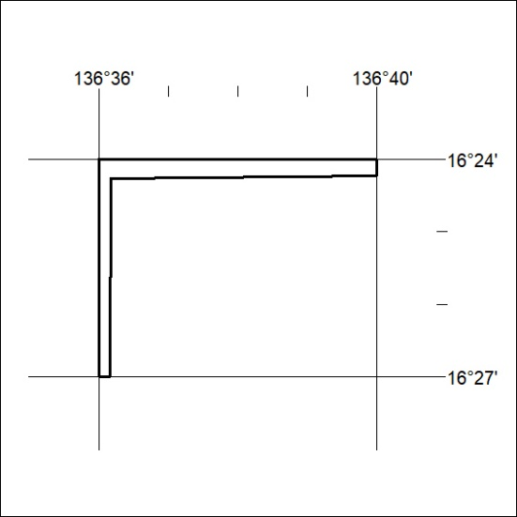
277/25

Mineral Titles Act 2010
NOTICE OF LAND CEASING TO BE A MINERAL TITLE AREA
Title Type and Number: | Exploration Licence 32465
Area Ceased on: | 16 April 2025
Area: | 10 Blocks, 4.78 km²
Locality: | GLYDE
Name of Applicant(s)/Holder(s): | 100% REDBANK OPERATIONS PTY LTD* [ACN. 109 362 165]
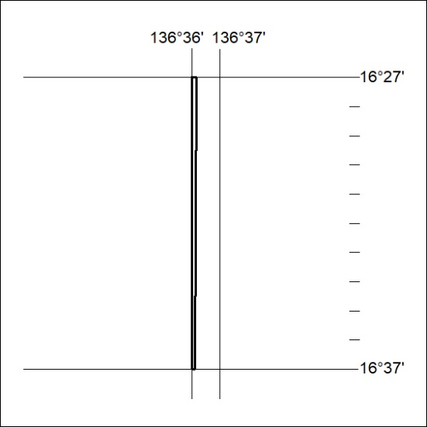
278/25

Mineral Titles Act 2010
NOTICE OF LAND CEASING TO BE A MINERAL TITLE AREA
Title Type and Number: | Exploration Licence 32466
Area Ceased on: | 16 April 2025
Area: | 15 Blocks, 5.38 km²
Locality: | GLYDE
Name of Applicant(s)/Holder(s): | 100% REDBANK OPERATIONS PTY LTD* [ACN. 109 362 165]
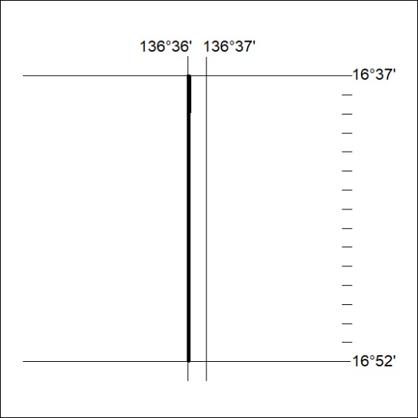
279/25

Mineral Titles Act 2010
NOTICE OF LAND CEASING TO BE A MINERAL TITLE AREA
Title Type and Number: | Exploration Licence 32467
Area Ceased on: | 16 April 2025
Area: | 166 Blocks, 521.50 km²
Locality: | LANCEWOOD
Name of Applicant(s)/Holder(s): | 100% REDBANK OPERATIONS PTY LTD* [ACN. 109 362 165]
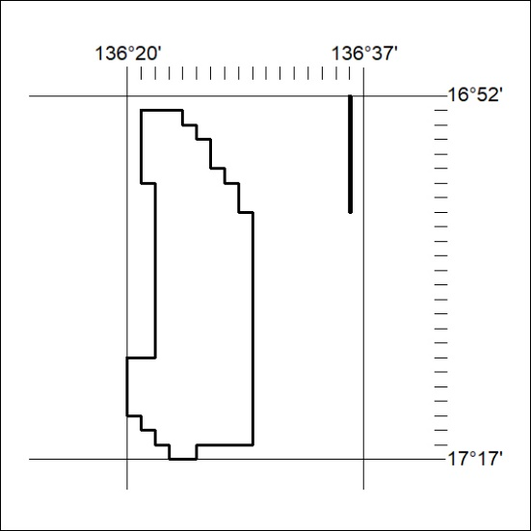
280/25

Mineral Titles Act 2010
NOTICE OF LAND CEASING TO BE A MINERAL TITLE APPLICATION AREA
Title Type and Number: | Exploration Licence 34010
Area Ceased on: | 15 April 2025
Area: | 119 Blocks, 386.83 km²
Locality: | BAUHINIA DOWNS
Name of Applicant(s)/Holder(s): | 100% G E RESOURCES PTY LTD [ACN. 096 473 737]
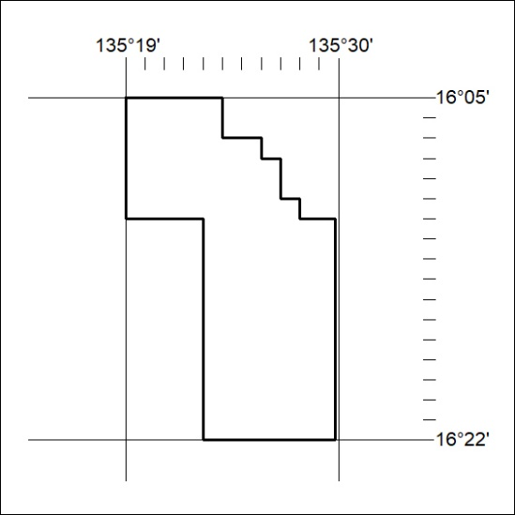
281/25

Mineral Titles Act
NOTICE OF GRANT OF A MINERAL TITLE
Title Type and Number: | Exploration Licence 33981
Granted: | 15 April 2025, for a period of 6 Years
Area: | 111 Blocks, 350.34 km²
Locality: | RIDDOCH
Name of Holder/s: | 100% BROKERAGEDIRECT PTY LTD [ACN. 629 383 357]
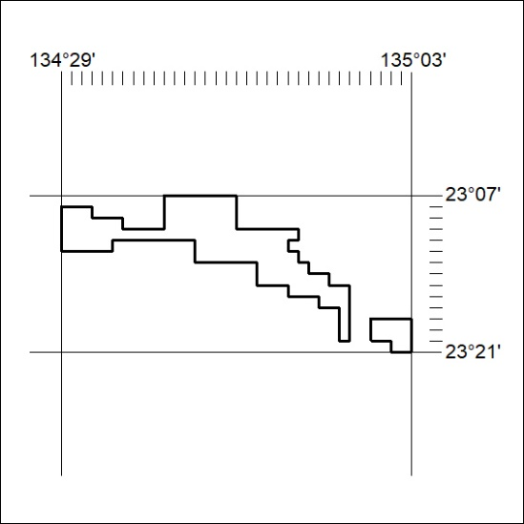
Area granted is indicated above. The titleholder is not permitted to exercise occupational rights on any land that is subject to a development title, or an application for a development title. Any land the subject of a Reserved Land gazettal under the Mineral Titles Act and all land vested in the Commonwealth of Australia is also excluded by description but not excised from the grant area.
282/25

Mineral Titles Act
NOTICE OF GRANT OF A MINERAL TITLE
Title Type and Number: | Exploration Licence 34009
Granted: | 14 April 2025, for a period of 6 Years
Area: | 97 Blocks, 318.77 km²
Locality: | WATERLOO
Name of Holder/s: | 100% ROSEWOOD MINERALS PTY LTD [ACN. 653 271 179]
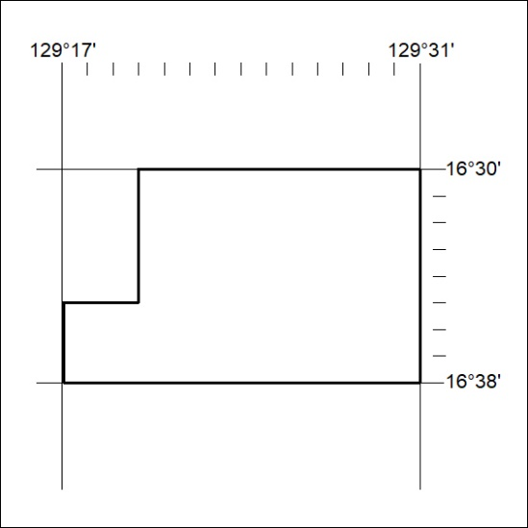
Area granted is indicated above. The titleholder is not permitted to exercise occupational rights on any land that is subject to a development title, or an application for a development title. Any land the subject of a Reserved Land gazettal under the Mineral Titles Act and all land vested in the Commonwealth of Australia is also excluded by description but not excised from the grant area.
283/25

