Mineral Titles Act 2010
NOTICE OF LAND CEASING TO BE A MINERAL TITLE AREA
Title Type and Number: | Exploration Licence 32496
Area Ceased on: | 04 September 2024
Area: | 23 Blocks, 74.56 km²
Locality: | LULU
Name of Applicant(s)/Holder(s): | 100% BREMA RESOURCES PTY LTD [ACN. 643 480 693]
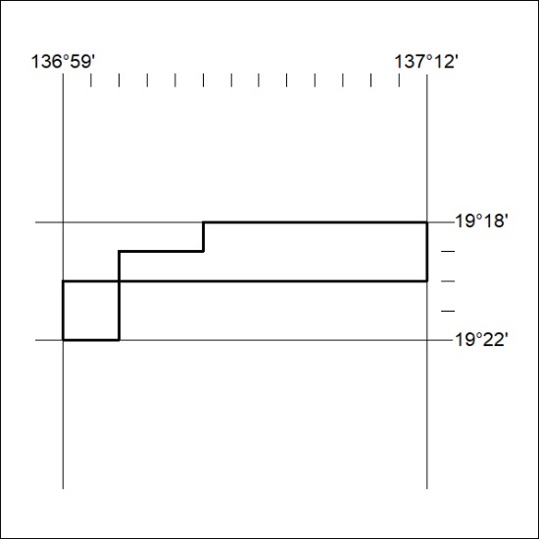
300/24

