Mineral Titles Act
NOTICE OF GRANT OF A MINERAL TITLE
Title Type and Number: | Exploration Licence 33331
Granted: | 30 January 2024, for a period of 6 Years
Area: | 246 Blocks, 802.06 km²
Locality: | CORELLA CREEK
Name of Holder/s: | 100% BAUDIN RESOURCES PTY LTD [ACN. 618 455 593]
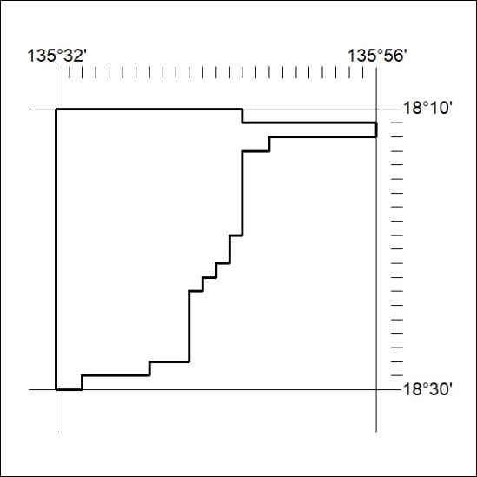
Area granted is indicated above. The titleholder is not permitted to exercise occupational rights on any land that is subject to a development title, or an application for a development title. Any land the subject of a Reserved Land gazettal under the Mineral Titles Act and all land vested in the Commonwealth of Australia is also excluded by description but not excised from the grant area.

25/24

