Land use mapping and permitted
land clearing in the Territory

Land use mapping
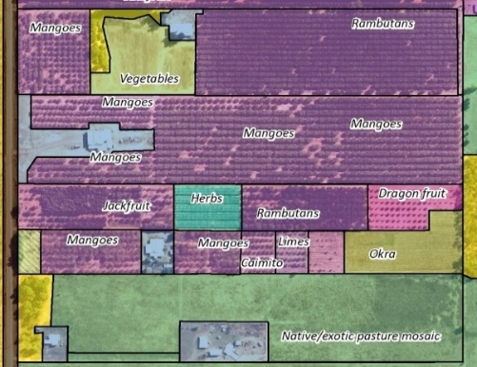
The Department of Environment, Parks and Water Security (DEPWS [the department]) carries out land use mapping in collaboration with the Australian Bureau of Agricultural and Resource Economics and Sciences. The most recent land use map of the Northern Territory (NT) was completed in November 2022. Land use mapping in the NT uses satellite imagery and up to date high-resolution aerial photography combined with a field program to detect changes over time. Using The Australian Land Use and Management Classification system, the updates provide a snapshot of how the Territory’s land resources are being utilised.
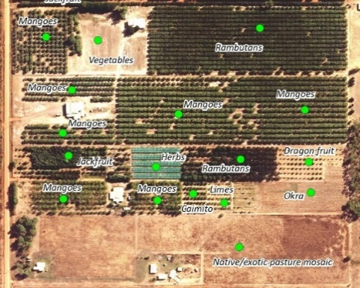
Field records, satellite imagery and aerial photography can be used to map land uses such as agricultural commodities.
Land use mapping products can be downloaded from the Northern Territory Government (NTG) Open Data Portal. The following table provides a summary of the major land uses in the NT.
Primary Land Use Class | Examples of Land Uses | Area (ha) | % NT
Conservation and natural environments | National Parks, conservation & indigenous protected areas | 71,842,079 | 53
Production from relatively natural environments | Cattle production on native vegetation | 56,588,012 | 42
Production from dryland agriculture and plantations | Non irrigated pastures, crops & forestry such as Jarra grass, forage sorghum & African mahogany plantations | 288,035 | 0.2
Production from irrigated agriculture and plantations | Irrigated pastures, horticulture & cropping such as Rhodes grass, mangoes & maize | 24,021 | 0.02
Intensive uses | Peri-urban, urban & industrial areas, road reserves & mines | 434,246 | 0.3
Water | Natural wetlands, major rivers & reservoirs | 6,015,264 | 4.5
 | Total (*includes marine parks, aquaculture leases & estuaries) | 135,191,657*
Land uses reflecting native vegetation represent 99.45% of the NT and non-native vegetation represent the remainder (0.55%). Agricultural production on cleared land comprises 0.22% of the NT.

Permitted land clearing
Under the NT Planning Act 1999, the Department regulates permitted land clearing on unzoned land. Unzoned land is freehold, crown and aboriginal freehold land generally outside the immediate vicinity of major population centres. Under the Pastoral Land Act 1992, the Pastoral Land Board regulates land clearing on pastoral leases. Where an application to clear native vegetation poses a significant risk to the environment, the application may trigger referral under the Environmental Protection Act 2019.
All applications to clear native vegetation on unzoned and pastoral land are publicly advertised. At the same time, advice is requested from other NTG agencies.
During the advertising period, a range of scientific experts from across the department assesses an application against the Land Clearing Guidelines. Once this assessment is completed, the information is compiled and provided to the Native Vegetation Assessment Panel (NVAP). With representation from a number of key environmental, planning and agricultural agencies and an independent chairperson, NVAP reviews all the scientific advice, input from other government agencies and public submissions before making a recommendation to the relevant consent authority.
The following table provides the number of permits issued, the permitted clearing area and cumulative totals for permitted clearing since 2003. Cumulative permitted clearing has been calculated as a percentage of the total area of the NT (134,620,000ha²).
Year | No. permits* | Permitted  clearing (ha) | Cumulative permitted  clearing (ha/%) | Year | No. permits* | Permitted  clearing (ha) | Cumulative permitted  clearing (ha/%)
2003 | 20 | 11,631 | 11,631 (0.0086%) | 2014 | 14 | 3,464 | 109,536 (0.0814%)
2004 | 16 | 10,432 | 22,063 (0.0164%) | 2015 | 18 | 7,916 | 117,452 (0.0872%)
2005 | 23 | 4,119 | 26,182 (0.0194%) | 2016** | 30 | 26,314 | 143,766 (0.1068%)
2006 | 26 | 11,774 | 37,956 (0.0282%) | 2017 | 18 | 7,940 | 151,706 (0.1127%)
2007 | 20 | 13,054 | 51,010 (0.0379%) | 2018 | 6 | 5,711 | 157,417 (0.1169%)
2008 | 15 | 8,002 | 59,012 (0.0438%) | 2019 | 19 | 11,548 | 168,965 (0.1255%)
2009 | 18 | 4,545 | 63,557 (0.0472%) | 2020 | 30 | 13,191 | 182,156 (0.1353%)
2010 | 8 | 613 | 64,170 (0.0477%) | 2021 | 16 | 17,218 | 199,374 (0.1481%)
2011 | 11 | 15,850 | 80,020 (0.0594%) | 2022 | 10 | 18,059 | 217,433 (0.1615%)
2012 | 11 | 6,153 | 86,173 (0.0640%) | 2023 | 10 | 10,632 | 228,065 (0.1694%)
2013 | 8 | 19,899 | 106,072 (0.0788%) | 2024*** | 5 | 4,415 | 232,480 (0.1727%)
*Unzoned and pastoral land clearing permits only
**In 2016 a permit from 2013 was reissued due to subdivision of a pastoral lease.
(The reissued permitted area has not been included in the 2016 figures).
***To date – 28 June 2024
Permits to clear native vegetation expire if clearing does not take place within a statutory timeframe.
Pastoral and unzoned land clearing permits by year and applications currently under assessment are available on the department’s website. These can also be viewed on NR Maps.

https://www.agriculture.gov.au/abares/aclump
ALUMCv8_Handbook4ednPart2_UpdateOctober2016.1 (agriculture.gov.au)
Land Use Mapping Project of the Northern Territory, 2016 - 2022 (LUMP) - Dataset - NTG Open Data Portal
Land clearing guidelines (nt.gov.au)
Pastoral land clearing applications and permits | NT.GOV.AU
Unzoned land clearing applications and approvals | NT.GOV.AU
NR MAPS (nt.gov.au)

