Mineral Titles Act 2010
NOTICE OF LAND CEASING TO BE A MINERAL TITLE AREA
Title Type and Number: | Exploration Licence 32244
Area Ceased on: | 10 February 2023
Area: | 102 Blocks, 319.81 km²
Locality: | TODD
Name of Applicant(s)/Holder(s): | 100% GEMPART (NT) PTY LTD* [ACN. 081 859 896]
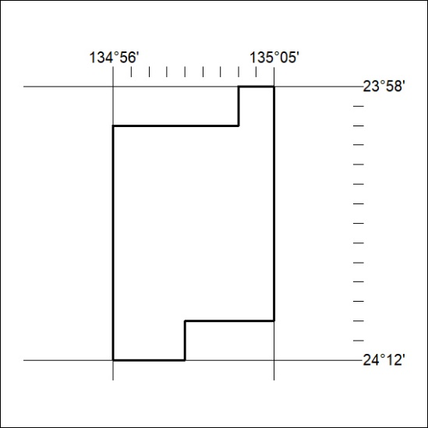

037/23

Mineral Titles Act 2010
NOTICE OF LAND CEASING TO BE A MINERAL TITLE AREA
Title Type and Number: | Exploration Licence 32943
Area Ceased on: | 10 February 2023
Area: | 238 Blocks, 719.34 km²
Locality: | FERGUSSON RANGE
Name of Applicant(s)/Holder(s): | 100% GEMPART (NT) PTY LTD* [ACN. 081 859 896]
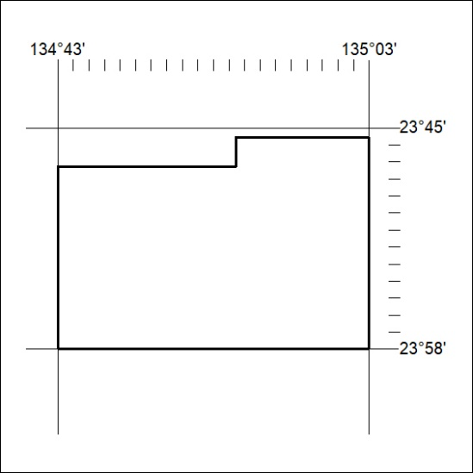

038/23

