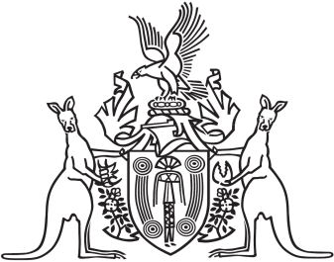
Northern Territory of Australia

Government Gazette
ISSN-0157-833X
No. S30 9 June 2017

Northern Territory of Australia

Local Government Act
Barkly Region
Alteration of Ward Name
I, Gerald Francis McCarthy, Minister for Housing and Community Development, under section 9(2) of the Local Government Act and with reference to section 9(1)(h) of the Act, alter the name of Yapakurlangu Ward, within the Barkly Region, to Kuwarrangu Ward.
Dated 2 June 2017
G. F. McCarthy
Minister for Housing and Community Development
Northern Territory of Australia

Local Government Act
Change of Number of Council Members
I, Gerald Francis McCarthy, Minister for Housing and Community Development:
(a) under section 9(2) of the Local Government Act and with reference to section 9(1)(i) of the Act, change the number of members to be elected:
(i) for each local government area specified in Schedule 1, Column 1, from the number of members specified in Column 2 to the number of members specified in Column 3; and
(ii) for each ward, in a local government area, specified in Schedule 2, Column 1, from the number of members specified in Column 3 to the number of members specified in Column 4; and
(b) make that change for the purpose of conducting the next general election to be held for each local government area specified in Schedules 1 and 2 and determining the composition of each local government council after that election.
8 June 2017
G. F. McCarthy
Minister for Housing and Community Development
Schedule 1
Column 1  Local Government Area | Column 2  Number of members | Column 3  New number of members
Palmerston Municipality | 7 | 8
Roper Gulf Region | 12 | 13
Wagait Shire | 7 | 5
Schedule 2
Column 1  Ward | Column 2  Local Government Area | Column 3  Number of members | Column 4  New number of members
Numbulwar Numburindi | Roper Gulf Region | 1 | 2
Barrah Ward | West Arnhem Region | 3 | 2
Maningrida Ward | West Arnhem Region | 3 | 4

