Mineral Titles Act 2010
NOTICE OF LAND CEASING TO BE A MINERAL TITLE APPLICATION AREA
Title Type and Number: | Exploration Licence 32511
Area Ceased on: | 03 July 2026
Area: | 250 Blocks, 789.28 km²
Locality: | PLENTY RIVER
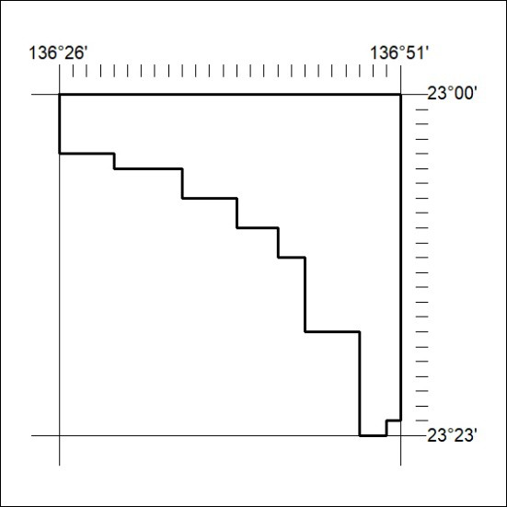  Name of Applicant(s)/Holder(s): | 100% LIBERATION RESOURCES  PTY LTD [ACN. 644 163 459]

188/26

Mineral Titles Act 2010
NOTICE OF LAND CEASING TO BE A MINERAL TITLE APPLICATION AREA
Title Type and Number: | Exploration Licence 32512
Area Ceased on: | 03 July 2026
Area: | 250 Blocks, 778.17 km²
Locality: | PLENTY RIVER
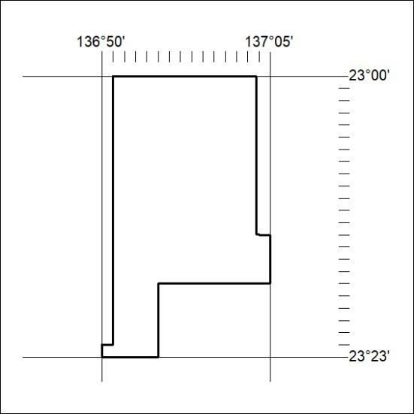  Name of Applicant(s)/Holder(s): | 100% LIBERATION RESOURCES  PTY LTD [ACN. 644 163 459]

189/26

