Mineral Titles Act
NOTICE OF GRANT OF A MINERAL TITLE
Title Type and Number: | Exploration Licence 33302
Granted: | 26 April 2023, for a period of 6 Years
Area: | 13 Blocks, 32.60 km²
Locality: | BYNOE
Name of Holder/s: | 100% NT LITHIUM PTY LTD [ACN. 659 411 926]
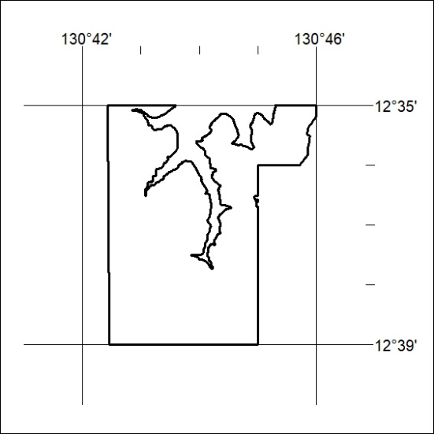
Area granted is indicated above. The titleholder is not permitted to exercise occupational rights on any land that is subject to a development title, or an application for a development title. Any land the subject of a Reserved Land gazettal under the Mineral Titles Act and all land vested in the Commonwealth of Australia is also excluded by description but not excised from the grant area.

115/23

