Mining Management Plan for Mines – Content Guide
  - April 2022

Document title | Mining Management Plan for Mines – Content Guide
Contact details | Andria Handley, Director Mining Operations Policy and Support
Approved by | Roslyn Vulcano, Executive Director Mining Operations
Date approved | 8 April 2022
Document review | Annually
TRM number | M2021/0007-0007~0001

Version | Date | Author | Changes made
1.0 | 30 March 2022 | A Handley | First version developed in consultation with industry

Acronyms | Full form
ABN | Australian Business Number
ABR | Australian Business Register
ACN | Australian Company Number
AMD | Acid and Metalliferous Drainage
ANCOLD | Australian National Committee on Large Dams Incorporated
ANZG 2018 | Fresh and Marine Water (Australia and New Zealand) (waterquality.gov.au)
ASIC | Australian Securities and Investments Commission
ARI | Annual Recurrence Interval
CoC | Chemical or contaminant of concern
CSM | Conceptual Site Model
EMS | Environmental Management System
EPBC Act | Environment Protection and Biodiversity Conservation 1999
FOS | Factor of Safety
GDE | Groundwater Dependent Ecosystem
HC | High Capacity (related to waste rock classification)
LC | Low Capacity (related to waste rock classification)
LOM | Life of Mine
MDE | Maximum Design Earthquake (in ANCOLD guidelines)
MIA | Mine Infrastructure Area (a domain type)
MOL | Maximum Operating Level
MMA | Mining Management Act 2001
MMP | Mining Management Plan
NAF | Non-acid Forming (related to waste rock classification)
NTASSA | Northern Territory Aboriginal Sacred Sites Act 1989
OBE | Operational Basis Earthquake (in ANCOLD guidelines)
PAF | Potential Acid Forming (related to waste rock classification)
PMF | Probable Maximum Flood
PMP | Probable Maximum Precipitation
PPE | Personal Protective Equipment
PSD | Particle Size Distribution
ROM Pad | Run of Mine pad
RQD | Rock Quality Designation (from Geotechnical site investigations AS 1726:2017)
SC | Sandy Clay (geotechnical classification from geotechnical site investigations AS 1726:2017)
SDS | Safety Data Sheet for chemicals, previously known as a materials safety data sheet (MSDS)
SM | Sand-silt Mixtures (geotechnical classification from geotechnical site investigations AS 1726:2017)
TARPS | Trigger Action Response Plans
TPWC Act | Territory Parks and Wildlife Conservation Act 1976
TSF | Tailings Storage Facility
UC | Uncertain (related to waste rock classification)
UG | Underground
WRD | Waste Rock Dump

Term | Definition
Closure | Closure is achieved subject to the MMA when it can be demonstrated that the closure objectives have been satisfied.  The department considers closure to have occurred at the conclusion of mining activities when no management is required of environmental liabilities by the operator, and security can be returned to the operator and a closure certificate issued under the MMA.
Closure criteria | The standard or level of performance, as specified in the mining management plan for the mine site, which demonstrates successful closure of the site. Criteria should be specific, measurable, achievable, relevant and time-based (SMART), and typically enable a return of the land to a safe, stable and non-polluting state.
Closure objective | Site-specific closure outcomes consistent with the post-mining land use(s) that are realistic and achievable based on the closure risk assessment.  The department requires operators to rehabilitate mine sites to be safe, stable and non-polluting.  Closure criteria are the means against which to measure achievement of the stated closure objective.
Conceptual site model | A written and/or illustrative representation of the conditions, including physical, chemical and biological processes, that identifies sources of potential chemicals of concern to the environment, and details their potential for transport to receiving environments (or “receptors”).
Corrective action | An action to eliminate an identified non-conformity or other undesirable situation.
Domain | A collection of specific areas on the mine with related characteristics or similar function with respect to environmental management requirements.
Environmental Management System | An integration of procedures and plans with clearly defined targets, performance criteria and corrective actions and includes site-specific Environmental Management Plans
Environmental Management Plan | A structured set of measures to minimise or manage the impact of operations on a specific part or aspect of the environment.
Environmental policy | A commitment to measure and minimise impact on the environment caused by an entities operations. An Environmental Policy establishes the attitude of an entity to environmental management, and is typically written and signed by senior management.
Footprint | The area or extent of land impacted by a specified mining activity.
Life of Mine | The expected number of years during which the mine will be productive.
Mining Management Plan | A plan for the management of a mine site for which the operator requires an Authorisation to carry out mining activities. Refer to section 40 of the MMA
Rehabilitation | Restoration of mining-related disturbances. Rehabilitation may include landform design, bulk earth works, demolition and revegetation considerations. Rehabilitation typically requires validation through medium-to-long-term monitoring.
Risk | A semi-quantitative ranking of a threat of harm (to the environment), which considers likelihood of an incident, multiplied by consequence.
Risk, environmental | Risk, environmental – A threat of harm to the environment, which may be  Low (Unlikely to occur over life of mine, with limited long-term environmental impact)  Medium (May occur over life of mine, with moderate and possibly significant long-term environmental impact)  High (Likely to occur over life of mine, with substantial and significant long-term environmental impact)
Suitably qualified person | A person with an extensive history of studies in a specific area (e.g. engineering, environmental studies), or equivalent work experience, that has earned them industry-wide recognition of their expertise.

Contents
How to use this guide 7
Section 1 - Application for Authorisation 8
1.1. Operator Details 8
1.1.1. Individual 8
1.1.2. Company 8
1.2. Title Details 9
1.3. Project Details 9
1.4. Declaration 9
Section 2 – Project Summary 10
2.1. Overview 10
2.1.1. Aspects of the Project 10
2.1.2. Disturbances Associated with the Project 11
2.2. Organisational Structure 12
Section 3 – Site Conditions 14
3.1. Site Setting 14
3.2. Conceptual Site Model (CSM) 17
3.3. Socio-Economic Status 18
Section 4 – Legislation and Obligations 19
4.1. Statutory Requirements 19
4.2. Non-Statutory Requirements 20
Section 5 – Operational Activities 21
5.1. Mine Infrastructure Area 22
5.1.1. Identification of Zones 22
5.1.2. Mine Infrastructure Area (MIA) Summary 23
5.1.3. MIA Risk, Controls and Management 23
5.1.4. MIA Summary of Environmental Performance 23
5.1.5. Independent Expert Oversight 23
5.1.6. MIA Closure 24
5.2. Pits and Extractives 24
5.2.1. Pit Summary 24
5.2.2. Pit Design Rationale 25
5.2.3. Pit Risk, Controls and Management 25
5.2.4. Independent Expert Oversight 25
5.2.5. Pit Summary of Environmental Performance 25
5.2.6. Pit Closure 26
5.3. Underground Operations 26
5.3.1. Underground Operations Summary 26
5.3.2. Underground Operations Risks, Controls and Management 26
5.3.3. Independent Expert Oversight 26
5.3.4. Underground Closure 27
5.4. Tailings Storage Facility and Dams 27
5.4.1. TSF and Dam Summary 27
5.4.2. TSF and Dam Design Rationale 27
5.4.3. TSF and Dam Design Components 27
5.4.4. TSF Lift Details 27
5.4.5. TSF and Dam Risk, Controls and Management 28
5.4.6. Independent Expert Oversight 28
5.4.7. TSF and Dam Closure 28
5.5. Waste Rock Dump 29
5.5.1. WRD Summary 29
5.5.2. WRD Design Considerations 29
5.5.3. Waste Rock Classification Criteria 29
5.5.4. WRD Material Quality and Beneficial Re-use 29
5.5.5. WRD Design Rationale 30
5.5.6. Capping design. WRD Risk, Controls and Management 30
5.5.7. Independent Expert Oversight 30
5.5.8. Additional detail 30
5.5.9. WRD Closure 30
5.6. Exploration Domain 30
5.7. Haul and Access Roads 31
5.7.1. Haul and Access Road Details 31
5.7.2. Haul and Access Road Risk, Controls and Management 31
5.7.3. Haul and Access Road Independent Expert Oversight 31
5.7.4. Haul and Access Road Closure 32
5.8. Diversion of Waterways 32
5.9. Other Activities 32
Section 6 – Project Risk Assessment 33
Section 7 – Management System 37
7.1. Environmental Management System 37
7.1.1. Overarching Environmental Objectives 38
7.1.2. Environmental Management Plan 38
7.2. Decision Framework 42
Section 8 – Closure Planning 44
8.1. Conceptual Closure Plan 44
Section 9 – Security 45

How to use this guide
A Mining Management Plan (MMP) is required by Section 40 of the Mining Management Act 2001 (MMA).
The MMP must be appropriate for the operation. This guide supports the development of a MMP that meets the requirements of the MMA and will streamline assessment. It guides the inclusion of details for the various stages through the life of mine (LOM), at a level commensurate with the anticipated length and risks of the project at the time of submission.
The purpose of the MMP is to:
- detail the management of the mining operation
- identify the key environmental risks associated with the operation
- demonstrate consideration of and proposed mitigation for the risks
- meet the requirements of the MMA.
Following approval the MMP, in conjunction with the Authorisation, are the operator’s key guiding documents with respect to:
- nature of disturbance approved on the mine site
- how to manage the approved mining activity to limit environmental impacts on the mine site and surrounding environment
- criteria to be met to achieve closure under the MMA.

This guide:
- is to be used in the preparation of a Mining Management Plan for a mins in support of a request for authorisation under the MMA
- is for operators/proponents to use as a companion to the Mining Project Mining Management Plan Template
- prompts the inclusion of critical information required in a MMP by the MMA
- provides clarity around the relationship between site disturbances and informs population of the Security Calculation Tool to arrive at a security amount based on sound evidence
- provides for the preparation and submission of a focused document that can be made public (with the exclusion of confidential information). It is suggested that potential commercial in confidence information be restricted to appendices which may be more easily removed from the document prior to the approved MMP being made public.

Section 1 - Application for Authorisation
The information required in this section:
- addresses requirements under section 40(2)(a), (b) and (h) of the MMA
- must be consistent with Australian Securities and Investment Commissions (ASIC) and Australian Business Register (ABR) records
- identifies the key contacts within the organisation to which correspondence from the department is directed
- identifies alternate contacts authorised by the operator’s primary contact to engage in correspondence and sharing of information with the department.

Operator Details
Key information about the entity making an application for authorisation under the MMA.
NOTE: Information contained in table 1.1.1 of the template will be retained in the public version of the approved MMP.
NOTE: Information contained in table 1.1.2 of the template will be removed from public version of MMP to protect personal privacy.

Individual
If an individual is submitting an application for authorisation, the requirement is to use the legal name of the applicant and provide both a physical address and postal address.
With respect to primary contact details, repeat the legal name and provide title, phone and email contact details.
The majority of correspondence from the department is conducted via email.
In the event that the individual is employing a third party to develop the MMP for the project, the details of the individual can be provided as an alternate contact. This scenario provides the authority for the department to direct questions that may arise during the MMP assessment process to the third party.
Any formal document issued in relation to administration of the MMA in relation to the project will be addressed to the primary contact and sent to the nominated email address.

Company
If a company representative is submitting an application for authorisation, the requirement is to use the ASIC registered name and either or both the Australian Business Number (ABN) and or Australian Company Number (ACN), and provide both a physical address and postal address.
With respect to primary contact details, provide the legal name and title of the responsible position in the organisation, phone and email contact details.
The majority of correspondence from the department is conducted via email.
Any formal document issued in relation to administration of the MMA in relation to the project will be addressed to the responsible individual and sent to the nominated email address.

Title Details
Section 40(2)(b) of the MMA requires details of the ownership of the mining interest to be provided in the MMP.
To meet this requirement the MMP template requires inclusion of both:
- a register of ownership for the mineral titles associated with the project including title numbers, title holders, expiry date, and underlining tenure e.g. crown land, pastoral lease. Include any titles under application at the time of preparing the MMP.
- a figure clearly showing the relevant titles overlaying the project site.
NOTE: If the operator/proponent is not the title holder, a nomination of operator form must be completed by the titleholder, appointing the operator for the site, as per Section 10 of the MMA.

Project Details
Sections 34 and 40(2) of the MMA state a MMP must include a description of mining activities, details of the organisational structure, and plans of proposed and current mine workings and infrastructure, among other required details.
Provide a brief summary of the project, including the mine site name, location and site access indicating proximity to nearest towns. More detailed information is to be provided in Section 5.

Declaration
The information required in this section provides evidence to the Minister that the responsible individual within the operator/proponent’s organisational structure:
- verifies the accuracy of the content of the document
- is submitting a formal request for assessment of the document as a MMP for authorisation under the MMA
- acknowledges that any omission of information required under section 40 of the MMA and as outlined in this guide may result in extended assessment timeframes.

Section 2 – Project Summary
Section 40(2)(c) of the MMA requires the MMP to include a description of the mining interest held for, or associated with, the mine site. Section 40(2)(d) requires the MMP to include details of the organisational structure for carrying out mining activities.

Overview
This section aims to obtain a high level Life of Mine (LOM) description of the project with clear separation of the proposed activities.
The high level summary of the project comprises two components relating to:
- aspects of the project as a whole (Table 2.1.1)
- the disturbances proposed to access and extract the ore for the reporting MMP period (Table 2.1.2).
SUGGESTION: Information presented in table format as in the Template will facilitate timely assessment by the department.

Aspects of the Project
Table 2.1.1 requires detail for various aspects of the project as a whole.
With respect to the Approval Sought aspect, include an indication of the intention to develop the resource using underground or open pit mining as detailed against the Element of the aspect. The Description of the aspect should summarise the extent of underground workings or size of pit.
For Commodity, under Element identify the target commodity, be that gold, copper, phosphate, etc. and include under Description the material of economic value and anticipated grades, identifying expected production outputs over time as appropriate.
In relation to Schedule, include details as under Elements as appropriate for the project. Detail for three phases of mining may be of relevance.
Minimum information is required for the various phases of the project:
- Exploration Phase: identify major exploration works undertaken for the project; include the periods and company. If the proposed project does not include an exploration phase, include details of the resource exploration campaign including the responsible party and time.
- Mining Phase: include a brief summary of the target resource including ore and various grades, key mining infrastructure proposed to be developed/refurbished, whether the intent is to process on site, any destination port and nominated mode of transport for product.
- Closure Phase: provide a summary of the closure criteria and anticipated rehabilitation to be undertaken.

Example Table 2.1.1: Project Aspect – Schedule (Note: this is an example the level of detail required for only one element of the table)
Project Aspect | Element | Description | Reference
Schedule | Detailed planning  Construction  Operation and progressive rehabilitation  Closure | 2019-2020 (2yrs)  2020/2021 (2yrs)  2021/2030 (10yrs)  2031-2032 (2yrs) | Appendix B – Life of Mine schedule

The location and nature of the Processing aspect will influence the detail required. For projects where processing is to occur off mineral titles, the nominated location only is required. For projects with processing to be undertaken on mineral titles, identify key infrastructure (run of mine pad, ore processing plant and ancillary infrastructure such as workshop, chemical storage etc), the anticipated rate of processing, and generic descriptions of key chemicals to be used in processing (such as acids, bases, organic solvents, etc). Supporting chemical safety data sheets (SDS) should be referenced in supporting information included as appendices informing the identification as chemicals of concern (CoC) requiring management.
For Ancillary Activities associated with the project provide an indication of their nature and the expected timeframes for their commencement and completion.
In relation to Water use/Management identify the main sources of water be that bore fields, surface water capture or abstraction from waterways. Sources, volumes and timeframes are to be identified. Any requirement for approvals under the Water Act 1992 is to be documented in Section 4.
Descriptions for Waste Management need to identify the relevant infrastructure including timeframes for construction.
Flood immunity considerations such as levy walls, and other flood mitigation structures and/or contouring are to be summarised.
The aspect of Site History has relevance from the perspective of historic disturbances from previous mining activity that may require redress by the operator/proponent in order to meet closure criteria. It is recommended that the operator/proponent discuss with the department how best to address pre-existing site disturbances during the early stages of MMP preparation.

Disturbances Associated with the Project
Table 2.1.2 summarises the disturbances attributable to the project. These must be identified and described in parallel with use of the Security Calculation Tool (Section 9).
For each disturbance type listed in Table 2.1.2, identify existing disturbance and planned disturbances separately and as a total figure. If a disturbance is temporary in nature, indicate expected timing to commencement of rehabilitation.
The tables should be supplemented by a diagram indicating current and proposed disturbances in relation to the site layout and proposed areas of disturbance included in hectares (ha).
NOTE: When populating the Security Calculator Tool, each disturbance identified in Table 2.1.2 should be reflected in the explanatory notes included in the comments column of the tool.

Organisational Structure
Section 40(2)(d) of the MMA requires details of the organisational structure to be included in a MMP.
Details are to be provided for key on-site contacts, including names where possible, and the position(s) of those responsible for implementing the MMP and maintaining relevant environmental management plans (EMPs).
NOTE: In the event of changes of personnel, the department is to be notified in writing and details updated in subsequent amended MMPs.
Options are provided in the Template to assist in the presentation of the organisational structure either in a tabulated or hierarchical format. Examples for each are included below.
Example Table 2.2a: Tabulated organisational structure
Position | Person | Responsibility
General Manager – Mining | Mr John Manager | Compliance with MMA and Authorisation
Environmental Manager | Ms Amy Grace | Implementation of EMS
Team Leader – Geology | Dr Rudy Rocky | Waste rock characterisation and management
Team Leader – Water Management | Mr Van Dam | Water quality and inventory management
Senior Environmental Scientist | Dr Evelyn Metal | Implementation of EMPs
Environmental Scientist(s) | Mr Ron Tist | Monitoring programs under EMPs

Example 2.2b: Figure of hierarchical organisational structure
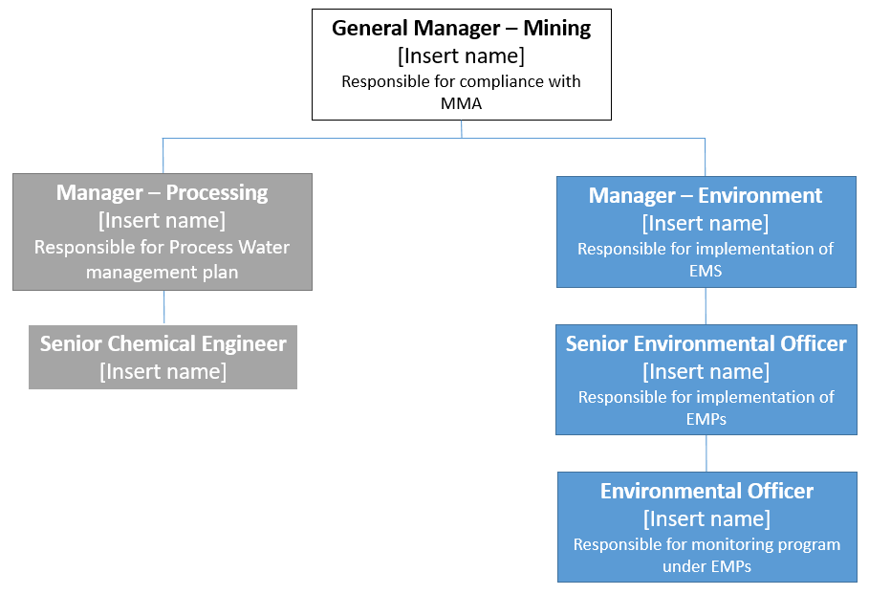

Section 3 – Site Conditions
Section 36(5)(a) of the MMA requires the Minister to be satisfied that the management system for the mine site, as detailed in the MMP, (i) is appropriate for mining activities described in the MMP and (ii) will, as far as practicable, operate effectively in protecting the environment on mine sites. For this to be assessed, the operator/proponent must demonstrate their understanding of site conditions, as this will inform management system requirements.

Site Setting
The table included in the Template identifies matters that must be addressed when describing the environmental conditions of the project area. The site details inform the development of a Conceptual Site Model (CSM) that identifies the sources (including contaminants), pathways and receptors for the proposed disturbance. For each project aspect, relevant site setting information is to be overlaid with proposed disturbances and provided as supporting figures to the table.
The inclusion of aspects such as seasonal variation, are to be limited to those that may impact, or be impacted by, the mine’s operation.
In relation to Climate, key aspects that influence environmental risks include type (wet/dry tropics, arid or other) with detail to be included only for temperature, rainfall and evaporation rates and an index of figures that present the information in graphical form. Other relevant information and relevant technical reports/management plans are to be included as appendices and referenced as appropriate.
With respect to Landscape and Soils include only high level information identifying landscape types and properties that will provide an indication as to the erosivity of the landscape. As a corollary the importance of erosion and sediment control measures to achieve effective management of the site will be highlighted. Use Cox (2019) Australian Soil and Land Survey Field Handbook (“the yellow book”) or similar reference material.
The description of Local Geology needs to include, or justify the absence of:
- a summary of the geology of area to be mined
- identification of host strata of the target ore body, including ore and grade cut-off
- summary of relevant geochemistry. Consider Acid and Metalliferous Drainage (AMD) and neutralising potential of overburden and tailings materials
- key structures/faults, mineralogy and other pertinent details, including relevance to water and contaminant movement, and excavation stability.
Use figures (including cross-sections) to convey key information that will assist the department determine the likelihood and consequence associated with environmental risks requiring management. Included below is an example high level analysis of local geology developed as a basis for the identification of geological characteristics influencing AMD potential which in turn will inform waste management processes.
Example content for inclusion in an appendix. A systematic analysis of the local geology and the identification of characteristics important to waste classification and management will assist in population of Table 3.1.1: Site reporting Local Geology aspect
Example Figure 3.1: Geo-environmental stratigraphy
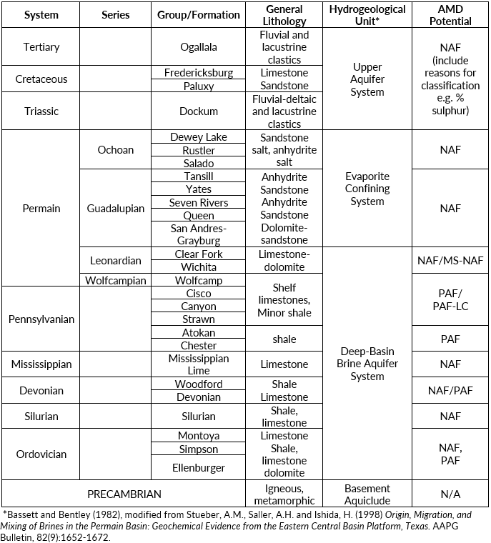
The Local Hydrogeology item is to capture details for key aquifers and aquitard units as informed by the geology and other relevant information, or to justify the absence of information against each of the following:
- Aquifers and depth
- Aquitards and depth
- Flow direction
- Standing Water Level (SWL)
- Yield
- Water quality.
Key local hydrogeological features are to be summarised visually in a figure showing the relative location of pertinent features to relevant existing or planned site works.
The description of relevant Local Hydrology requires identification of:
- the catchment/basin the site is situated within
- the regional flow direction for the catchment
- key drainage lines (creeks, rovers etc.)
- nature of the drainage lines (ephemeral, perennial etc.)
- the location of catchment/basin discharges
- classification of the catchment according to accepted guidelines (ANZECC & ARMCANZ, 2018) specifying the level of disturbance and level of protection to be achieved (99%, 95% or 80%)
- any declared values for the catchment/basin or any associated systems (e.g. Sites of Conservation Significance (SOCS),
- any declared water uses or allocation plans, subject to the Water Act 1992 or any other instrument.
Provide a summary of Sacred Sites on, or potentially impacted by, the project. This may be a figure showing pertinent locations relevant to existing or planned site works. It is requested that at a minimum AAPA registered sites be included. The AAPA certificate number should be included.
NOTE: Any detailed Sacred Site information will not be made public on the departmental website and it is recommended that it is included as an appendix.
NOTE: Operators are to consider their obligations under the Northern Territory Aboriginal Sacred Sites Act 1989.
For Other Heritage/Cultural Sites include a summary of considerations under the Heritage Act 2011 only referencing the Heritage Register as appropriate and include a figure showing pertinent locations relevant to existing or planned site works.
With respect to both Flora and Fauna provide a summary of searches for species protected under Territory and Commonwealth legislation. Include key matters considered under the Territory Parks and Wildlife Conservation Act 1976 and Environment Protection and Biodiversity Conservation Act 1999 (EPBC Act) for the project and a figure showing pertinent locations relevant to existing or planned site works.
It is important to identify and adequately describe Historical Mining Development and Disturbances to capture any environmental footprint from previous mining activity and/or existing structures.
Documentation of Underlying Land Use and Surrounding Land Use provides the department with context within which to assess the project in relation to considerations specific to each land use. For example pastoral lease, crown land and Aboriginal land. The project may be adjacent to land with specified conservation values or uses, which may be sensitive to mining related activities that may require specialist risk management actions.
A description of the Nearest Town(s) assists with identifying communities likely to be impacted by the project from a socio-economic and or cultural perspective.
The project’s proposed use of Regional Infrastructure, or any likely to be impacted by mining related activities, is to be outlined.
Note: All figures must include a scale, date of drawing, orientation (i.e. North point), and contours and use the Geocentric Datum of Australia (GDA) GDA94 datum.

Conceptual Site Model (CSM)
Section 36(5)(b) of the MMA requires the Minister to be satisfied the mining activities described in the plan will be carried out in accordance with good industry practice. Pursuant to section 36(5) of the MMA, a Conceptual Site Model (CSM) is required to describe the key project risks to enable assessment of the adequacy of the management system.
The MMP at a minimum must include a CSM which:
- details project environmental objectives
- summarises the main sources and contaminants of concern (CoC) associated with the proposed disturbance, pathways (e.g. air, water) and receptors (waterways, sacred sites, vulnerable flora or fauna etc.) for the project.
A CSM for the proposed mine site requires an accompanying brief description of the disturbances/activities proposed (e.g. pits, waste rock dumps, tailings storage facilities, settling ponds, water ponds etc.). A combination of written and illustrative CSMs will assist assessment of the MMP by the department.
Example Table 3.2: Conceptual Site Model (CSM)
Proposed Disturbance  (Source and CoC) | Pathways | Receptors
Pit  (As, Pb, Zn, Cd, Ni, Ti, SO₄) | Groundwater (seepage to groundwater) | Sensitive aquifer (e.g. drinking water quality or high value) or groundwater dependent ecosystem (GDE)
Waste Rock Dump A  (As, Pb, Zn, Cd, Ni, Ti, SO₄, Cr, etc) | Surface water (surface runoff)  Groundwater (basal seepage)  Air (dust) | Creek or river  Sensitive groundwater aquifer or GDE or sacred site  Flora/fauna (e.g. Gouldian Finch), sacred site
Run of Mine  (As, Pb, Zn, Cd, Ni, Ti, SO₄, Cr, etc) | Surface water (surface runoff)  Groundwater (basal seepage)  Air (dust) | As above
Tailings Dam  (As, Pb, Zn, Cd, Ni, Ti, SO₄, Cr, hydrocarbons, etc) | Surface water (surface runoff)  Groundwater (basal seepage)  Air (dust) | As above
Water Dam  (As, Pb, Zn, Cd, Ni, Ti, SO₄, Cr, etc) | Surface water (surface runoff)  Groundwater (basal seepage) | Creek or river  Sensitive groundwater aquifer or GDE

Socio-Economic Status
The definition of “environment” in Section 4 of the MMA extends to economic, cultural and social conditions. In detailing the socio-economic status of a mine site, proponents/operators must consider:
- Section 40(2)(e) of the MMA requires MMPs to include details of the site’s management system
- A management system is defined in the MMA as “the environmental protection management system…”
Inclusion of socio-economic parameters of interest to the community will addresses this requirement.
A description of the Workforce in terms of the number of people likely to be employed during the construction and operation of each phase of the project is required. Such information provides an indication of the broader economic contribution of the project to the Territory as a whole. The potential contribution to payroll tax and the likely flow on benefits to the community as a result of the operator/proponent’s access to the mineral resources of the Territory are of interest to the government.
The anticipated Economic Output of the project has implications for royalty payments.
Stakeholder Engagement is of importance to demonstrate an appreciation of the social licence to operate. Provide here a summary of the key stakeholders, consultation undertaken, what was agreed and timelines to achieving objectives of the agreement.
Any Other Items Deemed Pertinent will be guided by commitments made in relation to Major Project Status, or previous assessments under the repealed Environmental Assessment Act 1982.
Indicative content for Table 3.3 has been provided below.
Example Table 3.3: Socio-economic status descriptors for the proposal
Item | Description
Workforce  - Phase 1  - Phase 2  - Phase 3  - Phase 4 | Construction 300, Operation 100  Construction 200, Operation 200  Operation 150  Operation 150
Economic Output | Phase 2: $XXX per annum  Phase 3; $xx  Phase 4 $x
Stakeholder Engagement | Northern Land Council  NT Cattleman’s Association  Pastoralists Smyth and Jones  Local towns  Note: More detail can be found in the Project EIS – provide web address or link
Other Details | Environmental Impact Statement (EIS) commitments

Section 4 – Legislation and Obligations
While the department’s administrative responsibilities in relation to mining projects are limited to the MMA and the Mineral Titles Act 2010, other legislation will underpin management systems required by Section 40(e) of the MMA. Non-statutory requirements are also considered during the development of mine management systems.

Statutory Requirements
List legislation applicable to the project activities (products or services) in Table 4-1. The list must include relevant legislation at the following levels:
- Commonwealth
- Northern Territory and local government
Provide information on approvals or permits required under relevant legislation. Where this includes information relevant to cultural heritage and sacred sites, associated certificate numbers should be included.
Operators/proponents should contact the department with any concerns regarding the disclosure of potentially confidential information in this section. An example is presented below in Table 4-1.
Example Table 4.1: Relevant Northern Territory/Commonwealth legislation and requirements
Legislation | Pertinent information | Timing
Mining Management Act 2001 | Grant of Authorisation | Prior to mining
Water Act 1992 | Permit to extract groundwater  Permit to interfere with waterway | Application with Water Resources (application No). Licence needed by LOM year 2  Application with Water Resources (reference No). Licence required by LOM year 1 during clearing
Environmental Assessment Act 1982 (repealed) | Assessment Report No X was issued at the conclusion of the NT EPA’s assessment of the project. | The NT EPA Recommendations, if accepted by the responsible Minister for Mining, are directly relevant to the project.
Environment Protection Act 2019 (EP Act) | EP #, conditions 1-10. | Life of project, as per EPA Act conditions.
Environment Protection and Biodiversity Conservation Act 1999 (EPBC Act) | EPBC #, conditions 1-8. | Life of project, as per EPBC Act conditions.
Weeds Management Act 2001 | Weed management plan developed in consultation with Weeds Branch consistent with NT Government guidelines | Life of project
Northern Territory Aboriginal Sacred Sites Act 1984 | Project area has registered sacred sites | AAPA certificate No: xxxx

Non-Statutory Requirements
Operators/proponents must consider non-statutory requirements that have been key considerations in the development of their management systems. Summarise key considerations to demonstrate that industry best practice guides have been considered. Technical information of relevance is expected to be captured in corresponding appendices.
An example summary of non-statutory requirements is presented in the Table 4-2.
Example Table 4.2: Projects pertinent Non-Statutory requirements
Non Statutory Requirement | Description | Relevance to Project
MCA Water Accounting Framework | Water balance in accordance with leading practice | To achieve/support no uncontrolled discharges
International Cyanide Code | International guideline for management of cyanide in mining | Cyanide proposed to be used in extraction  Operator is a signatory to this code
GARD Guidelines | Geochemical assessment in accordance with leading practice | Waste classification system developed based on these guidance documents
Australian National Committee on Large Dams (ANCOLD) Guidelines | These guidelines have been considered in the design of both the TSF and dams, and their management systems, detailed in Section 5.4. | There will be one TSF and three dams constructed on site.
RAMSAR wetlands agreement | RAMSAR-listed wetland is located 40 km south east of the mine, and supports a number of endangered species. | The catchment in which the mine sits drains to a RAMSAR wetland
Global Industry Standard on Tailings (GISTM) | International standard adopted by Australia for safe management of tailings facilities, toward the goal of ‘zero harm’. | Operators will use specified measures to prevent failures and other events that put the safety of mining staff and adjacent communities at risk

Section 5 – Operational Activities
Section 40(2) of the MMA details the information required for MMPs, which includes
- (c) a description of the mining activities for which the operator requires an Authorisation,
- (e) details of the management system,
- (f) plans of proposed and current mine workings and infrastructure.
Operators/proponents must consider other aspects of the MMA in this section, including the definitions of “mine site”, “mining activity” and “management system”.
NOTE: This section presents guidelines that set out specific risk assessment and mitigation processes for the operator to follow. Alternative risk assessment and mitigation processes will be considered, but require detailed justifications from the operator/proponent.
The MMP must detail key areas of disturbance associated with each key activity. Key activities to be covered include:
- Infrastructure areas, including run-of-mine (ROM) pad and operations areas (e.g. processing, refuelling, offices etc.)
- Mining voids (e.g. pits, quarries, underground mines)
- Construction and maintenance of tailings storage facilities and dams (including saline water, process water, general use dams, evaporation ponds and settling ponds)
- Construction and maintenance of overburden stockpile/waste dump
- Haul and access roads/tracks
- Diversions of waterways
- Exploration (see MMP structure guide for exploration activities for additional guidance).
Sections 5.1 through 5.9 provide specific guidance on key mine activities. However, other disturbances may be present, for which the operator/proponent is to provide relevant description details. Where appropriate, include figures in the MMP for each of these key activities, including detailed design/figures, presented as an index of attachments that support the information provided in the table.
Development considerations underpinning each key activity must be described, including:
- Relevant designs (from concepts through to detailed designs), informed by site investigation
- Clearing works required (e.g. excavate topsoil and subsoil, and subsequent management)
- Supporting infrastructure required (e.g. installation of haul and access roads, drainage, pumping stations and other civil works)
- Key constraints for the development of each activity. These are typically operational, environmental and engineering constraints. Other constraints should be listed if relevant
- Controls and management strategies for identified risks.
Where relevant, the MMP is to document knowledge gaps, and a work plan to address them.
Summary information provided in the tables should be supported by detailed documents provided as appendixes referred to in the tables as appropriate.

Mine Infrastructure Area
Typical mine infrastructure includes:
- ROM pad to feed ore
- Processing (including crushing, chemical extraction plant, chemical storage or chemical production in house e.g. acids/bases and use, ore concentrate storage)
- Buildings for storage/workshops/offices/explosives/other equipment
- Fuel farm
- Power supply
- Equipment storage (low risk) in open
- Water treatment plant
- Dams to collect drainage, and erosion, sediment and control works (including bunding and hardstand for toxic chemicals) and overtopping of dams
- Power lines
- Bore fields
- Accommodation
- Sewage treatment
- Landfill
Key matters for the operator/proponent to address include:
- footprints
- development sequence
- key risk and controls
- performance monitoring
- plans for rehabilitation at closure or end of planned activities.

Identification of Zones
The operator/proponent is required to describe mine infrastructure and associated management systems. For more complex sites infrastructure may be grouped into “zones” where similar source, pathway, receptor linkages informed by the Conceptual Site Model should help simplify the development, interpretation and implementation of management systems.
For less complex sites the use of zones may not be necessary. If in doubt discuss possible approaches with the department.
Example Figure 5.1: Application of ‘zones’
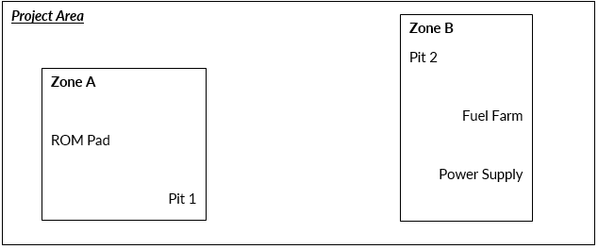

Mine Infrastructure Area (MIA) Summary
This section requires the operator/proponent to describe the location and specifics of each item comprising the mine infrastructure area (MIA) and identify zones with similar management requirements within the project area. The clear identification of existing and proposed infrastructure is critical to site regulation and management, the calculation of security and tracking of rehabilitation over the life of the mine.

MIA Risk, Controls and Management
The MMP is to include a sequential discussion of the timing and nature of clearing, construction, commissioning, operation and unplanned closure considerations for mine infrastructure. For less complex sites there will be no need to use zones.

MIA Summary of Environmental Performance
For proposed infrastructure as relevant to the project, indicate: timing, key environmental risks for each phase of the mining project, controls to mitigate and/or manage the identified risks, and performance and monitoring criteria to determine the performance of the infrastructure/success of controls. Only high level summary information is to be included in Table 5.1.3 with detailed information to be provided in appendices with the location of relevant information referenced in the last column of the summary table.
For pre-existing structures identified on the mine site, provide information in relation to their performance against the criteria to demonstrate they are/will be safe, stable and non-polluting.

Independent Expert Oversight
The option to explain the requirement for engagement of independent expert advice is accommodated in the template, however, the level of detail outlined may not be required.
Dependent on project specifics, it may be more appropriate that all independent oversight is summarised in one section of the MMP. The operator/proponent should consider what works best for their project in consultation with the department.
At a minimum the department will require:
- a list of standard guidelines/standards to be followed
- an indication of whether the operator/proponents will be engaging third party consultants or using their own engineers
- demonstrated consideration of risks, if any, if independent engineers are not engaged.
Where an independent certifying engineer is employed by the operator/proponent, indicate any delegation of on-site verification of activities by site based engineers and the associated level of accountability and oversight.

MIA Closure
The focus of this section is rehabilitation to achieve a safe, stable and non-polluting end point.
The MMP should state how infrastructure will be rehabilitated, the objectives of rehabilitation and the criteria against which achievement of rehabilitation objectives will be evaluated.
The department acknowledges that there will always be a level of uncertainly and knowledge gaps (i.e. things you need to know/investigate/trial until it is known exactly how the rehabilitation objectives will be achieved).
The MMP should identify the knowledge gaps and uncertainty, outline the appropriate studies or lines of investigation to be undertaken to address these, and the expected timeframe within which these will be completed. Include the anticipated timeframe by when uncertainly and knowledge gaps should be minimised.
For example, rehabilitation of a mine camp and roads would require removal of buildings and rehabilitation of disturbed areas with a view to returning them to a state reflective of the surrounding landforms and native vegetation. Criteria could relate to requirement for evidence of minimal erosion and established vegetation with similar species composition to project site surrounds. Knowledge gaps may exist with respect to suitable species for revegetation. This could be addressed in consultation with local Aboriginal peoples who could potentially participate in the collection, germination and planting of suitable species to achieve the agreed species composition for revegetated areas post removal of camp infrastructure within identified timeframes.

Pits and Extractives
Provide details of pits and extractives (top soil, clay, sand gravel - if applicable), and how they will be managed.

Pit Summary
Where relevant, proponents/operators must provide information for proposed and existing pits, including:
- Number of proposed pits and their footprint relative to existing footprints (if any)
- Purpose of the pit
- Location on specific mineral titles
- Target commodity
- Scheduling in terms of LOM
- Pit dimensions
- Waste generated.
NOTE: Description of waste is to be consistent with the waste rock classification system for the project as detailed in section 5.5.

Pit Design Rationale
Document the rationale underpinning pit design (e.g. unstable faces require cutting, or competent rock so blasting will form the design angles) describing:
- Regulatory obligations and industry guidelines considered
- Pit wall engineering competency, waste rock properties and management, temporary dumps/stockpiles and/or pit partial/full backfill
- Bench/berm length, height, angles
- Geochemical quality, with reference to the waste classification system, of material placed in pits (if any)
- Waste water management considering potential impact on groundwater table, including upon exhaustion of target strata/resource.

Pit Risk, Controls and Management
Document the anticipated development of pits and extractive sites in stages, detailing clearing surveys, vegetation clearing, drilling, bores/dewatering, blasting and excavation considerations.
Detail to be provided may include, but is not limited to:
- Performance monitoring (e.g. groundwater, wall stability/faults, dust, groundwater quality and migration, high rainfall/pit flooding, levees, diversions)
- Any detailed operations plan to be developed e.g. surveillance, trigger action response plans (TARPS).

Independent Expert Oversight
Refer to section 5.1.5.

Pit Summary of Environmental Performance
For proposed pits and extractives as relevant to the project, indicate: timing, key environmental risks for each phase of the mining project, controls to mitigate and/or manage the identified risks, and performance and monitoring criteria to determine the performance of the pits/success of controls. Only high level summary information is to be included in Table 5.2.5 with detailed information to be provided in appendices with the location of relevant information referenced in the last column of the summary table.
For pre-existing pits and extractives identified on the mine site, provide information in relation to their performance against the criteria to demonstrate they are/will be safe, stable and non-polluting.

Pit Closure
Provide a summary for rehabilitation plans at closure or end of planned activities, including objectives, options and landform designs. Detail is to be provided in referenced appendices.
Where existing structures are present, current performance of the structure with respect to the design, knowledge gaps and timelines is to be addressed.
At a minimum, conceptual designs are to be included, progressing to detailed design at the earliest possible dates. This may be dependent on the life of mine. Refer to section 8.
NOTE: there is an expectation that any Factor of Safety (FoS) will be based on modelling. Detail underpinning the FoS should be included as an appendix.

Underground Operations
This section requires the operator/proponent to provide details of activities for the underground domain (if applicable) and where relevant demonstrate consideration of key aspects.

Underground Operations Summary
- Number of proposed underground voids and their dimensions
- Location on mineral titles
- Scheduling of development
- Description, development stages, including clearing surveys, clearing, drilling, bores/dewatering, blasting, excavation, waste rock management, temporary dumps/stockpiles and/or pit partial or full backfill. The description must include bench/berm length, height, angles
  - Detail any plans to backfill underground void and associated risks such as likelihood of encountering groundwater, or requirement for diversion of waterways or similar
- Rationale for the chosen design (e.g. room-pillar, stopping etc.).

Underground Operations Risks, Controls and Management
The operator/proponent is required to identify key risks and appropriate controls detailing:
- Performance monitoring (e.g. groundwater, wall stability/faults, dust, groundwater quality and migration, high rainfall/pit flooding, levees, diversions)
  - Risks associated with excavated products, including waste products and their classification
  - Extracted groundwater management
  - Any potential AMD production or emissions/discharge of chemicals of concern
- Detailed operations plan to developed, e.g. surveillance, TARPS are to be included as appendices and referenced accordingly.

Independent Expert Oversight
Refer to section 5.1.5.

Underground Closure
Provide a summary for rehabilitation plans at closure or end of planned activities, including objectives, options and landform designs. Detail is to be provided in referenced appendices.
Where existing structures are present, current performance of the structure with respect to the design, knowledge gaps and timelines is to be addressed.
At a minimum, conceptual designs are to be included, progressing to detailed design at the earliest possible dates. Refer to section 8.

Tailings Storage Facility and Dams
Provide details of activities in the Tailings Storage Facility (TSF) and Dams Domain (if applicable).

TSF and Dam Summary
Provide details of:
- Number of TSFs and dams, their footprint and height
- Waste to be stored must be consistent with appropriate geochemical or waste water classification
- Life of Mine (LOM) year of construction (i.e. when does it need to be used) – e.g. LOM Yr 3 (i.e. staging, scheduling and timelines for all TSFs/cells)
- Supporting infrastructure (e.g. dams, sumps etc.) dimensions.

TSF and Dam Design Rationale
The operator/proponent must detail the design rationale/philosophy, with reference to ANCOLD guidelines as appropriate. Key aspects to consider include, but are not be limited to:
- Basal layer design
- Liming or other treatment requirements (if any)
- Management strategy, including freeboard and beach management
- Capping design.

TSF and Dam Design Components
In this section the finer specifications are to be provided to demonstrate consideration of all key aspects and inform population of the security calculator tool.

TSF Lift Details
This section requires lift height detail for the planned development of individual TSFs.
Example Table 5.4.3 provides an example of the operator/proponent requesting approval to develop two TSFs with the proposed lifts detailed in accordance with concept designs developed consistent with ANCOLD guidelines.
Example Table 5.4.3: TSF lift details
TSF 1 | TSF 2
 | Cell 1 | Cell 2
Stage 2 – 146.5m | Stage 1 – 138.0m | Stage 1 – 138.0m
Stage 3 – 149.0m | Stage 2 – 143.0m | Stage 2 – 143.0m
Stage 4 – 151.5m | Stage 3 – 148.0m | Stage 3 – 148.0m
Stage 5 – 154.0m | Stage 4 – 153.0m | Stage 4 – 153.0m
Stage 6 – 156.5m | Stage 5 – 158.0m | Stage 5 – 158.0m
Stage 7 – 158.5m | Stage 6 – 163.0m | Stage 6 – 163.0m
Stage 8 – 160.0m | Stage 7 – 165.0m | Stage 7 – 165.0m

TSF and Dam Risk, Controls and Management
The operator/proponent is to demonstrate appropriate consideration of risks, controls (including relevant criteria) and management across all phases (i.e. construction, operation, remediation) of TSF and dam operation.
This may include, but is not limited to:
- surveillance requirements (as per ANCOLD guidelines)
- critical operating parameters
- freeboard levels (between tailings and embankment crest, between decant pond level and minimum breach level at perimeter embankment)
- phreatic surface levels
- management of environmental discharge
- commitment to monitoring deviation between actual and target tailings stage storage curve.

Independent Expert Oversight
Refer to section 5.1.5.

TSF and Dam Closure
Provide a summary for rehabilitation plans at closure or end of planned activities, including objectives, options and landform designs. Detail is to be provided in referenced appendices.
Where existing structures are present, current performance of the structure with respect to the design, knowledge gaps and timelines is to be addressed.
At a minimum, conceptual designs are to be included, progressing to detailed design at the earliest possible dates. This may be dependent on the life of mine. Refer to section 8.
NOTE: The description of waste stored needs to be consistent with the waste rock classification criteria.

Waste Rock Dump
Provide details of activities in the waste rock dump (WRD) domain as appropriate.

WRD Summary
Where relevant, this section must demonstrate the operator/proponent has considered, providing additional detail in appropriately referenced appendices, the following:
- Number of WRDs, the year of construction
- Location and description of existing and planned WRDs
- Waste stored and its classification – justification for the waste classification can be included as an appendix
- Dump configuration
- Flood immunity relative to annual recurrence intervals (ARIs)
- Method of construction
- Phreatic conditions that may develop in the WRD and the potential for basal seepage.
In the event supporting infrastructure (e.g. dams, sumps etc.) are proposed, operators/proponents should ensure they are fully discussed in Section 5.5.6.

WRD Design Considerations
Operators/proponents are required to demonstrate consideration has been given to various regulatory obligations such as potential impacts on receptors of importance, industry standards, and/or commitments made in an EIS. Any matters of relevance should be summarised here with supporting detail provided in referenced appendices.

Waste Rock Classification Criteria
Key to the appropriate design and successful performance of a WRD is a robust waste classification system. The operator/proponent is required to demonstrate a suitably thorough understanding of the characteristics and volumes of waste types likely to be generated in the processing of the target commodity. Key information should be presented in the tables of the MMP supported by additional information in referenced appendices. The classification system is critical to demonstrating an adequate understanding of risk, controls and management associated with the operation of the WRD.
NOTE: The department uses terminology consistent with Standards Australia Geological site investigation AS 1726:2017.

WRD Material Quality and Beneficial Re-use
Efficient management of waste material is facilitated by using benign materials on site. The operator/proponent is to identify classes of waste suitable for beneficial use. Details should be provided in referenced appendices as needed.

WRD Design Rationale
The operator/proponent must detail the design rationale/philosophy making reference to any guidelines and detailed information provided in appendices as appropriate. Key aspects to consider include, but are not be limited to:
- Basal layer design
- Liming or other treatment requirements (if any)
- Management strategy, including methods to prevent sulphur oxidation and “the chimney effect”, if relevant.

Capping design. WRD Risk, Controls and Management
The operator/proponent is to demonstrate appropriate consideration of risks, controls (including relevant criteria) and management across all phases (i.e. construction, operation, remediation) including hold points during operation, as relevant. Due consideration should be given to the management of environmental discharge.

Independent Expert Oversight
Refer to section 5.1.5.

Additional detail
In the event the operator/proponent elects not to implement independent expert oversight, additional information is required to enable assessment of the proposed activity under the MMA.
Documentation of WRD design as informed by site investigation details, performance objectives and criteria, design considerations and method of construction need to be provided with supporting information provided in appropriately referenced appendices.

WRD Closure
Provide a summary for rehabilitation plans at closure or end of planned activities, including objectives, options and landform designs. Detail is to be provided in referenced appendices.
Where existing structures are present, current performance of the structure with respect to the design, knowledge gaps and timelines is to be addressed.
At a minimum, conceptual designs are to be included, progressing to detailed design at the earliest possible dates. Refer to section 8.
NOTE: The description of waste stored needs to be consistent with the waste rock classification criteria.

Exploration Domain
The Mining Management Exploration Activities guideline may be used to describe exploration activities.
If the operator/proponent elects to populate tables in the Mining Management Plan Template for Mines, it is recommended that the template developed for exploration projects available from the department’s website here - under advisory notes and structure guides and be populated and submitted as a referenced appendix.

Haul and Access Roads
The MMP must document for any haul and access roads constructed across the site, details pertaining to the nature and location of the roads, risk controls and management, independent oversight of construction and closure considerations.

Haul and Access Road Details
The MMP must contain the following information:
- Number of haul roads and their footprint
- Location, length and width of roads on the project site
- Construction materials used for the haul roads, including source and general properties
- For existing roads, a summary of the performance of the structure with respect to the design, knowledge gaps and timelines to address these
- A general description of works relevant to the construction of the haul roads and access tracks is to address the materials and methodology aspects
- Consideration of statutory requirements guiding placement and construction.

Haul and Access Road Risk, Controls and Management
The operator/proponent is to demonstrate appropriate consideration of risks, controls for all activities associated with construction and operation of haul and access roads. Note runoff management (i.e. erosion and sediment controls) in particular is of relevance.

Haul and Access Road Independent Expert Oversight
The MMP should include;
- a list of standard guidelines/standards to be followed
- an indication of whether the operator/proponents will be engaging third party consultants or using their own engineers
- demonstrated consideration of risks, if any, if independent engineers are not engaged.
Where an independent certifying engineer is employed by the operator/proponent, indicate any delegation of on-site verification of activities by site based engineers and the associated level of accountability and oversight.

Haul and Access Road Closure
Provide a summary for rehabilitation plans at closure or end of planned activities, including objectives, options and landform designs. Detail is to be provided in referenced appendices.
Where existing structures are present, current performance of the structure with respect to the design, knowledge gaps and timelines is to be addressed.
At a minimum, conceptual designs are to be included, progressing to detailed design at the earliest possible dates. This may be dependent on the life of mine. Refer to section 8.

Diversion of Waterways
Approval to divert any waterway is subject to assessment for approval under the Water Act 1992.
Inclusion of the requested information in the MMP is to enable structural and risk assessments to be undertaken and inform security calculation under the MMA.
Plans and supporting documentation approved under the Water Act 1992 are to be provided as appendices to the MMP.

Other Activities
Briefly summarise activities to be completed on (or associated with) the site during the Life of Mine that have not been captured in the preceding sections such as rehabilitation trials.
Detailed information in support of the summary is to be provided as appendices.
Where existing structures are present, provide information regarding the performance of the structures with respect to them meeting the requirement to be safe, stable and non-polluting. Design details, monitoring, and timelines are to be provided to address any knowledge gaps (if relevant).

Section 6 – Project Risk Assessment
A project risk assessment is a critical part of the management system required by Section 40(2)(e) and (f) of the MMA. Section 36(5) of the MMA requires the Minister to be satisfied the management system for the mine site will, as far as practicable, operate effectively in protecting the environment.
A summary of the risk assessment framework is to be included with supporting information included in a referenced appendix.
The risk assessment must address the following broad categories:
- Design and engineering
- Performance and maintenance of engineered structures
- Environment.
For each activity, detail the key risks and how each will be addressed. Operators are to consider the following for inclusion in the MMP:
- Identification of risks across all mine phases, including from unexpected or emergency conditions
- Analysis of these risks to derive an inherent risk rating, prior to the application of treatments and/or controls
- Appropriate risk treatment and/or controls
- An evaluation of the risk pathways to derive a residual risk rating
- Demonstration that all identified residual risks are as low as reasonably practicable.
An example project risk assessment for a waste rock dump with supporting risk rating, controls and residual risk is outlined below.
Example risk assessment process: Waste Rock Dump
The proposed waste rock dump (WRD) risk assessment requires development of conceptual models to detailed design, as informed by hydrogeological and geotechnical engineering studies. The detailed design will be submitted for approval prior to construction commencing following approval of the conceptual design.
Risks
Key engineering, environmental and performance risks are summarised below.
Key engineering risks are:
- Structural failure/design flaw
- Material specifications for use in construction
- QA/QC in construction and appropriate engineering signoff
- Failure of basal layer, leading to acid metalliferous drainage breaking containment
Key environmental risks are:
- AMD generation
- Proposed WRD footprint contains sensitive flora species
- Chimney effect in WRD
Key performance risks:
- Failure of seepage collection system
A summary of the management system for each of these risks is provided in Section 7.

Example Table 6.1: Environmental Risk Assessment Summary – Waste Rock Dump – risk rating, controls and residual risk.
Following is a summary of results of the WRD risk assessment resulting from use of a risk matrix to determine a risk rating based on likelihood and consequence of foreseeable risks. Note: the risk ratings used are taken from the example likelihood ratings and risk matric in tables 6.3 and 6.4 below.
Aspect | Risk | Risk Rating | Control | Residual Risk | Reference
Engineering
Structural failure | WRD incorrectly designed | 6 | Certified engineer to sign-off designs  24 hr/7 day per week laser survey to detect mass movement | 4 | Section A, Appendix X
Capping materials | Materials used to cap WRD do not meet specification | 7 | Testing certification issued by supplier prior to importation | 2 | Section B, Appendix X
Environmental
AMD drainage | AMD exceeds modelling prediction, overwhelming treatment system | 7 | Treatment system -engineered to accommodate AMD with pH as low as 2.3 | 2 | Section E, Appendix X
WRD chimney effect | Underestimation of pyrite content, leading to very high WRD temperatures | 8 | WRD design specifies inclusion of alluvial barrier layers or equivalent | 2 | Section F, Appendix X
Performance
Monitoring | Monitoring fails to pick up leakage from WRD | 8 | Comprehensive monitoring system installed, with fully trained environmental officers enacting monitoring plan. Monitoring results to be regularly checked to determine whether management system is adequate.  WRD to be checked for seepage on an incidental and weekly basis | 2 | Section H, Appendix X

Example Table 6.3: Definition of Likelihood ratings
Rating | Likelihood | Definitions
5 | Almost certain | The event if expected to occur in most circumstances.
4 | Likely | The event will probably occur in most circumstances.
3 | Possible | The event might occur at some time.
2 | Unlikely | The event could occur at some time
1 | Rare | The event may occur only in exceptional circumstances.

Example table 6.4: Risk Analysis Matrix
Severity of consequence
Likelihood of consequence |  | Critical (5) | Major (4) | Significant (3) | Moderate (2) | Minor (1)
 | Almost certain (5) | Extreme | Extreme | High | High | Medium
 | Likely (4) | Extreme | High | High | Medium | Medium
 | Possible (3) | Extreme | High | Medium | Medium | Low
 | Unlikely (2) | High | Medium | Medium | Low | Very Low
 | Rare (1) | Medium | Medium | Low | Low | Very Low

Section 7 – Management System
Section 36(5) of the MMA notes the Minister must be satisfied that the management system for the mine site, as detailed in the plan (i) is appropriate for the mining activities described in the plan; and (ii) will as far as practicable, operate effectively in protecting the environment and relevant water rights. Section 40(2)(e) requires a MMP to include details of the management system for the mine.

Environmental Management System
The section requires the operator/proponent to briefly describe how the Environmental Management System aligns with the project’s overall management system. An example of an environmental management system hierarchy is provided in Figure 7-1.
NOTE: MMPs must clearly demonstrate how the EMS has been developed to be consistent with industry best practice, with a clear recognition of the distinct Life of Mine phases of mining (exploration, exploration and active mining, rehabilitation and closure). A flow-chart that describes how the Environmental Objectives of the Project (Life of Mine) will be achieved will assist assessment.
NOTE: A flow chart or similar graphic, which depicts the hierarchy of environmental management plans and how they integrate with the overall EMS would help to illustrate integration of the EMS with staff training and education. The information should be sufficient to allow the department to infer confirm appropriate training is provided by the operator.
NOTE: In the event the operator/proponent has obtained AS/NZS ISO 14000 accreditation for the proposed environmental management system, provision of the details of the certification is all that is required.
Example Figure 7.1: example of an environmental management system hierarchy
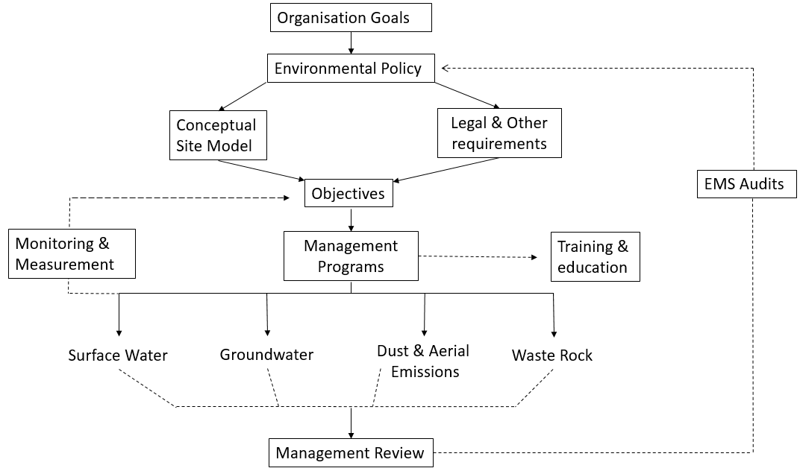

Overarching Environmental Objectives
This sections requires the operator/proponent to summarise the Environmental Objectives for the project.
NOTE: Examples of Environmental Objectives include, but are not limited to:
- No long term pollution of water on the mine site
- Maintenance of baseline health indicators of major down-gradient river and its tributaries
- No unacceptable negative ecosystem impacts to occur
- Food collected from receiving environments is safe to eat
- Ecosystem function of the natural or regional landscape is maintained
- No unacceptable negative impacts to water supply and security of local or regional communities
- Those detailed by NT EPA in their assessment (if applicable).
The MMP could include a flow-chart that depicts how the environmental objectives will be achieved by implementing the EMS.
Successful implementation of the EMS is contingent on:
- Appropriate environmental plans
- Appropriate allocation of staff with designated responsibilities and accountabilities from the top of the operation to the bottom of the operational hierarchy, from executive decision-makers to staff on the ground.
To achieve the first, the MMP could document and use the Conceptual Site Model to inform the (i) sources and contaminants, (ii) pathways and (iii) receptors to inform the development of appropriate plans.
- Incorporate and/or address relevant statutory matters under existing Authorisation (specific conditions that require monitoring etc.) and other legislation (EPBC Act, Environment Protection Act 2019 etc.).
To achieve the second:
- A decision making process (Section 7.2.1) will be required to demonstrate how results from an individual management plan informs the achievement of the environmental objectives.
NOTE: For environmental management, the department will recognise relevant accreditation under the Certified Environmental Practitioner Scheme (CEnvP), or other equivalent bodies, or equivalent practical experience, as evidence of a suitably qualified engineer.
NOTE: For engineered structures, the department will recognise membership of Engineers Australia, Association of Professional Engineers Australia, or other equivalent bodies, or equivalent practical experience, as evidence of a suitably qualified engineer.

Environmental Management Plan
- Environmental Management Plans are typically required for:
- Waste Rock
- Surface Water, including flood immunity considerations
- Groundwater
- Marine water (if likely to be impacted by mining activity)
- Air Quality (Dust and Aerial Emissions)
- Erosion and sediment control
- Hazardous Materials (Hydrocarbons and Other Chemicals of Concern)
- Non-mineral wastes
- Biological (Flora, fauna, macroinvertebrate etc)
- Rehabilitation.
Briefly describe how the operator/proponent has developed the environmental management plans to address the overlying Project Environmental Objective, informed by the CSM. The plans developed must address all the matters identified by the CSM. The environmental management plans (EMPs) must be provided in their entirety as Appendices.
Each EMP must include:
- Objectives, which are SMART, or:
  - Specific and unambiguous
  - Measurable
  - Achievable
  - Realistic
  - Time-Based.
NOTE: The objectives of each EMP must align with the overall EMS objectives detailed in Section 7.1.
- Scope, including the process of implementing the plans (i.e. its application), and identification of responsible people and their accountabilities.
- Relevant guidelines, including how statutory and non-statutory requirements have been addressed (e.g. compliance to EPA matters or EPBC Act approval conditions).
NOTE: The EMP is expected to be consistent with industry best practice guidelines, and contain trigger or action levels which are based on such guidelines.
- A monitoring sub-plan detailing the sampling, analysis including QA/QC requirements, acceptance criteria (typically multi-tiered to include early warnings through to critical warnings)
- Reporting requirements
- Sequence of corrective actions in the event a relevant guideline/acceptance criteria or trigger value, is not met. Inclusion of a flow chat may be helpful here.
NOTE: Monitoring is NOT a management action; it is a tool to assess the effectiveness of the management actions applied. Management actions need to be based on the hierarchy of risk management ranging, from elimination through to provision of personal protective equipment (PPE). The department will place importance on the operator/proponent’s identification of actions required to address likely serious issues, the validity of existing approvals, and/or the need to apply for amendment to approvals.
An example outline of an environmental management plan is presented as a figure in example 7-1.
An example of a summary environmental management plan for surface water monitoring is presented in example 7-2 and 7-3.
The information in this section provided by the operator/proponent must demonstrate how the environmental management plan/s are used in decision making on the site. This is discussed further in Section 7.2.
Example 7-1: Figure showing the outline of an environmental management plan
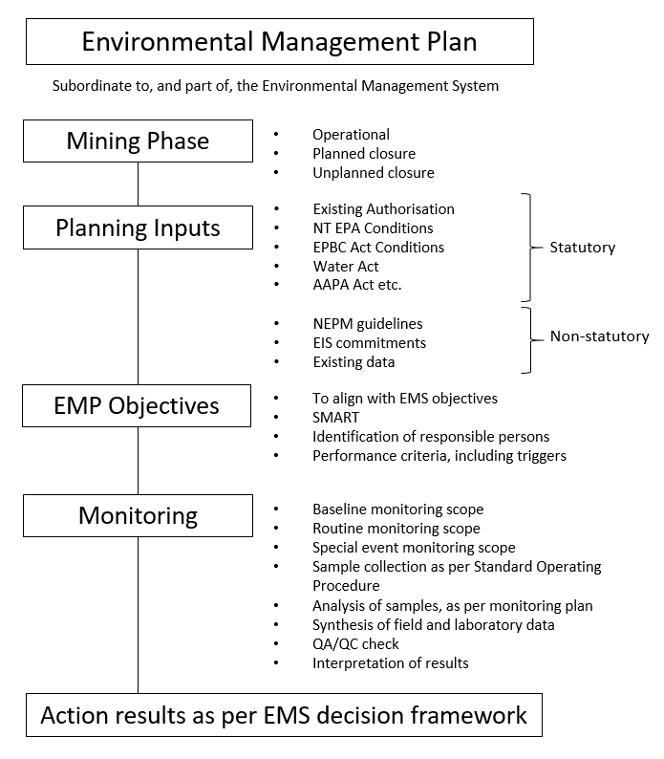

Example Table 7.2: Example environmental management plan for surface water monitoring
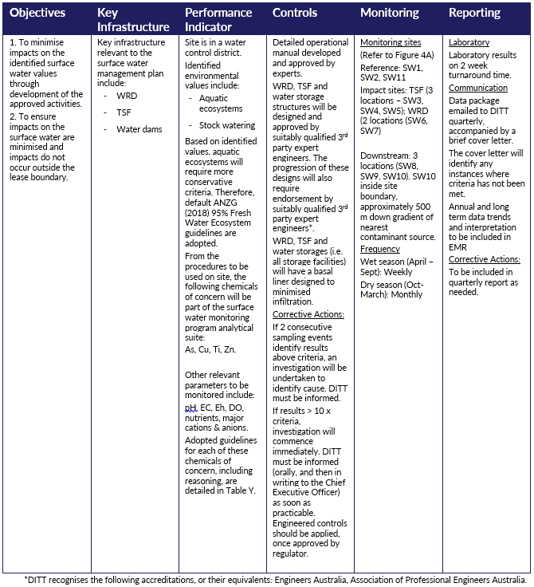

Example Table 7.3: Environmental Management Plan – Surface Water – legend providing detail in support of critical chemicals of concern referred to in Table 7-2
Chemical of Concern | Adopted Guideline Value | Reasoning
Metals
As | XX µg/L | Default ANZG (2018) guideline
Al | XX µg/L | ANZG (2018) guidelines for waters with pH<6.5
Cu | XX µg/L | Default ANZG (2018) guideline
Ti | XX µg/L | No ANZECC values, therefore Dutch guidelines adopted.
Zn | XX µg/L | Default ANZG (2018) guideline
Field parameters
pH | X.X - X.X pH units | ANZECC (2000) guidelines
EC | <X,XXX mg/L | ANZECC (2000) guidelines
Eh | XX µg/L | -
DO | XX-XX ppm | ANZECC (2000) guidelines
Nutrients
K | XX mg/L | No guidelines, historical maximum used
NO₃⁻ | XX mg/L | NEPM guidelines

NOTE: The Reasoning provided in Table 7-3 are examples only and may not reflect project specific reasoning for all relevant chemicals of concern.

Decision Framework
Summarise and demonstrate how the EMS and EMP will used to inform decisions and management (i.e. how to apply the EMP).
This must include, or justify the absence of, triggers for decisions, noting:
- management actions should be commensurate with the level of risk.
  - monitoring is NOT a management action; it is a tool to assess the effectiveness of the management actions applied.
- management actions must be based on the hierarchy of risk management ranging, from elimination through to provision of PPE.
SUGGESTION: It is additionally important to identify at what management level actions are required for serious issues (i.e. regulator intervention), and validity of existing approvals, or the need to apply for amendment
The EMS framework should provide a guide for both the operator’s environment team, and the department’s mining officers, of the decision making process in meeting environmental objectives.
The EMS decision framework should clearly define responsibility for different decision makers across the process. An example EMS decision framework is presented in example 7-4.

Example Figure 7-4: Decision framework with responsible person identified for each stage.
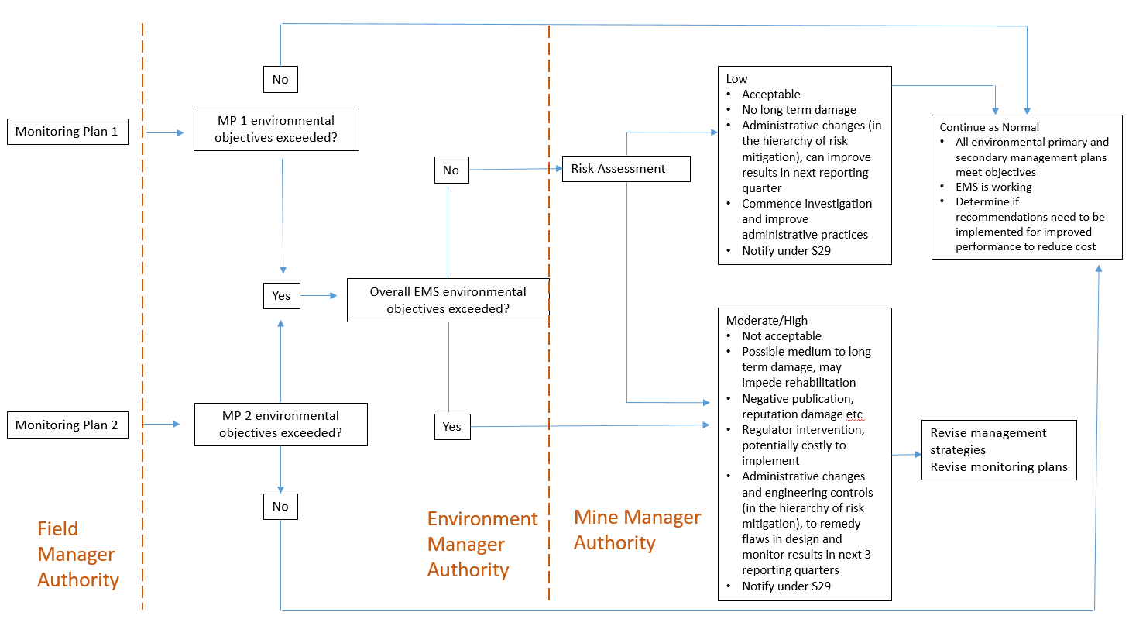

Section 8 – Closure Planning
Section 40(2)(g) of the MMA requires MMPs to include a plan and costing of closure activities

Conceptual Closure Plan
For both the general mine site and each of the disturbances listed in Section 5, the MMP must:
- include closure objectives for each stage of life of mine
- provide details of the consultation that will be completed.
Useful resources providing suitable guidance available online include:
- Mine Closure guidelines: Department of Industry, Science, Energy and Resources
- WA Statutory Guideline for Mine Closure Plans and Mine Closure Plan Guidance - March 2020
NOTE: A conceptual closure plan is a minimum requirement for all mine MMPs. However, a final closure plan is required for all mines with a Life of Mine of less than four years. For all other mines, a closure plan must be submitted for approval no less than four years from the date of planned closure.

Section 9 – Security
Section 40(2)(g) of the MMA requires MMPs to include a plan and costing of closure activities.
Costing of closure activities is typically referred to as “security”. Security calculations are typically submitted as an appendix to the MMP. The department’s ‘Security Calculation Tool’ should be used and can be found here: Security-and-levy.
In the event that the operator/proponent proposes an alternative method to calculate security, the proposal must be discussed with the department prior to finalisation of the MMP.
The security estimate calculated must be consistent with third party costs and remediation requirements in the event of an unplanned closure at the end of the life of the plan (i.e. rehabilitation costs for disturbances proposed in the MMP and for any previous disturbances generated by the operation).
Post rehabilitation monitoring and maintenance costs must be included.
NOTE: A mine will not be closed subject to the MMA unless rehabilitation has been completed as demonstrated by rehabilitation monitoring and closure objectives have been achieved.

https://nt.gov.au/industry/mining-and-petroleum/mining-activities/develop-a-mining-management-plan
https://nt.gov.au/industry/mining-and-petroleum/mining-activities/develop-a-mining-management-plan
https://www.industry.gov.au/
https://www.dmp.wa.gov.au/Documents/Environment/REC-EC-111D.pdf
https://nt.gov.au/industry/mining-and-petroleum/mining-activities/security-and-levy

