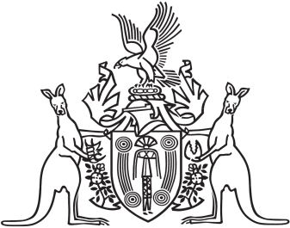
Northern Territory of Australia

Government Gazette
ISSN-0157-833X
No. S30 15 May 2018
Northern Territory of Australia

Northern Territory Civil and Administrative Tribunal Act
Appointment of Ordinary Members of Tribunal
I, Vicki Susan O'Halloran, Administrator of the Northern Territory of Australia, acting with the advice of the Executive Council, under section 16(1) of the Northern Territory Civil and Administrative Tribunal Act, appoint each person named in the Schedule, with reference to the provision of the Act specified opposite the person's name, to be an ordinary member of the Northern Territory Civil and Administrative Tribunal for 5 years.
Dated 14 May 2018
V. S. O'Halloran
Administrator
By Her Honour's Command
N. K. Fyles
Attorney-General and Minister for Justice
Schedule
Name | Provision of Act
David Graham Alderman  David Richard Baldry  Helena Sarah Blundell  Nardine Rosemary Collier  Cassandra Jane Ellis  Andrew Gordon Anschutz George  Russell Raymond Goldflam  Kenneth John Grime  Lesley Hastwell  Ron Michael David Levy  Alister Athol Lindsay  Leslie Alexander McCrimmon  Benjamin O'Loughlin  Robert Frederick Perry  George Michael Roussos  Jodi Marie Truman | Section 16(2)(a)
Kathleen Gail Blair  John Brears  Anthony Hilton Brownjohn  Kathryn Jane Crawley  Kerry Francis Eupene  Jill Diane Huck  Paul Hubert Rysavy  Diane Louise Szarkowicz | Section 16(2)(b)

