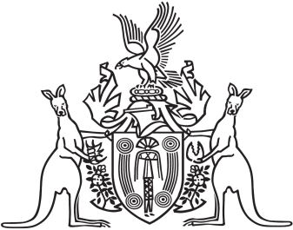
Northern Territory of Australia

Government Gazette
ISSN-0157-833X
No. S17 10 April 2017
Northern Territory of Australia

Northern Territory Environment Protection Authority Act
Appointment of Member of NT EPA
I, John Laurence Hardy, Administrator of the Northern Territory of Australia, acting with the advice of the Executive Council, under section 10(1)(a) of the Northern Territory Environment Protection Authority Act, appoint Colin Joseph Woodward to be a member of the Northern Territory Environment Protection Authority for 3 years on and from the date of this instrument.
Dated 10 April 2017
J. L. Hardy
Administrator
By His Honour's Command
L. J. Moss
Minister for Environment and Natural Resources

