Mineral Titles Act 2010
NOTICE OF LAND CEASING TO BE A MINERAL TITLE AREA
Title Type and Number: | Exploration Licence 32834
Area Ceased on: | 08 April 2025
Area: | 94 Blocks, 299.85 km²
Locality: | HOME OF BULLION
Name of Applicant(s)/Holder(s): | 100% PEGMATITE ONE PTY LTD [ACN. 652 853 391]
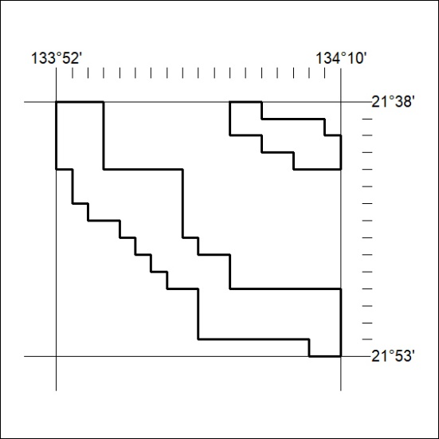

248/25

Mineral Titles Act 2010
NOTICE OF LAND CEASING TO BE A MINERAL TITLE AREA
Title Type and Number: | Exploration Licence 32840
Area Ceased on: | 08 April 2025
Area: | 12 Blocks, 38.34 km²
Locality: | CONICAL HILL
Name of Applicant(s)/Holder(s): | 100% PEGMATITE ONE PTY LTD [ACN. 652 853 391]
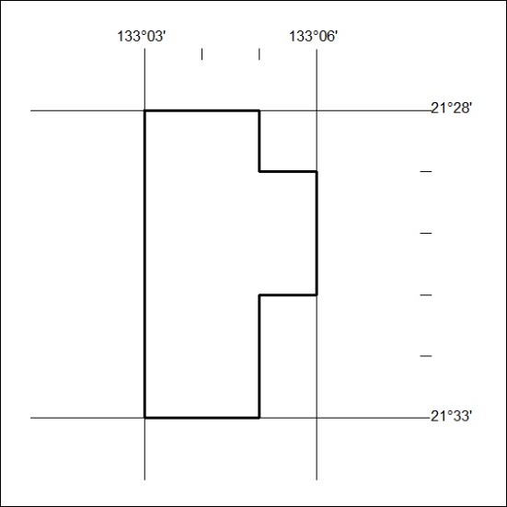

249/25

Mineral Titles Act 2010
NOTICE OF LAND CEASING TO BE A MINERAL TITLE AREA
Title Type and Number: | Exploration Licence 32848
Area Ceased on: | 08 April 2025
Area: | 11 Blocks, 35.17 km²
Locality: | CRAWFORD
Name of Applicant(s)/Holder(s): | 100% PEGMATITE ONE PTY LTD [ACN. 652 853 391]
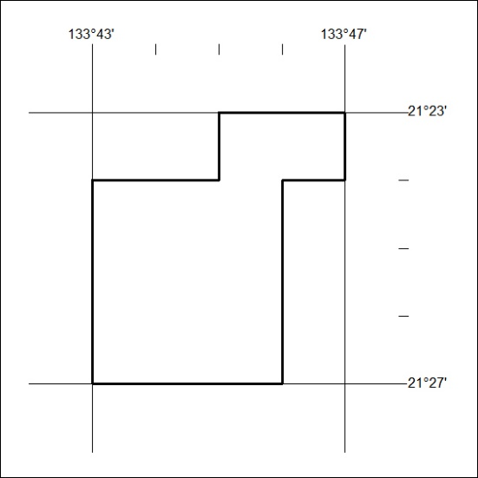

250/25

Mineral Titles Act 2010
NOTICE OF LAND CEASING TO BE A MINERAL TITLE AREA
Title Type and Number: | Exploration Licence 32851
Area Ceased on: | 08 April 2025
Area: | 34 Blocks, 108.22 km²
Locality: | DENISON
Name of Applicant(s)/Holder(s): | 100% PEGMATITE ONE PTY LTD [ACN. 652 853 391]
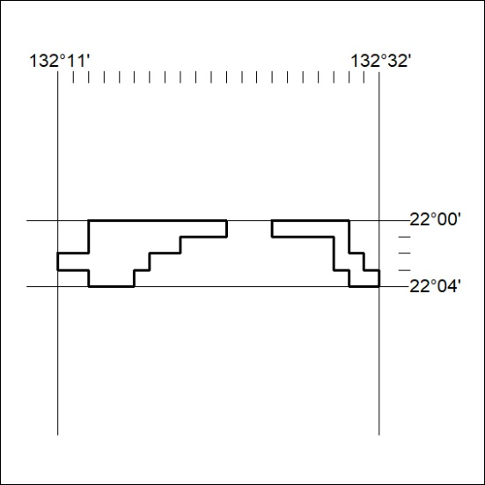

251/25

Mineral Titles Act 2010
NOTICE OF LAND CEASING TO BE A MINERAL TITLE AREA
Title Type and Number: | Exploration Licence 32852
Area Ceased on: | 08 April 2025
Area: | 9 Blocks, 28.63 km²
Locality: | DENISON
Name of Applicant(s)/Holder(s): | 100% PEGMATITE ONE PTY LTD [ACN. 652 853 391]
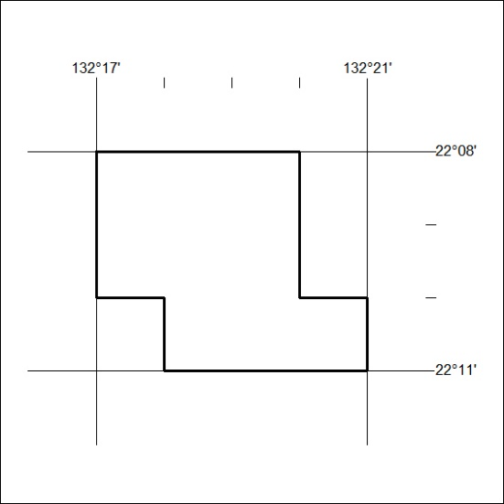

252/25

Mineral Titles Act 2010
NOTICE OF LAND CEASING TO BE A MINERAL TITLE AREA
Title Type and Number: | Exploration Licence 32854
Area Ceased on: | 08 April 2025
Area: | 59 Blocks, 180.51 km²
Locality: | LAUGHLEN
Name of Applicant(s)/Holder(s): | 100% PEGMATITE ONE PTY LTD [ACN. 652 853 391]
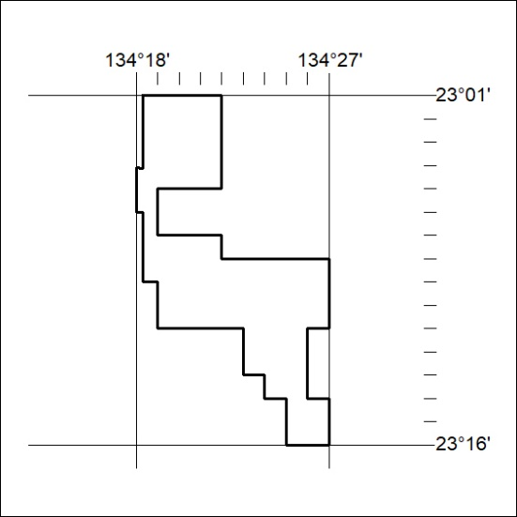

253/25

Mineral Titles Act 2010
NOTICE OF LAND CEASING TO BE A MINERAL TITLE AREA
Title Type and Number: | Exploration Licence 32855
Area Ceased on: | 08 April 2025
Area: | 29 Blocks, 91.53 km²
Locality: | RIDDOCH
Name of Applicant(s)/Holder(s): | 100% PEGMATITE ONE PTY LTD [ACN. 652 853 391]
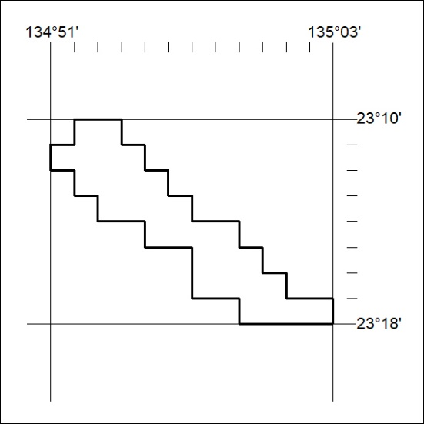

254/25

Mineral Titles Act 2010
NOTICE OF LAND CEASING TO BE A MINERAL TITLE AREA
Title Type and Number: | Exploration Licence 32866
Area Ceased on: | 08 April 2025
Area: | 40 Blocks, 126.50 km²
Locality: | BUSHY PARK
Name of Applicant(s)/Holder(s): | 100% PEGMATITE ONE PTY LTD [ACN. 652 853 391]
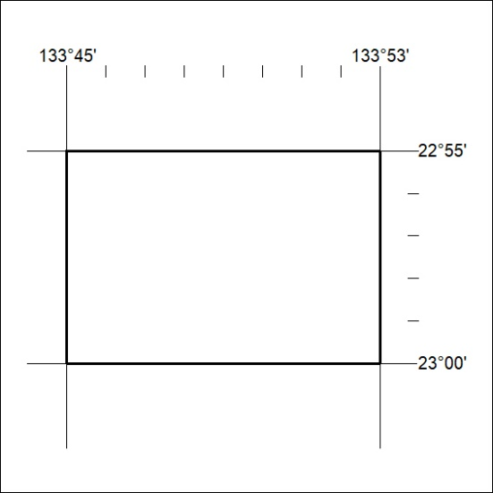

255/25

Mineral Titles Act 2010
NOTICE OF LAND CEASING TO BE A MINERAL TITLE AREA
Title Type and Number: | Exploration Licence 32868
Area Ceased on: | 08 April 2025
Area: | 16 Blocks, 51.14 km²
Locality: | HOME OF BULLION
Name of Applicant(s)/Holder(s): | 100% PEGMATITE ONE PTY LTD [ACN. 652 853 391]
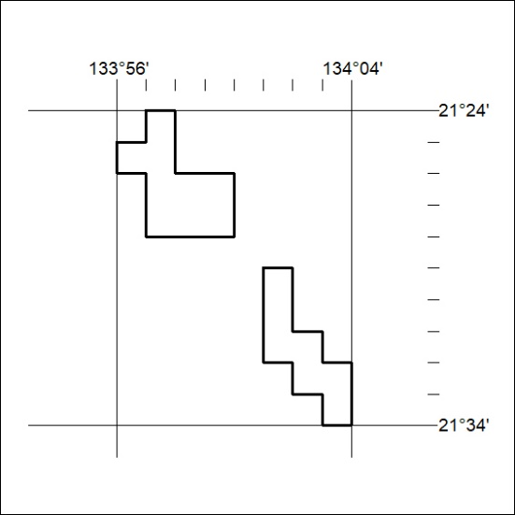

256/25

Mineral Titles Act 2010
NOTICE OF LAND CEASING TO BE A MINERAL TITLE AREA
Title Type and Number: | Exploration Licence 32869
Area Ceased on: | 08 April 2025
Area: | 24 Blocks, 75.65 km²
Locality: | AILERON
Name of Applicant(s)/Holder(s): | 100% PEGMATITE ONE PTY LTD [ACN. 652 853 391]
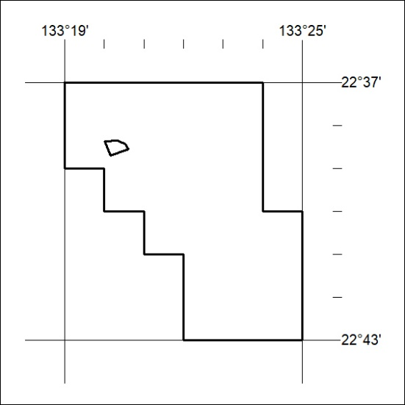

257/25

Mineral Titles Act 2010
NOTICE OF LAND CEASING TO BE A MINERAL TITLE AREA
Title Type and Number: | Exploration Licence 32871
Area Ceased on: | 08 April 2025
Area: | 59 Blocks, 187.24 km²
Locality: | WOODGREEN
Name of Applicant(s)/Holder(s): | 100% PEGMATITE ONE PTY LTD [ACN. 652 853 391]
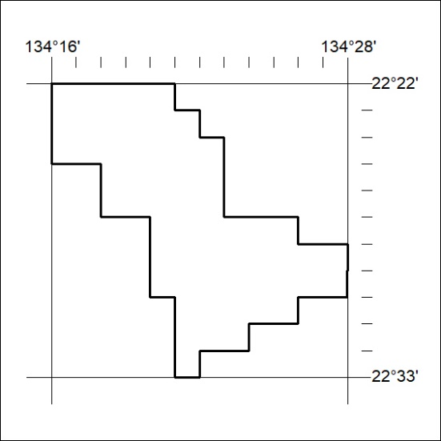

258/25

Mineral Titles Act 2010
NOTICE OF LAND CEASING TO BE A MINERAL TITLE AREA
Title Type and Number: | Exploration Licence 32946
Area Ceased on: | 08 April 2025
Area: | 102 Blocks, 324.35 km²
Locality: | DOREEN
Name of Applicant(s)/Holder(s): | 100% JALEIN PTY LTD [ACN. 124 331 157]
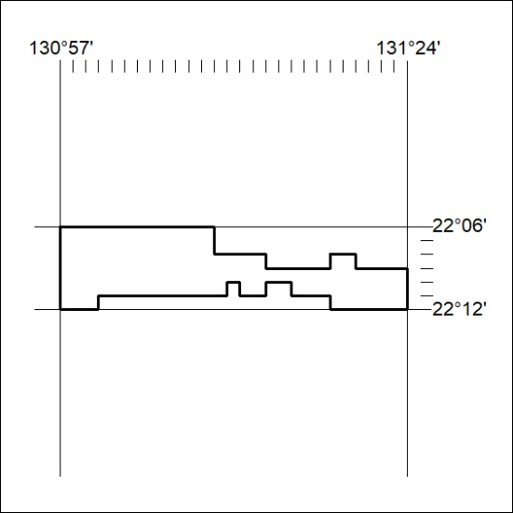

259/25

Mineral Titles Act
NOTICE OF GRANT OF A MINERAL TITLE
Title Type and Number: | Exploration Licence 33921
Granted: | 08 April 2025, for a period of 6 Years
Area: | 42 Blocks, 132.78 km²
Locality: | GLEN HELEN
Name of Holder/s: | 100% THE AUSTRALIAN MINING SERVICE PTY LTD [ACN. 625 506 247]
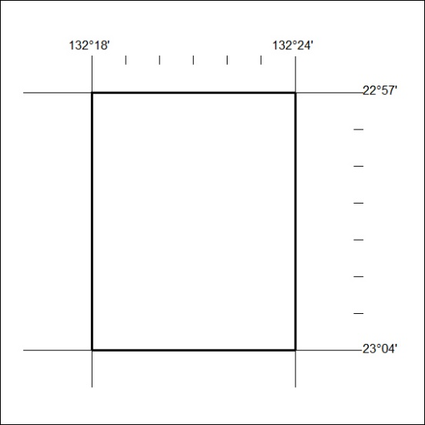
Area granted is indicated above. The titleholder is not permitted to exercise occupational rights on any land that is subject to a development title, or an application for a development title. Any land the subject of a Reserved Land gazettal under the Mineral Titles Act and all land vested in the Commonwealth of Australia is also excluded by description but not excised from the grant area.
260/25

Mineral Titles Act
NOTICE OF GRANT OF A MINERAL TITLE
Title Type and Number: | Exploration Licence 33931
Granted: | 08 April 2025, for a period of 6 Years
Area: | 248 Blocks, 740.02 km²
Locality: | MT WEDGE
Name of Holder/s: | 100% THE AUSTRALIAN MINING SERVICE PTY LTD [ACN. 625 506 247]
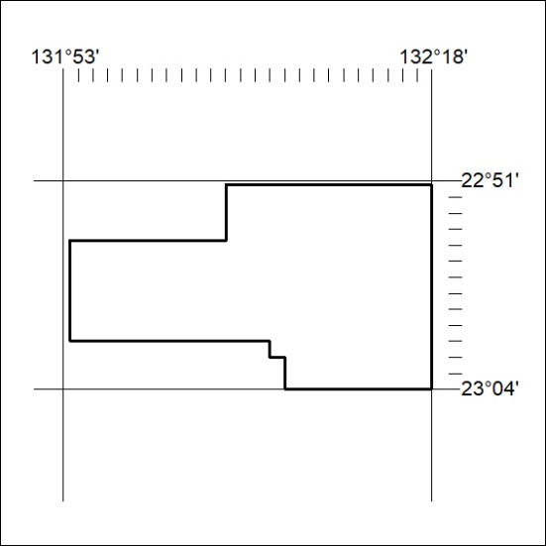
Area granted is indicated above. The titleholder is not permitted to exercise occupational rights on any land that is subject to a development title, or an application for a development title. Any land the subject of a Reserved Land gazettal under the Mineral Titles Act and all land vested in the Commonwealth of Australia is also excluded by description but not excised from the grant area.
261/25

