Mineral Titles Act 2010
NOTICE OF LAND CEASING TO BE A MINERAL TITLE AREA
Title Type and Number: | Exploration Licence 33077
Area Ceased on: | 29 January 2024
Area: | 184 Blocks, 587.65 km²
Locality: | SANDOVER
Name of Applicant(s)/Holder(s): | 100% RIO TINTO EXPLORATION PTY LIMITED [ACN. 000 057 125]
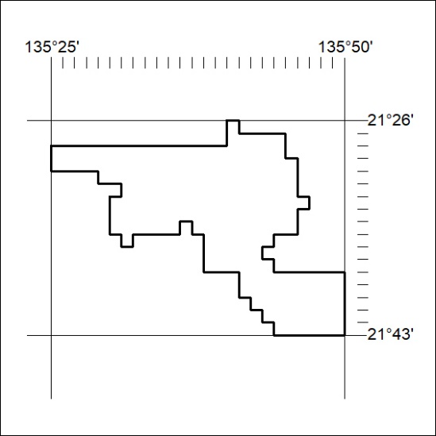

23/24

Mineral Titles Act 2010
NOTICE OF LAND CEASING TO BE A MINERAL TITLE AREA
Title Type and Number: | Exploration Licence 32361
Area Ceased on: | 29 January 2024
Area: | 40 Blocks, 126.32 km²
Locality: | LAUGHLEN
Name of Applicant(s)/Holder(s): | 100% TERRITORY EXPLORATION PTY LTD [ACN. 123 338 376]
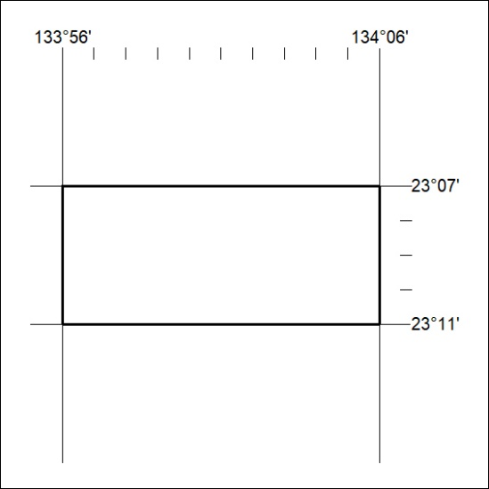

24/24

