Corrigendum
Notice Number 370/23 appearing in MN105/23 on 12 September 2023 is hereby cancelled and replaced by the following:

Mineral Titles Act 2010
NOTICE OF LAND CEASING TO BE A MINERAL TITLE AREA
Title Type and Number: | Exploration Licence 32181
Area Ceased on: | 12 September 2023
Area: | 85 Blocks, 279.58 km²
Locality: | GLYDE
Name of Applicant(s)/Holder(s): | 100% CERBERUS RESOURCES PTY LTD [ACN. 615 192 535]
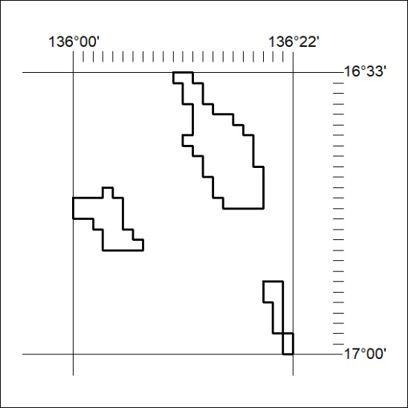

381/23

