Mineral Titles Act
NOTICE OF GRANT OF A MINERAL TITLE
Title Type and Number: | Exploration Licence 33142
Granted: | 17 May 2023, for a period of 6 Years
Area: | 68 Blocks, 205.85 km²
Locality: | QUARTZ
Name of Holder/s: | 100% RIO TINTO EXPLORATION PTY LIMITED [ACN. 000 057 125]
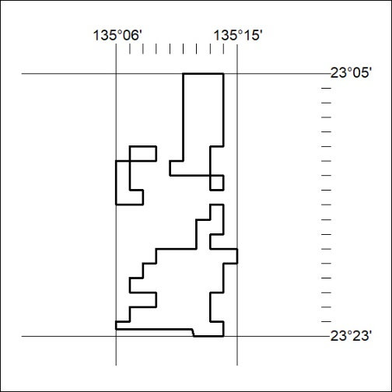
Area granted is indicated above. The titleholder is not permitted to exercise occupational rights on any land that is subject to a development title, or an application for a development title. Any land the subject of a Reserved Land gazettal under the Mineral Titles Act and all land vested in the Commonwealth of Australia is also excluded by description but not excised from the grant area.

155/23

Mineral Titles Act
NOTICE OF GRANT OF A MINERAL TITLE
Title Type and Number: | Exploration Licence 33143
Granted: | 17 May 2023, for a period of 6 Years
Area: | 45 Blocks, 133.19 km²
Locality: | QUARTZ
Name of Holder/s: | 100% RIO TINTO EXPLORATION PTY LIMITED [ACN. 000 057 125]
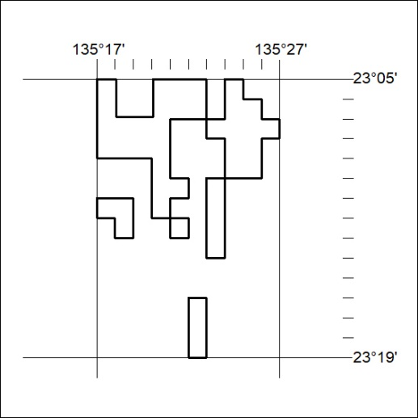
Area granted is indicated above. The titleholder is not permitted to exercise occupational rights on any land that is subject to a development title, or an application for a development title. Any land the subject of a Reserved Land gazettal under the Mineral Titles Act and all land vested in the Commonwealth of Australia is also excluded by description but not excised from the grant area.

156/23

