Mineral Titles Act 2010
NOTICE OF LAND CEASING TO BE A MINERAL TITLE AREA
Title Type and Number: | Extractive Mineral Exploration Licence 32585
Area Ceased on: | 06 May 2023
Area: | 4 Blocks, 13.21 km²
Locality: | LARRIMAH
Name of Applicant(s)/Holder(s): | 100% TERRITORY SANDS PTY LTD [ACN. 632 797 972]
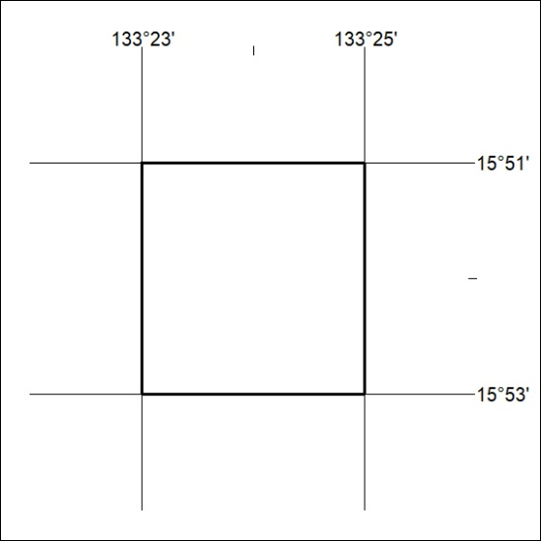

126/23

Mineral Titles Act 2010
NOTICE OF LAND CEASING TO BE A MINERAL TITLE AREA
Title Type and Number: | Extractive Mineral Exploration Licence 32586
Area Ceased on: | 06 May 2023
Area: | 4 Blocks, 13.23 km²
Locality: | WESTERN CREEK
Name of Applicant(s)/Holder(s): | 100% TERRITORY SANDS PTY LTD [ACN. 632 797 972]
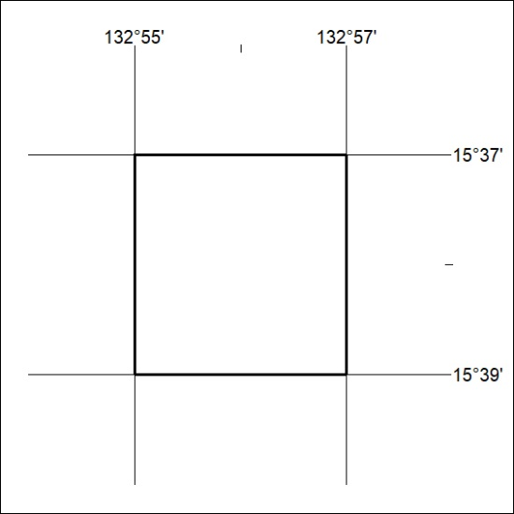

127/23
Mineral Titles Act 2010
NOTICE OF LAND CEASING TO BE A MINERAL TITLE AREA
Title Type and Number: | Extractive Mineral Exploration Licence 32587
Area Ceased on: | 06 May 2023
Area: | 4 Blocks, 13.23 km²
Locality: | WESTERN CREEK
Name of Applicant(s)/Holder(s): | 100% TERRITORY SANDS PTY LTD [ACN. 632 797 972]
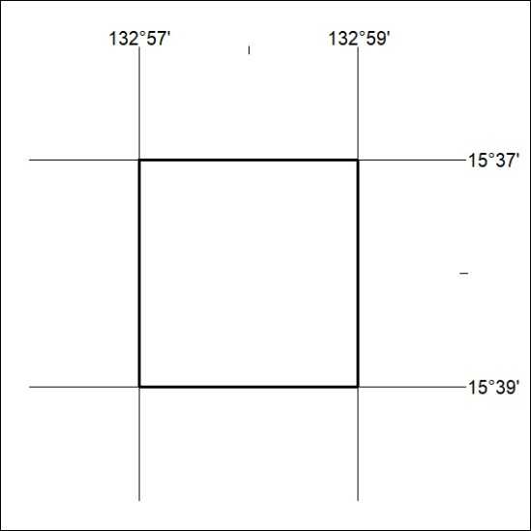

128/23

Mineral Titles Act 2010
NOTICE OF LAND CEASING TO BE A MINERAL TITLE AREA
Title Type and Number: | Extractive Mineral Exploration Licence 32593
Area Ceased on: | 06 May 2023
Area: | 4 Blocks, 13.23 km²
Locality: | LARRIMAH
Name of Applicant(s)/Holder(s): | 100% TERRITORY SANDS PTY LTD [ACN. 632 797 972]
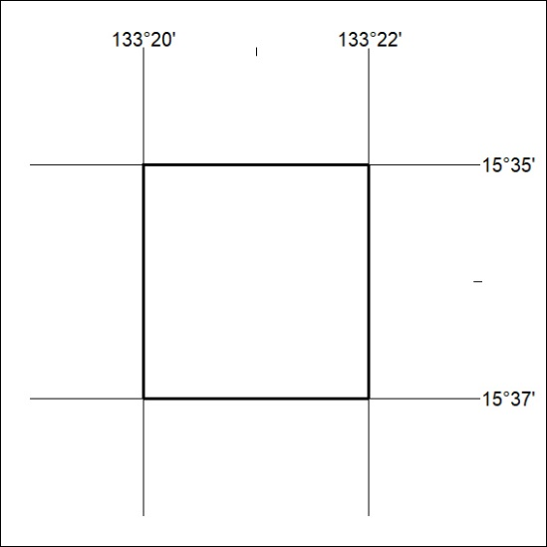

129/23
Mineral Titles Act 2010
NOTICE OF LAND CEASING TO BE A MINERAL TITLE AREA
Title Type and Number: | Extractive Mineral Exploration Licence 32594
Area Ceased on: | 06 May 2023
Area: | 4 Blocks, 13.23 km²
Locality: | LARRIMAH
Name of Applicant(s)/Holder(s): | 100% TERRITORY SANDS PTY LTD [ACN. 632 797 972]
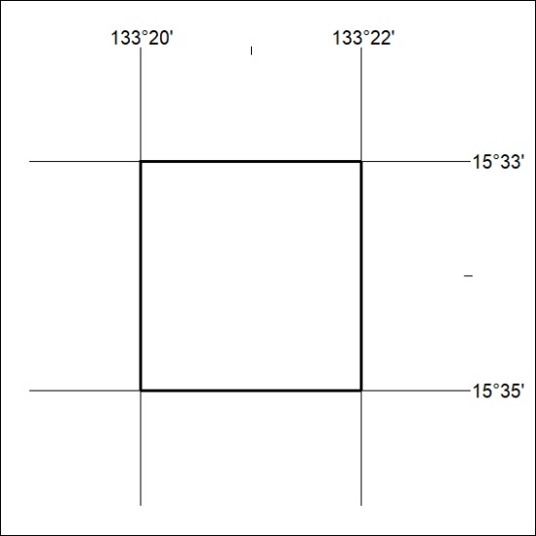

130/23

Mineral Titles Act 2010
NOTICE OF LAND CEASING TO BE A MINERAL TITLE AREA
Title Type and Number: | Extractive Mineral Exploration Licence 32598
Area Ceased on: | 06 May 2023
Area: | 4 Blocks, 13.13 km²
Locality: | MURRANJI
Name of Applicant(s)/Holder(s): | 100% TERRITORY SANDS PTY LTD [ACN. 632 797 972]
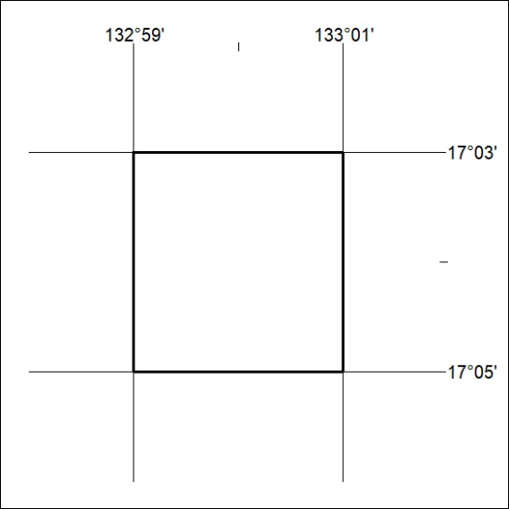

131/23
Mineral Titles Act 2010
NOTICE OF LAND CEASING TO BE A MINERAL TITLE AREA
Title Type and Number: | Extractive Mineral Exploration Licence 32599
Area Ceased on: | 06 May 2023
Area: | 4 Blocks, 13.13 km²
Locality: | NEWCASTLE WATERS
Name of Applicant(s)/Holder(s): | 100% TERRITORY SANDS PTY LTD [ACN. 632 797 972]
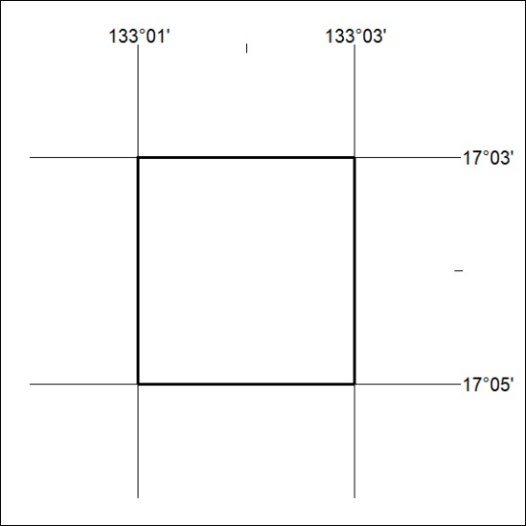

132/23

Mineral Titles Act 2010
NOTICE OF LAND CEASING TO BE A MINERAL TITLE AREA
Title Type and Number: | Extractive Mineral Exploration Licence 32601
Area Ceased on: | 06 May 2023
Area: | 4 Blocks, 13.13 km²
Locality: | MURRANJI
Name of Applicant(s)/Holder(s): | 100% TERRITORY SANDS PTY LTD [ACN. 632 797 972]
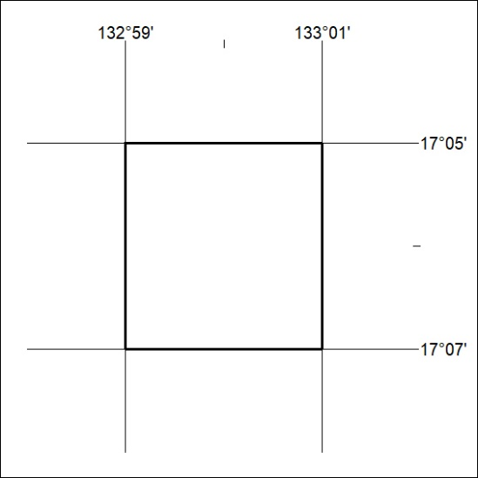

133/23
Mineral Titles Act 2010
NOTICE OF LAND CEASING TO BE A MINERAL TITLE AREA
Title Type and Number: | Extractive Mineral Exploration Licence 32602
Area Ceased on: | 06 May 2023
Area: | 4 Blocks, 13.13 km²
Locality: | NEWCASTLE WATERS
Name of Applicant(s)/Holder(s): | 100% TERRITORY SANDS PTY LTD [ACN. 632 797 972]
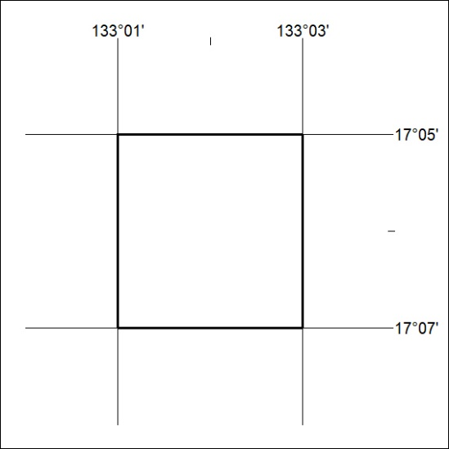

134/23

Mineral Titles Act 2010
NOTICE OF LAND CEASING TO BE A MINERAL TITLE AREA
Title Type and Number: | Extractive Mineral Exploration Licence 32606
Area Ceased on: | 06 May 2023
Area: | 4 Blocks, 13.12 km²
Locality: | NEWCASTLE WATERS
Name of Applicant(s)/Holder(s): | 100% TERRITORY SANDS PTY LTD [ACN. 632 797 972]
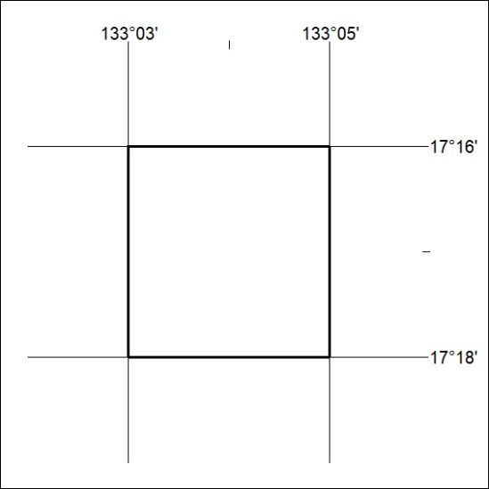

135/23
Mineral Titles Act 2010
NOTICE OF LAND CEASING TO BE A MINERAL TITLE AREA
Title Type and Number: | Extractive Mineral Exploration Licence 32607
Area Ceased on: | 06 May 2023
Area: | 4 Blocks, 13.12 km²
Locality: | NEWCASTLE WATERS
Name of Applicant(s)/Holder(s): | 100% TERRITORY SANDS PTY LTD [ACN. 632 797 972]
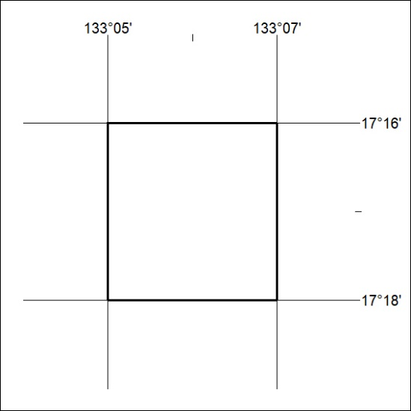

136/23

Mineral Titles Act 2010
NOTICE OF LAND CEASING TO BE A MINERAL TITLE AREA
Title Type and Number: | Extractive Mineral Exploration Licence 32608
Area Ceased on: | 06 May 2023
Area: | 4 Blocks, 13.12 km²
Locality: | NEWCASTLE WATERS
Name of Applicant(s)/Holder(s): | 100% TERRITORY SANDS PTY LTD [ACN. 632 797 972]
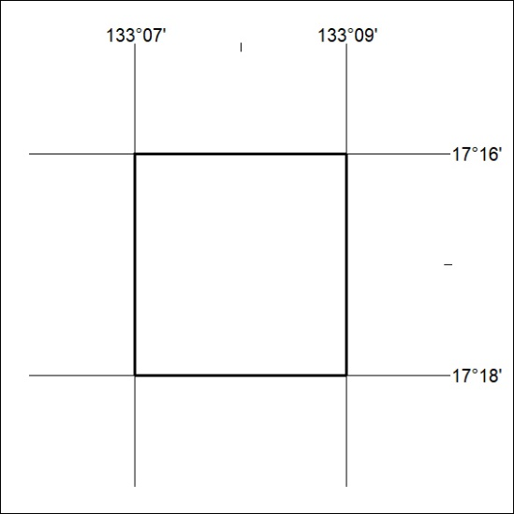

137/23

