Mineral Titles Act 2010
NOTICE OF LAND CEASING TO BE A MINERAL TITLE AREA
Title Type and Number: | Exploration Licence 32406
Area Ceased on: | 08 March 2023
Area: | 4 Blocks, 12.63 km²
Locality: | FLORA
Name of Applicant(s)/Holder(s): | 100% MICRONISED MINERAL SOLUTIONS PTY LTD [ACN. 126 378 318]
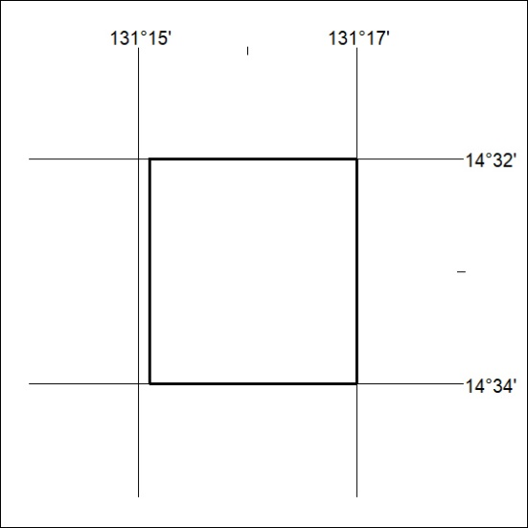

063/23

