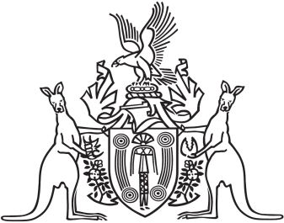
Northern Territory of Australia

Government Gazette
ISSN-0157-833X
No. S51 3 July 2018

Assent to Proposed Laws
Her Honour the Administrator declared assent to the following proposed laws:
28 June 2018
Appropriation (2018-2019) Act 2018 (Act No. 13 of 2018)
Revenue Legislation Amendment Act 2018 (Act No. 14 of 2018)
Michael Tatham
Clerk of the Legislative Assembly
Date 29 June 2018

