Mineral Titles Act 2010
NOTICE OF LAND CEASING TO BE A MINERAL TITLE AREA
Title Type and Number: | Exploration Licence 31546
Area Ceased on: | 19 January 2024
Area: | 152 Blocks, 500.28 km²
Locality: | PUNGALINA
Name of Applicant(s)/Holder(s): | 100% MANGROVE RESOURCES PTY LTD [ACN. 612 043 240]
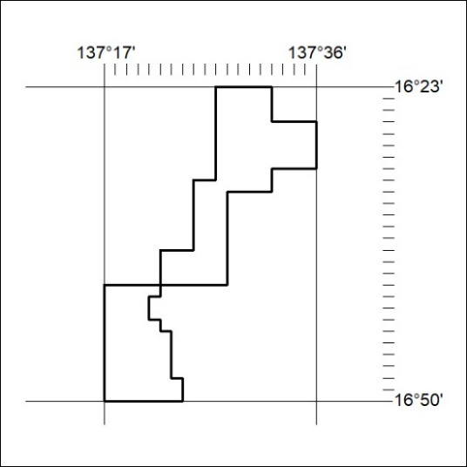

17/24

Mineral Titles Act 2010
NOTICE OF LAND CEASING TO BE A MINERAL TITLE AREA
Title Type and Number: | Exploration Licence 31548
Area Ceased on: | 19 January 2024
Area: | 87 Blocks, 286.47 km²
Locality: | SELBY
Name of Applicant(s)/Holder(s): | 100% MANGROVE RESOURCES PTY LTD [ACN. 612 043 240]
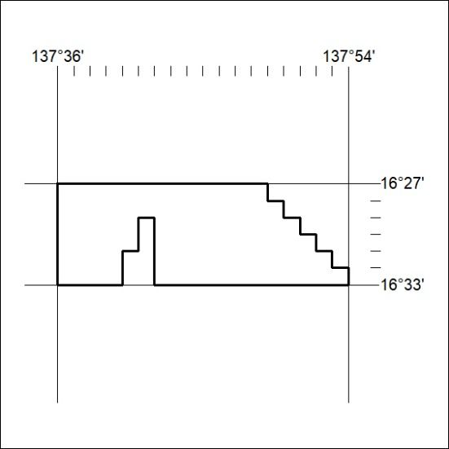

18/24
Mineral Titles Act 2010
NOTICE OF LAND CEASING TO BE A MINERAL TITLE AREA
Title Type and Number: | Exploration Licence 31549
Area Ceased on: | 19 January 2024
Area: | 90 Blocks, 293.01 km²
Locality: | SELBY
Name of Applicant(s)/Holder(s): | 100% MANGROVE RESOURCES PTY LTD [ACN. 612 043 240]
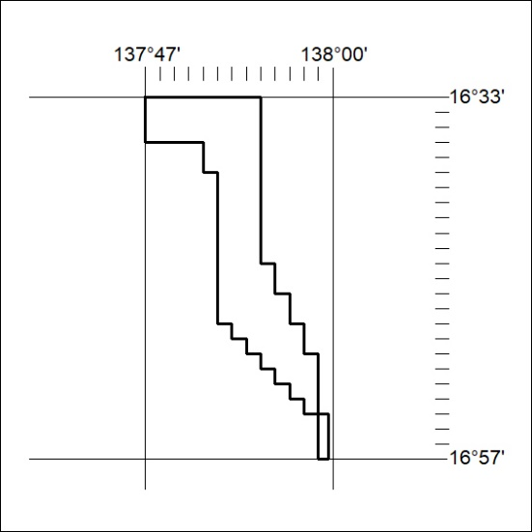

19/24

Mineral Titles Act 2010
NOTICE OF LAND CEASING TO BE A MINERAL TITLE AREA
Title Type and Number: | Exploration Licence 31550
Area Ceased on: | 19 January 2024
Area: | 124 Blocks, 407.41 km²
Locality: | ADAM
Name of Applicant(s)/Holder(s): | 100% MANGROVE RESOURCES PTY LTD [ACN. 612 043 240]
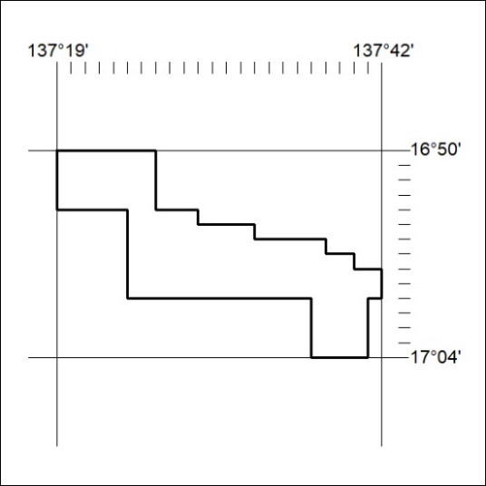

20/24
Mineral Titles Act 2010
NOTICE OF LAND CEASING TO BE A MINERAL TITLE AREA
Title Type and Number: | Exploration Licence 32064
Area Ceased on: | 22 January 2024
Area: | 10 Blocks, 32.95 km²
Locality: | KILLARNEY
Name of Applicant(s)/Holder(s): | 100% WRIGHT Anthony
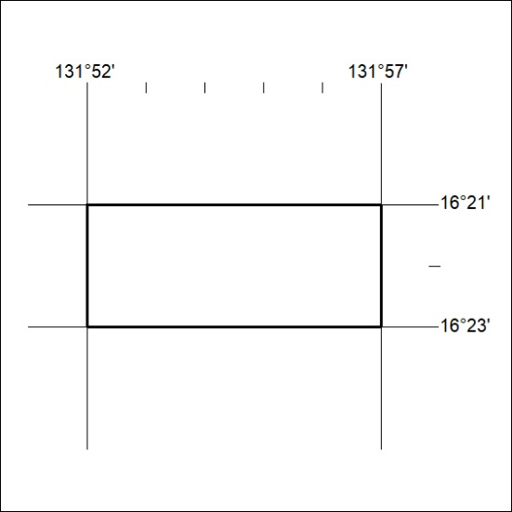

21/24

