Chemigation / Fertigation Systems
- Section 95 of the NT Agricultural and Veterinary Chemicals (Control of Use) Act 2004 allows the Chemical Coordinator or a chemical advisor to attend and inspect premises’ to prevent, detect and investigate offences against the act. This includes the inspection of machines and equipment used with agricultural and veterinary chemicals, fertilisers and stock food.
- Pursuant to Section 95(j) of the Act, where machinery and equipment does not meet specified requirements or poses a risk of harm to the health of the user, the public or the environment due to its condition, damage or serviceability; the chemical coordinator or chemical advisor can direct the person in charge to cease operating the equipment or machine until repairs are completed or the machine or equipment meets a specified requirement.

Specified Requirements
- For chemigation and fertigation equipment used in the deployment of chemicals or fertilisers, the specified requirements are:
  - the mandatory installation of back flow prevention devices that meet Australian and New Zealand Standards AS/NZ 2845 and 3500.1,
  - No off take or injection points in between the ground water source and the back flow prevention device,
  - Mixing point is separate to the bore head and the injection / intake point and has suitable protections to prevent discharge into the environment. For example the use of bunding or mixing on a concrete slab.

Backflow Prevention Devices
- As a property owner or occupier, you need to be aware of the backflow prevention requirements for your business. There are a number of different types of backflow prevention devices. These include:
  - Registered Air Gap (RAG)
  - Atmospheric Vacuum Breaker.
  - Pressure Vacuum Breaker.
  - Double Check Valve.
  - Reduced Pressure Zone Device (RPZD)
- According to the AS/NZS 3500.1 when injecting chemicals and/or fertiliser into the water pump discharge pipes only a RPZD or RAG are considered acceptable for the high hazard rating.
- The landholder is responsible for ensuring that these devices are installed and are working correctly in order to prevent the pollution of ground and surface water. For specific installation advice, landholders should engage with certified plumbers and system retailers.

Chemical / Fertiliser Compatibility
- Only chemicals registered for chemigation can be used in irrigation systems. The approved APVMA labels or permit will state the registration status and identify approved irrigation systems, safety measures, and worker protection requirements which must be adhered to at all times.
- As fertiliser products do not have the same direction of use requirements as pesticides or other chemicals, it is the responsibility of landholders to ensure that the quantity, mix rate and composition of mixed fertilisers does not pose a risk to human, animal or environmental health and is suitable to the size and nature of the crop.
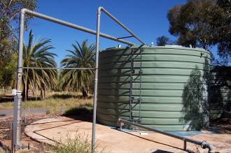
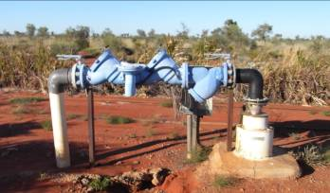
- The landholder has a duty to ensure that any fertiliser used does not contain contaminants or other harmful ingredients. Where cadmium, lead or mercury is present, it must not be above the prescribed limits in accordance with Part 7 of the Agricultural and Veterinary Chemicals (Control of Use) Regulations 2005.
Figure 2 – Air Gap via water tank, photo courtesy DEPWS
Figure 1 – RPZD Device, photo courtesy DEPWS

Offences
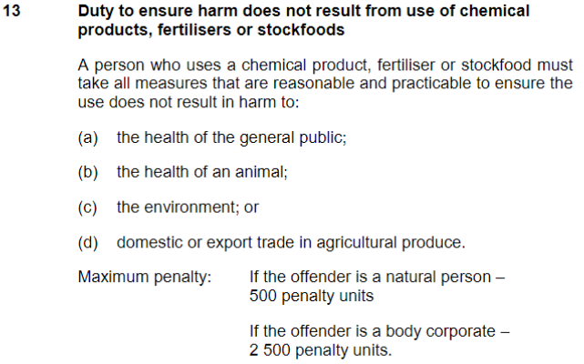
- The inappropriate use of chemicals and fertilisers constitutes an offence under Section 13 of the Agricultural and Veterinary Chemicals (Control of Use) Act 2004.

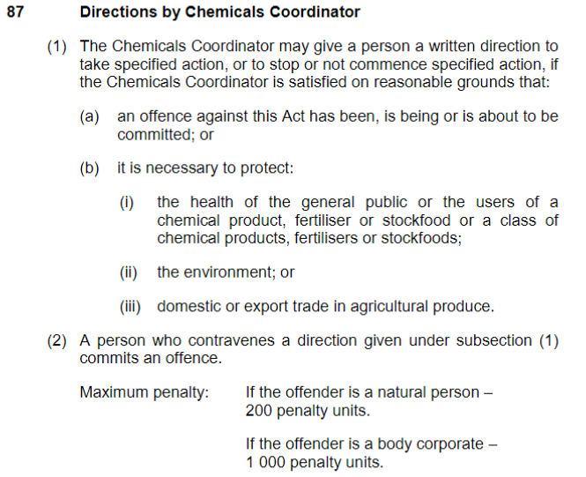
- Furthermore a person who contravenes a direction by the Chemical Coordinator commits a further offence under Section 87 of the Agricultural and Veterinary Chemicals (Control of Use) Act 2004.

Further Information
- Further information on the safety and handling of chemicals and fertilisers can be found on their respective labels, safety data sheets as well as the APVMA or Chem Alert websites.
- www.chemalert.rmt.com.au
- https://portal.apvma.gov.au/pubcris

