Recreational activities on beaches have the potential to impact on turtle nesting success
Marine turtles in Australia are listed threatened species and are vulnerable to many threatening processes including ghost nets, entanglement in fishing gear, marine debris, habitat loss, boat strike and feral animal predation.
Non-invasive turtle viewing requires an understanding of the nesting process and appropriate behaviour around turtles and their habitat. Untrained and self-guided viewing often disturbs the nesting process, affecting the female turtle's valuable energy reserves and potentially, her reproductive success.
These community guidelines suggest appropriate behaviour for commercial and non-commercial beach-users, to engage with marine turtles in a safe, enjoyable and sustainable manner.
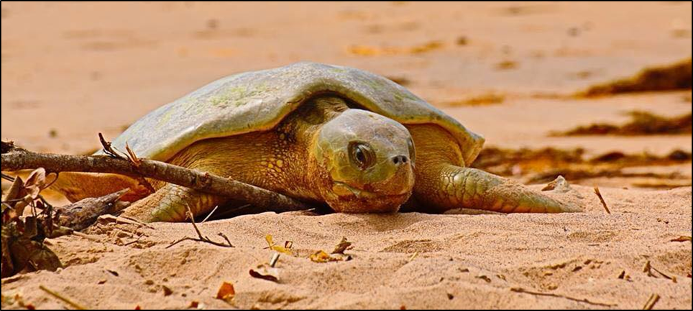

On the beach
- Avoid driving on known turtle nesting beaches. If necessary, drive with care below the high tide mark or at least 20 metres from the base of the dunes away from where nests are most likely to be found.
- Restrict light spill from vehicle headlights by shielding the upper and lower part of the beam, producing a slit in the middle of the headlights.
- Do not light campfires on turtle nesting beaches.
- Remove rubbish.
- Walk at a safe distance (more than 10m) from the water’s edge given the presence of saltwater crocodiles and to allow nesting turtles to emerge from the water.

On the water
- Do not disturb or interfere with mating turtles. Observe them from a distance and do not impede their movement or block their escape.
- Lighting on vessels may disturb nesting turtles and attract turtle hatchlings. Lights on vessels may also attract crocodiles, so keep lighting to a practical, safe level.

Nesting turtles
- Use red lights or low-level lights directed at the ground within groups to prevent trips, falls and stumbling on coral and debris. Tour guides should direct torch-shine during tours, and within groups, should provide only enough torches for safety.
- Do not use white lighting from when a turtle is located until it has started laying.
- While waiting for turtles to emerge from the water wait in a group at the base of the dunes. Tour guides are to act as forward scouts to look for turtles, and position groups of people at least 20m to the side of the turtles’ likely route up the beach.
- Stand still while turtles emerge from the water, avoiding rapid movements and keeping noise to a minimum.
- When the guide or a leader has confirmed that the turtle has started to lay, the group may approach. Avoid touching the turtle when removing sand to view the egg laying.
- Stay away from the front of flatback turtles as they bite.
- Low-level lights directed at the rear of the turtle enables viewing of egg laying and covering of the nest.
- Flash photography can be used in a controlled manner once the turtle starts to lay, but should be avoided at the front of the turtle.
- Do not disturb the nests.
- Allow turtles to return to the sea without disturbance or assistance.

Hatchlings
- Do not touch or handle hatchling turtles unless you have a permit issued by the Parks and Wildlife Commission.
- Do not use lighting while hatchlings are on the beach.
- Allow hatchlings to move to the sea without disturbance or assistance.

Tour operators
Tour guides have a particular responsibility to provide a positive nature experience without disturbing marine turtles.
- Tour operators must not touch, interact or interfere with wildlife unless they hold a permit issued by the Parks and Wildlife Commission.
- All activities must comply with relevant legislation and policies, including Animal Ethics Code of Practice, Territory Parks and Wildlife Conservation Act and By Laws (permits), NT Animal Welfare Act (licence) and the PWCNT Marine Turtle Watching Policy. Copies must be held in or on the vehicle or vessel.
- Tour guides must be trained in marine turtle biology and marine turtle watching codes of practice before leading tours. The Parks and Wildlife Commission will consider standards of training when issuing permits.
- The tour guide is to ensure all participants are to remain with the group at all times.
- Tour companies must ensure First Aid and emergency procedures are in place, especially where saltwater crocodiles are known to occur.
- All staff and participants to be inducted in safety and emergency procedures.
- Tour operators should explain these turtle watching guidelines to tour participants.
- There are heavy penalties for taking or interfering with wildlife without a permit. Refer also to the PWCNT Marine Turtle Watching Policy.

Contacts
Permits Office (office hours Monday to Friday 8:00 – 4:00pm)
 (08) 8999 4795  pwpermits@nt.gov.au ✓ http://parksandwildlife.nt.gov.au/permits
Wildlife Operations (office hours Monday to Friday 8:00 – 4:20pm)
 (08) 8995 5008  wildlife.management@nt.gov.au ✓ http://parksandwildlife.nt.gov.au
Marine Wild Watch (to report signs of turtle nesting and incidents involving marine wildlife)
 Hotline 1800 453 941
Remember You Are In Croc Country. Be Crocwise. http://www.parksandwildlife.nt.gov.au/becrocwise

The Department of Environment and Natural Resources, Flora and Fauna Branch, Marine Ecosystems Team; Research Scientists from Charles Darwin University; and members of the NT Tourism Industry assisted with the development of this document.

